**CLOUD NATIVE APPLICATION**

**ARCHITECTURE NANODEGREE PROGRAM**

1. **WELCOME**

**LESSON 1 Welcome to the Nanodegree Program!**

# Welcome to Udacity



### **Welcome to Udacity!**

I am Sebastian, the founder of Udacity.

Our mission is to power careers through tech education. We’re honored that you’ve chosen us to help in your career journey. Whether embarking on a new path. Curious about a new field. Or advancing in your own field. I want you to know, you’re in the right place. We are here to help you accomplish your goals.

I can’t wait to see where this journey takes you!

# The Udacity Experience



If this is your first Nanodegree program, welcome. If you have taken a Nanodegree program with us before, you already know a little bit of what to expect. Udacity is always improving our learning experience for students. So you can watch this to see what is changed or skip ahead. You can also read this in the FAQ located in the resources tab.

Let’s get started.

We truly believe you couldn’t have chosen a better place to learn. A lot of people have worked tirelessly to create the course material and platform features, as we all want you to get the most of your learning journey. Our pledge is to provide you with resources and services that will further enable you to succeed in your Nanodegree program. As you go through the lessons, you may find some to be difficult and may feel discouraged. If this happens, we encourage you to take advantage of your community channels and mentor services to help clarify the concepts, or just to share your doubts. Our mentors are there to help you! You will get advice and guidance to ensure you are on track to complete the projects. We WANT you to succeed and graduate with a Udacity Nanodegree certificate.

We value the trust you have put in us by making this investment in your future career. We take it seriously and we are here to help you achieve whatever you came here to accomplish.

# Meet your Instructors

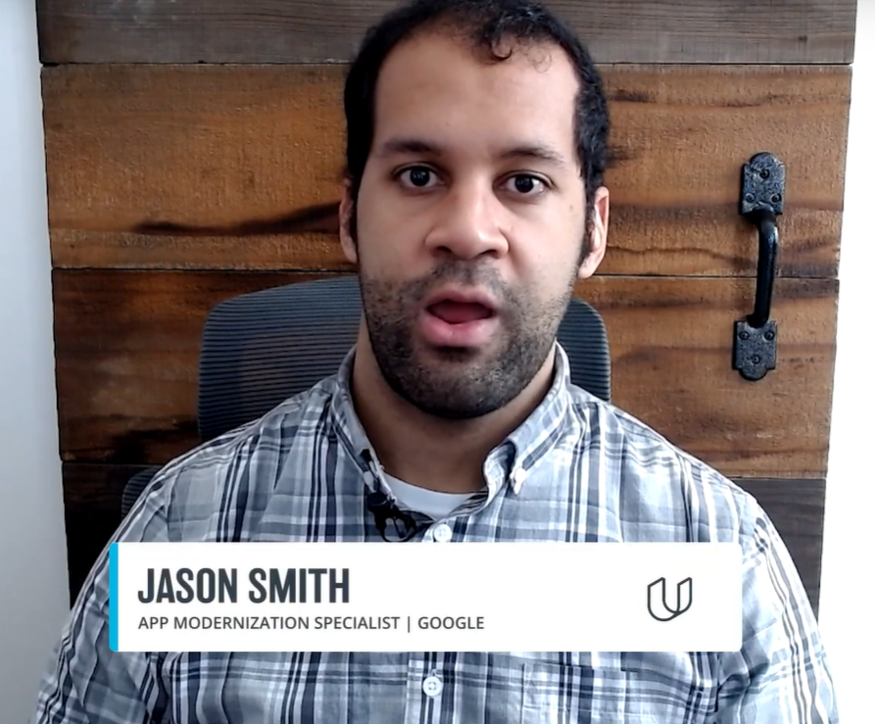



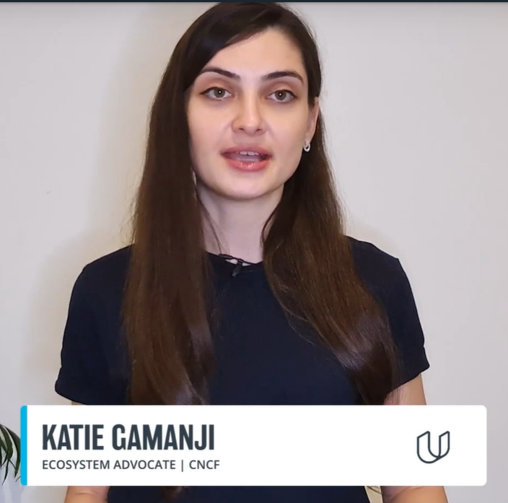

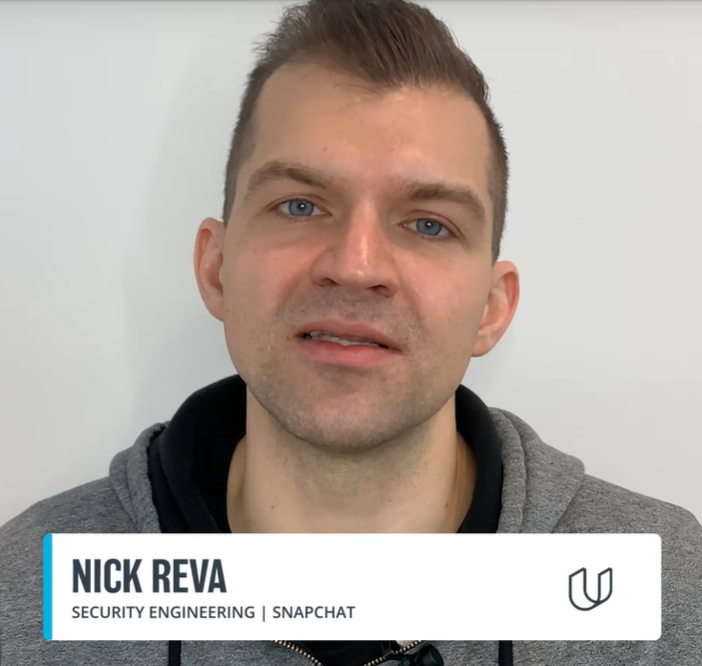

# How to Succeed



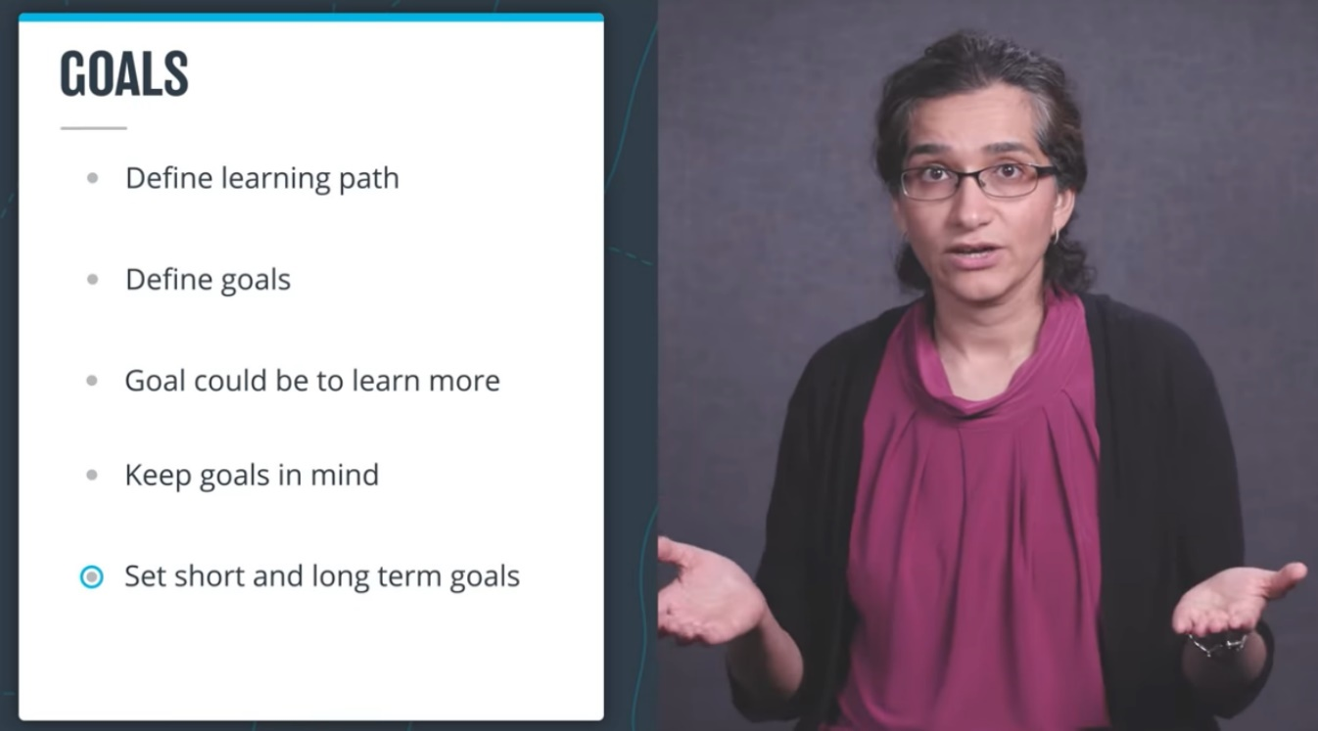

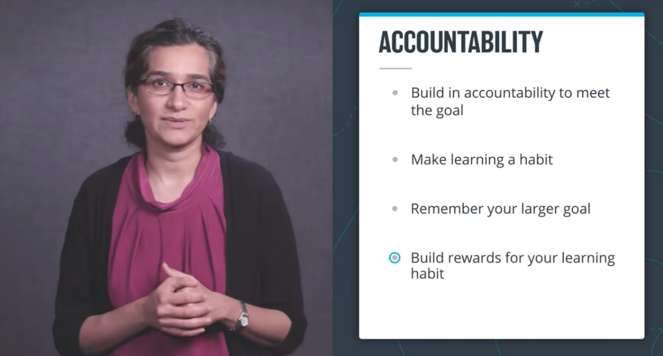

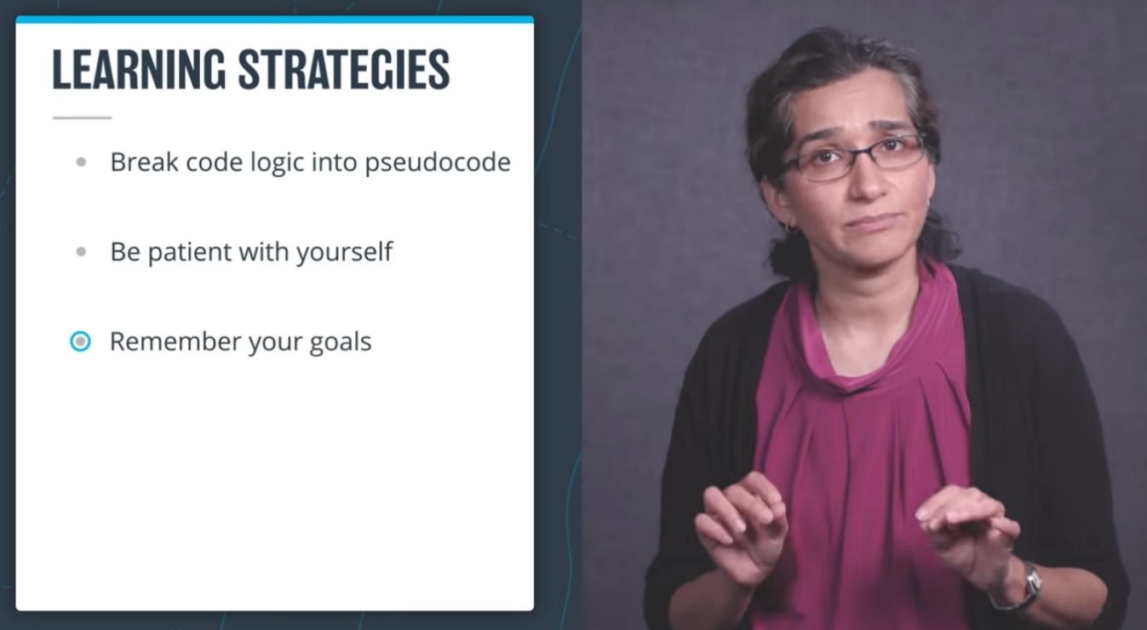

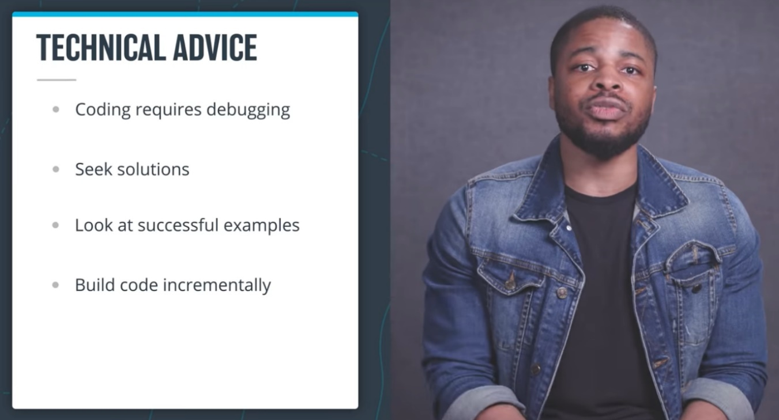

**LESSON 2 Getting Help**

# What It Takes

# What it Takes

Completing a Udacity program takes perseverance and dedication, but the rewards outweigh the challenges. Throughout your program, you will develop and demonstrate specific skills that will serve you for a lifetime. Congratulations on taking the first step towards developing the skills you need to power your career through tech education!

The videos, text lessons, and quizzes you encounter in the classroom are optional but recommended. The project at the end of this course will test your ability to apply the skills and strategies you have learned in the classroom to real-world problems. It will also provide tangible outputs you can use to demonstrate your skills for current and future employers.

The project is designed to be challenging. Many students initially struggle, but with a little grit, they are able to learn from their mistakes and build their skills. Data from nearly 100,000 Udacity graduates show that commitment and persistence are the highest predictors of whether or not a student will graduate.

At some point, nearly every student will get stuck on a new concept or skill, and doubt may set in. Don’t panic. Don’t quit. Be patient, and work through the problem. Remember that you are not alone and the problem that you are encountering is likely one that many others have experienced as well. Whether you are stuck or simply looking for encouragement, you’ll find Udacity Mentors and students there to help.

# Getting Help

# Getting Help

As questions come up during this course, click on the Help button on the left sidebar of your classroom. You’ll see four options, each for a separate type of support:

* **Technical Mentor Help**: is available on Knowledge, our expert Q&A platform, by clicking on "Mentor Help". You can search for answers to questions similar to yours or post new questions related to your project or lessons. Udacity’s expert technical mentors answer all new questions.
* **Udacity Support Community:**Receive peer support and find answers to your non-technical questions quickly through [Udacity Support Community](https://udacity.zendesk.com/hc/en-us/community/topics). Receive peer support from our global community of lifelong learners that help each other succeed by sharing their experience and expertise. Start a discussion [here](https://udacity.zendesk.com/hc/en-us/community/topics).
* **General Account Help**: This is where you can get details on non-technical issues such as 3rd party tools, billing, deadlines, and more. You can even find additional help here via. live chat. Simply click on Account Help or visit our [Help Center](https://udacity.zendesk.com/hc) to find answers. .

# Mentor Help

# Mentor Help

**Technical Mentor Support**: is provided through Knowledge, our expert Q&A platform. You can search for answers to questions similar to yours or post new questions related to your project or lessons. **Udacity’s expert technical mentors answer all-new questions.**

### **How to Use Knowledge**

To ensure you’re getting the quality and prompt support you need, it’s helpful to follow these best practices and guidelines for Knowledge.

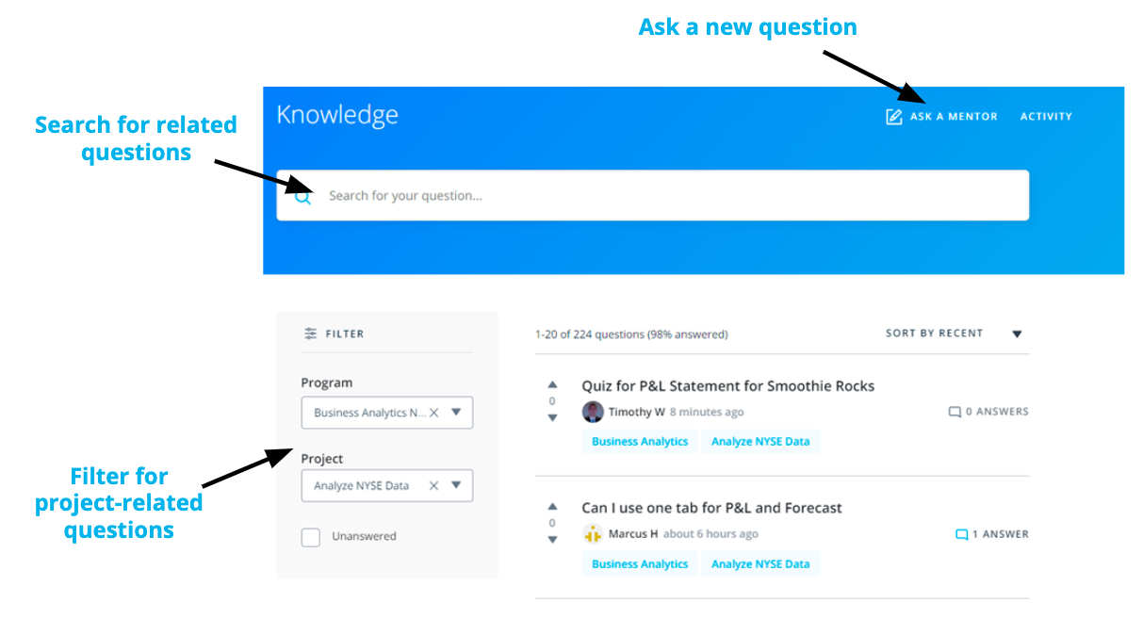

* **Search for Similar Existing Questions**: with tens of thousands of students enrolled in our programs, many of your questions may have already been asked and answered. To look for existing answers to similar questions that may provide the immediate support you need, use the **filter on the left side of your screen** to select your course and related project or write in the key terms related to your question in the **search bar** at the top of the page.
* **Ask a New Question**: if you want to ask a new question, select “Ask a Mentor” at the top of the page. Kindly remember that Knowledge is for technical questions only; for other types of support and feedback, please write to support at [support@udacity.com](mailto:support@udacity.com).

When you ask a new question, the platform immediately assigns it to one of our expert mentors spread across the globe to ensure prompt replies. Of note, when a mentor answers your question, you will see “Mentor” next to their name to differentiate their support from comments your fellow learners may also provide.

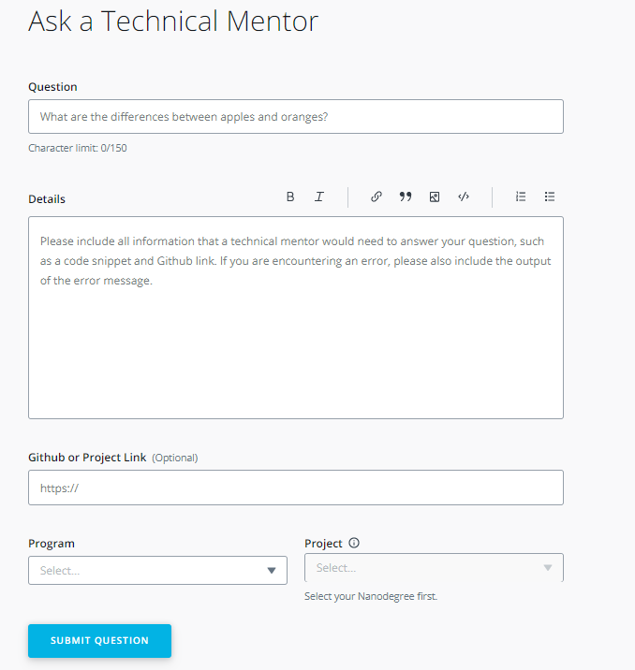

If you don't see your question, simply create a new post. You are likely to get an answer within 24 hours and you'll be helping future students who may encounter the same problem.

### How to Ask a Good Question?

Students that follow these tips typically receive the strongest initial support and avoid back-and-forth with mentors:

* **Ask Specific Questions**: if you have closely related questions that form part of a general theme, it’s okay to ask them all together. But consider using bullet points to separately list each of the questions in your post. Keeping your questions organized helps ensure mentors provide clear answers to each specific question. If your questions are less closely connected, it’s best to submit new, separate questions for each one.
* **Provide Details and Links:** explaining what (if anything) you’ve already attempted to solve the problem helps mentors know where to start when answering your question. Likewise, if your question is not related specifically to a project, but rather to an exercise, quiz, or lesson, it’s helpful to include information such as lesson or quiz name, screenshots, and classroom links.

*Overall the key to asking a good question is to imagine yourself trying to answer your own question. Imagine you were coming to it without any prior knowledge. Does the question make complete sense? Or are there gaps around the context?*

* **Start with a Clear Question Title**: attempt to summarize your entire question in one sentence. You may even write the title at the end, just before posting the question. This will help you summarize the issue before you include details in the question itself.
* **Share Code Correctly**: by using the “Code Block” option to properly format your code. If your question concerns a piece of external code, include a link to the file on Github.

*In fact, Github lets you create a link to a specific line in a file. To do so, just click to the left of the line number, and then select*copy permalink*in the ellipsis that appears in the margin. Paste the*permalink*right into the Github box on your question submission form.*

* **Figuring out Errors**: if your question is about an error message or stack trace, include the entire error message, by either formatting the error message using the “Code Block” option or creating a Gist or a Paste on Pastebin, and including a link to it in the description.
* **Avoid Screenshots of Code or Error Messages**: do not use screenshots of code or error messages. They are hard to read and the text cannot be copied to debug it.

If you receive a helpful answer, kindly select it as the “accepted answer.” For questions from other students, if you see other helpful answers kindly select the “upvote” option. Conversely, if you don’t think an answer strongly answers a question, select the “downvote” option.

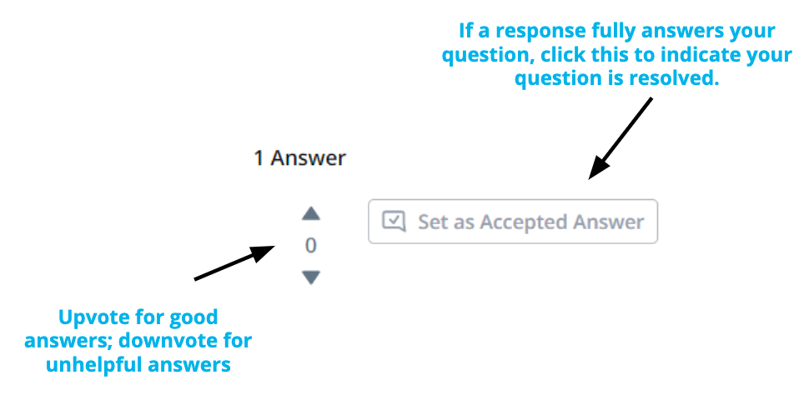

### Getting Additional Support

At times, students want support from a different mentor. As everyone learns differently, we want to make this a simple process for learners like you.

If you receive an answer that you are not satisfied with and want a different mentor to chime in, kindly select the option at the top of the page in Knowledge. If you reply directly in the comments section, without clicking on the link at the top of the page, your question will not be answered by another mentor.

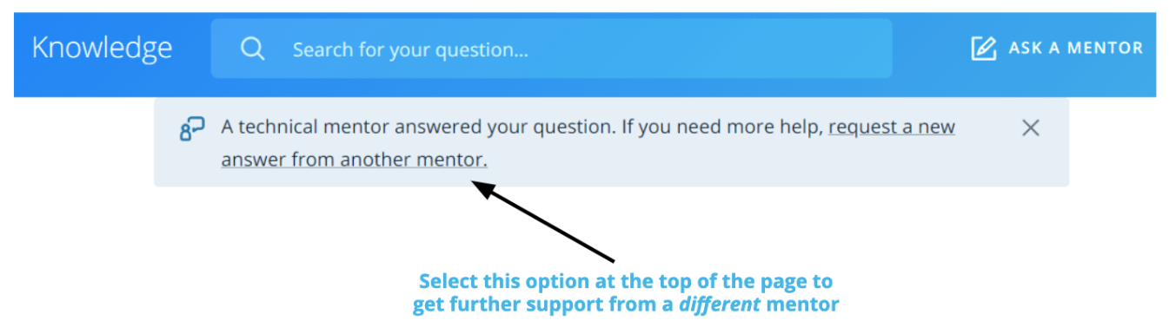

# Submitting Classroom Feedback

If you would like to share feedback on your learning experience or need to report any errors in the classroom content, click the ‘Submit Feedback’ button on the upper-right corner of the classroom. This feature is available in all of your lessons and allows you to provide comments on specific sections of the lesson you’re on.

NOTE: When you report feedback through the classroom, you won’t receive a direct response, but don’t worry! Your feedback will be documented and shared with the appropriate team for review. We strive to create the best learning experience for each unique individual and we’ll take your feedback into account as we continue to improve the program!

**How Classroom Feedback Works**

Click the ‘Submit Feedback’ button on the upper-right corner of the classroom:

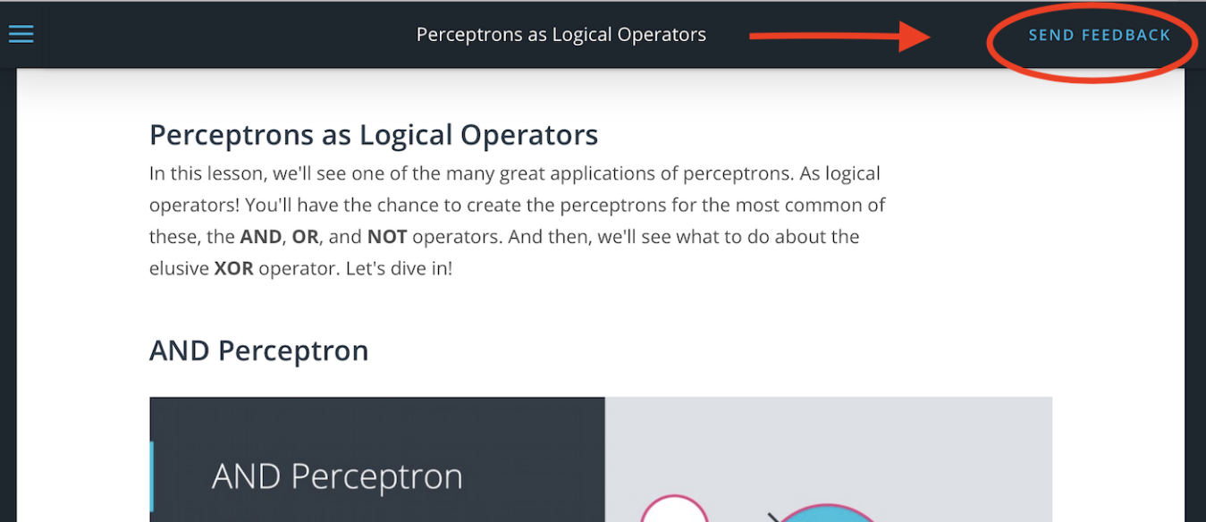

This will highlight different sections on the current concept that you’re in. Click ‘Select’ on the section you would like to provide feedback on:

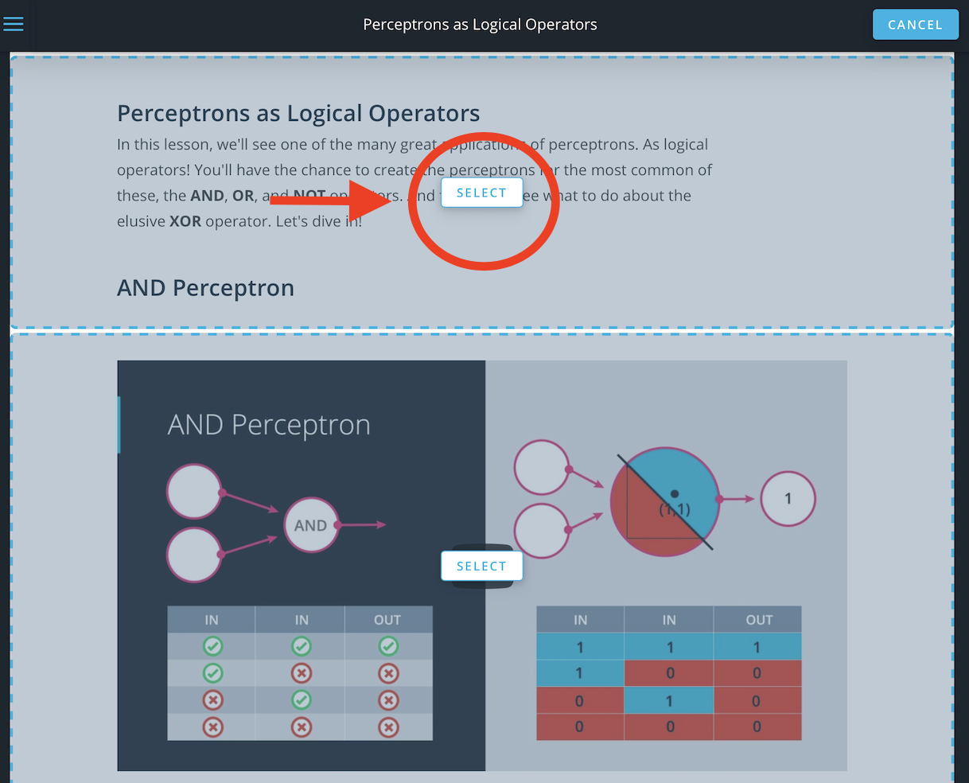

Once you select a section, you will see a feedback box appear on the bottom-right corner of the classroom where you can fill in additional information that you would like to share with us. Once you click ‘Send,’ you will see a confirmation message that your feedback has been sent and received.

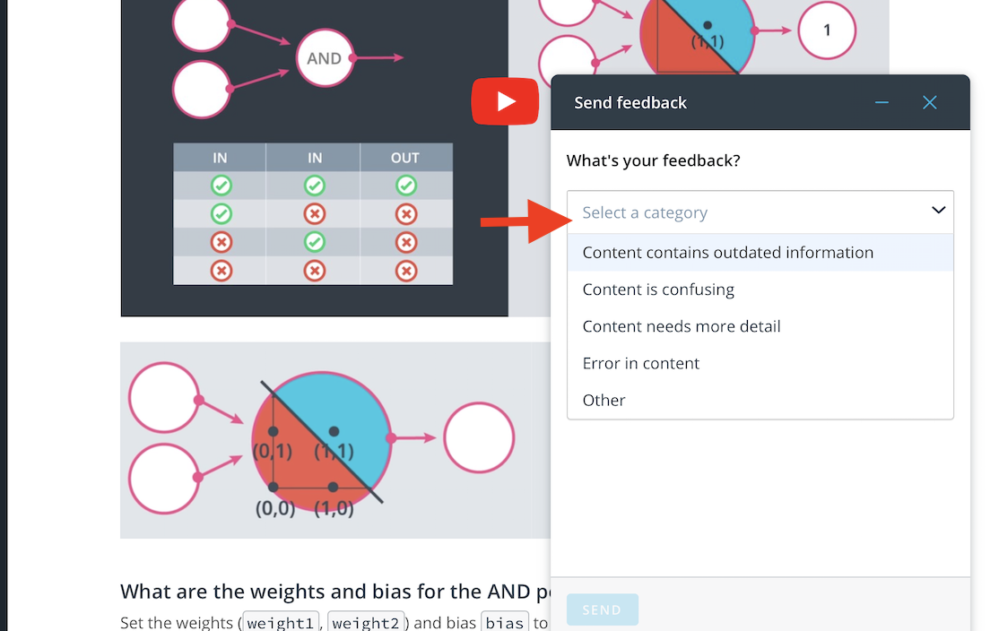

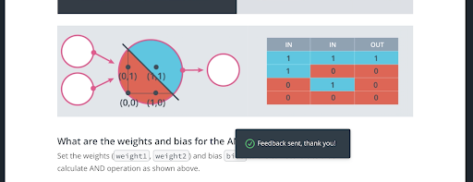

And that’s it! As a reminder, you won’t receive a direct response for classroom feedback submission, but please know that your comments have been shared with the appropriate team for review.

# Help Center

Get help with your account, browse categories of FAQs, and more!

**Get Account help**

Read detailed help articles on account-related topics like billing, third-party tools, project deadlines, graduation, and more.

**Choose the type of help you require**

For your specific questions, look through categories of Frequently Asked Questions and find answers quickly.

**Get in touch with us**

Reach out to our Support team directly via [Live Chat](https://udacity.zendesk.com/hc/en-us). Click on Account Help in the Classroom or visit our [Help Center](https://udacity.zendesk.com/hc) to get started.

# Udacity Support Community

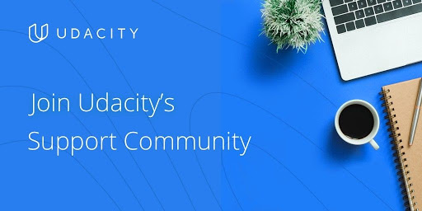

**Welcome to Udacity’s Support Community!**

Become a part of our global community of lifelong learners that help each other succeed by sharing their experience and expertise. Receive peer support and find answers to your non-technical questions quickly through Udacity Support Community.

**Find answers to your questions**

Search Udacity Support Community for answers to commonly asked questions.

**Receive peer support**

Ask the community by posting a question and following discussions.

**Share your expertise**

Get recognized for sharing your insights, experiences, and tips with fellow learners.

**Checkout status of your Support tickets**

Manage and streamline your view of the support tickets, community conversations, and people you follow in the 'My Profile' section.

**Solved, helpful, and recommended posts**

Let other learners know which posts solved your problem, highlight helpful responses, and get the answers you want faster with recommended posts.

**Build your reputation in the community**

Explore and participate in Support Community programs to earn points, levels, and badges. Have fun and unlock rewards along the way.

### Join the [Support Community](https://udacity.zendesk.com/hc/en-us/community/topics) now

# Plagiarism

# Plagiarism and Academic Dishonesty

## Overview of Plagiarism at Udacity

### Defining Plagiarism

**Any act claiming or implying another person’s work as your own.**

Examples:

* Submitting a project you didn’t create to copying code into a program without citation.
* Any action in which you misleadingly claim an idea or piece of work as your own, when it is not.

### Copying and Combining Code

**Using another person’s work in your own work**

Examples:

* Following a guide that someone may have created for completing a Udacity project, whether from a video or website.
* Taking a part of someone else's project and changing some variable and function names, - regardless of whether you give the source credit or not.
* If you have not done the work yourself and attempt to mask it.

### Using Someone Else’s Code to Inform your Solution

You should never knowingly view someone else’s work until you have completed the project yourself - nor should you share your project with someone who has not yet completed theirs. However, once you have completed your project, you are encouraged to see how other people have approached the same challenge in a different way. This allows you to compare your different strategies and ways of thinking.

### Submitting Identical Works Post Collaboration

If you decide to work together with another student on a project, you are then expected to write your code separately. Submitting identical projects or submissions with identical portions is considered plagiarism as described in the Udacity [Honor Code](https://www.udacity.com/legal/en-us/honor-code).

## Seeking Help without violating the Honor Code

To be clear, you are encouraged to seek help by talking to Mentors on Knowledge, other students, and alumni. You’re also welcome to use frameworks and libraries to assist you, as long as they aren't removing important goals from the project that you should know how to do yourself.

If you are struggling and need help, we encourage you to ask technical questions on Knowledge to explore why your approach is not the correct approach. Mentors typically provide answers within an hour of questions being posted, so you can expect quick guidance on your question.

If you’re ever in doubt as to whether or not something would be considered plagiarism, ask a Mentor on Knowledge. Our goal is for every student to graduate armed with a toolbox of skills that they can apply across a variety of concepts and problems. The best way to achieve this is to ensure every student does their own work and is able to demonstrate their skills in each project submission.

# Quiz: Plagiarism at Udacity

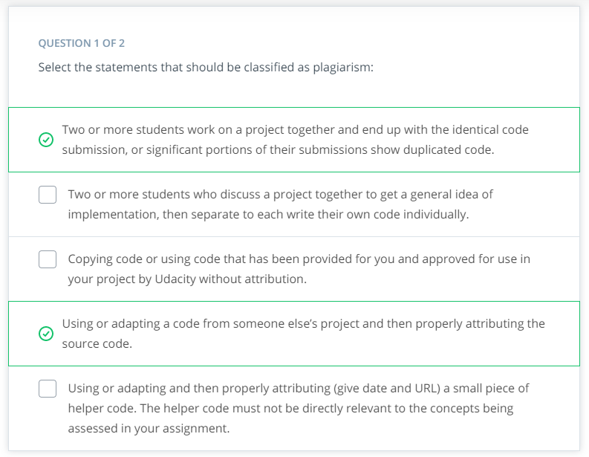

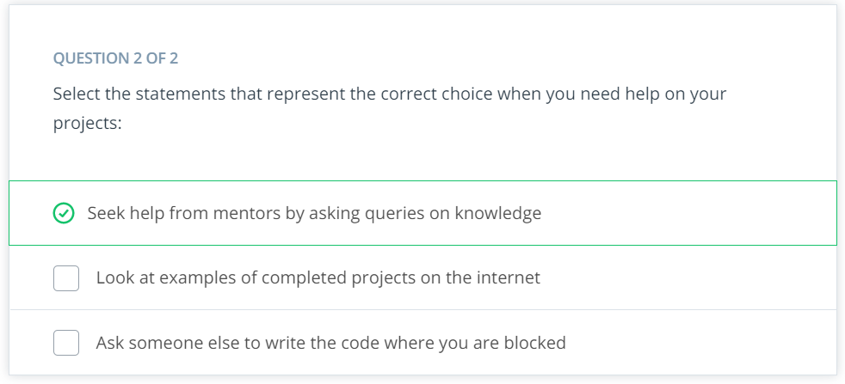

1. **CLOUD NATIVE FUNDAMENTALS**

**LESSON 1 Introduction to Cloud Native Fundamentals**

# Meet Your Instructor

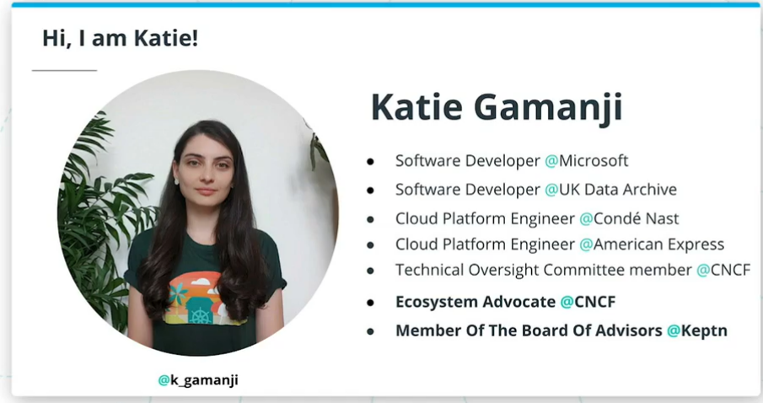

## Summary

Welcome to the Microservice Fundamentals course! My name is Katie Gamanji, and I will be your instructor.

In this course, we will learn how to construct a CI/CD pipeline that will containerize an application and deployed it to a Kubernetes cluster.

I have been working as a cloud platform engineer for many years. In these roles, I built and maintained platforms that would enable developers to deploy and host their applications. This revolves around a high degree of automation, upskilling, and constant iterations on user feedback.

In my current role, I am working for CNCF ( Cloud Native Computing Foundation) as Ecosystem Advocate, representing and growing the End User Community. Also, I am a member of the advisory board for Keptn, which currently is a sandbox CNCF project.

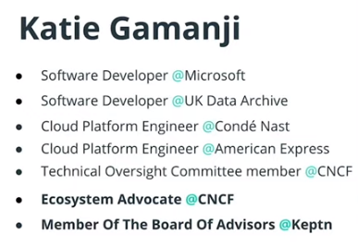

# Prerequisites

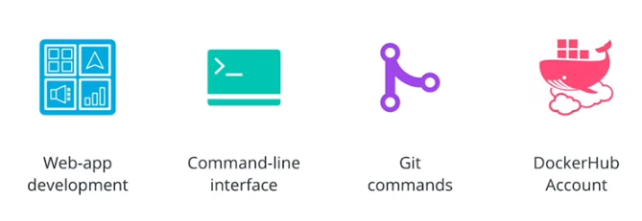

## Summary

For this course, students should be comfortable with:

* **web application development with Python**
* using the **CLI**or command-line interface
* using **git commands**
* creating a **DockerHub account**

These pre-requisites will be used throughout the course. Make sure you have them installed to closely follow the demos and exercise solutions.

# Course Outline

## Summary

Throughout the course, we will walk through a realistic example of applying good development practices and containerizing an application, before it's released to a Kubernetes cluster using an automated CI/CD pipeline.

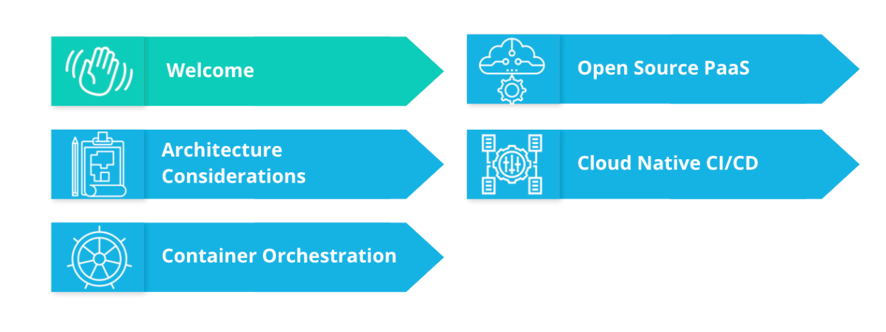

This **course** has the following lessons:

* Welcome
* Architecture Considerations
* Container Orchestration
* Open Source PaaS
* Cloud Native CI/CD

In the first lesson, we will cover:

* Introduction to Cloud Native
* CNCF and Cloud Native tooling
* Stakeholders
* Tools, Environment & Dependencies

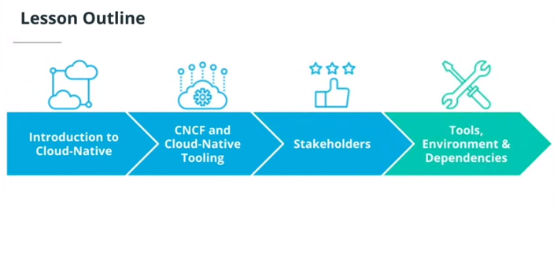

# Introduction to Cloud-Native

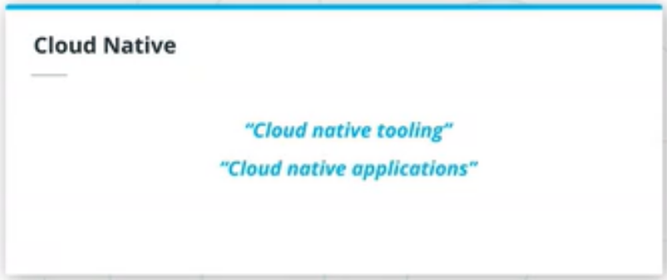

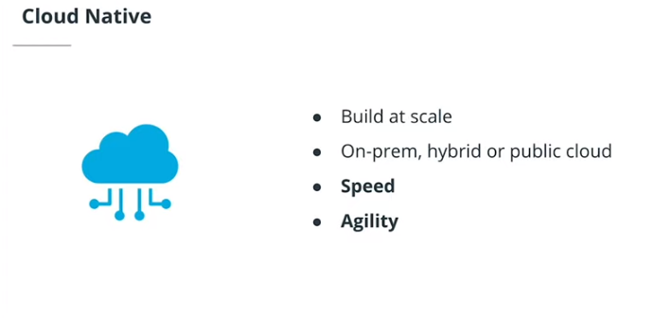

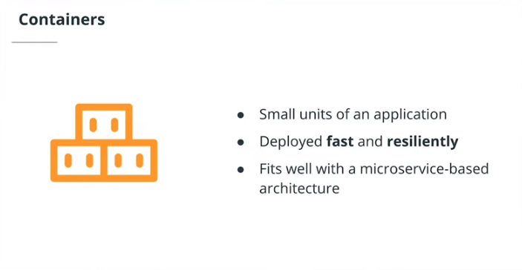

## Summary

Cloud-native refers to the set of practices that empowers an organization to **build and manage applications at scale**. They can achieve this goal by using private, hybrid, or public cloud providers. In addition to scale, an organization needs to be agile in integrating customer feedback and adapting to the surrounding technology ecosystem.

**Containers** are closely associated with cloud-native terminology. Containers are used to run a single application with all required dependencies. The main characteristics of containers are easy to manage, deploy, and fast to recover. As such, often, a microservice-based architecture is chosen in tandem with cloud-native tooling. Microservices are used to manage and configure a collection of small, independent services that can be easily packaged and executed within a container.

# CNCF and Cloud-Native Tooling

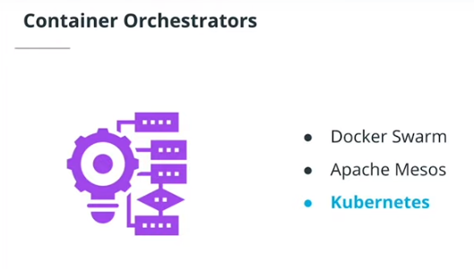

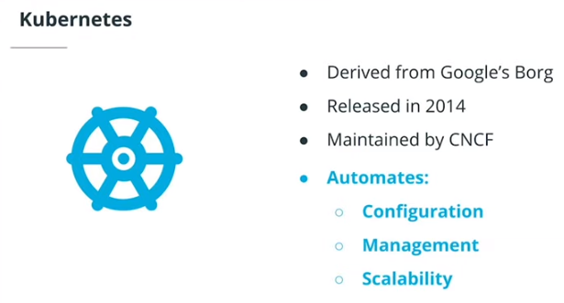

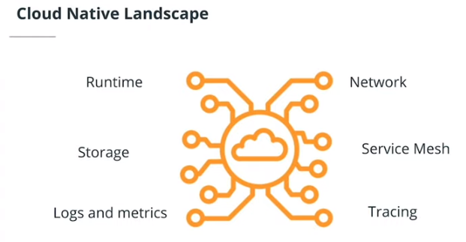

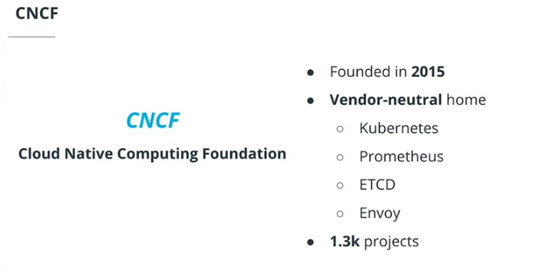

**Summary**

**Kubernetes** had its first initial release in 2014 and it derives from Borg, a Google open-source container orchestrator. Currently, Kubernetes is part of **CNCF**or **Cloud Native Computing Foundation**. CNCF was founded in 2015, and it provides a **vendor-neutral home to open-source projects** such as Kubernetes, Prometheus, ETCD, Envoy, and many more.

Overall, Kubernetes is a container orchestrator that is capable to solutionize the integration of the following functionalities:

* Runtime
* Networking
* Storage
* Service Mesh
* Logs and metrics
* Tracing

# Stakeholders

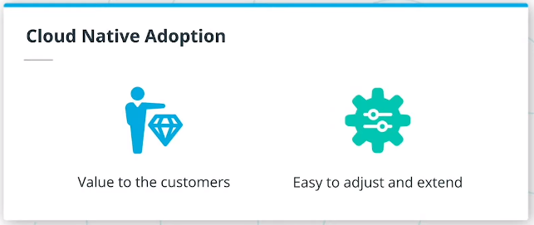

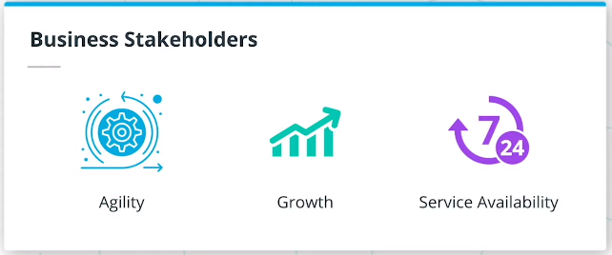

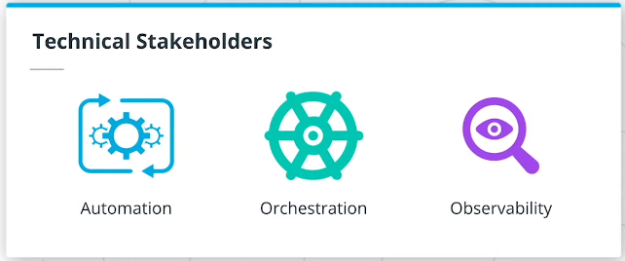

**Summary**

An engineering team can use cloud-native tooling to enable quick delivery of **value to customers** and **easily extend** to new features and technologies. These are the main reasons why an organization needs to adopt cloud-native technologies. However, when trialing cloud-native tooling, there are two main perspectives to address: business and technical stakeholders.

From a **business perspective**, the adoption of cloud-native tooling represents:

* Agility - perform strategic transformations
* Growth - quickly iterate on customer feedback
* Service availability - ensures the product is available to customers 24/7

From a **technical perspective**, the adoption of cloud-native tooling represents:

* Automation - release a service without human intervention
* Orchestration - introduce a container orchestrator to manage thousands of services with minimal effort
* Observability - ability to independently troubleshoot and debug each component

# Tools, Environment & Dependencies

## Summary

For this course, make sure you have the listed pre-requisites installed. These tools will be used throughout the course, so make sure you install them to follow the demo and exercise solutions closely.

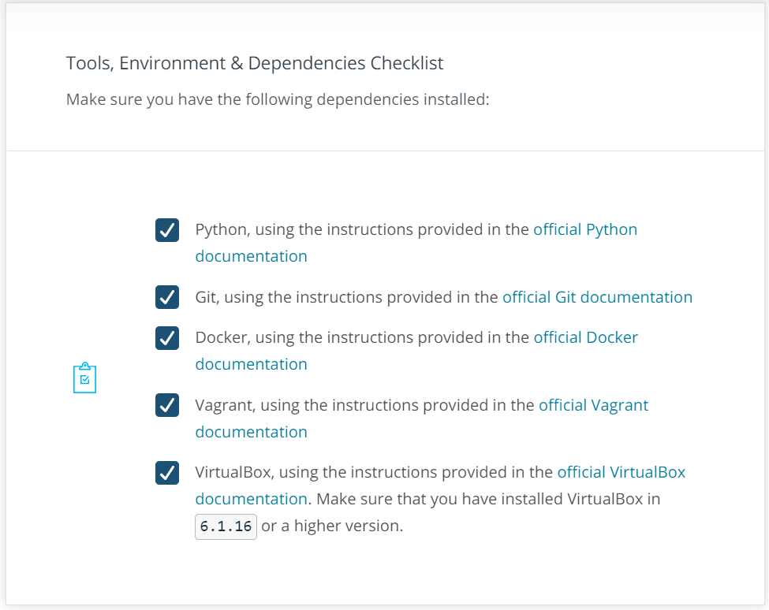

# Recap

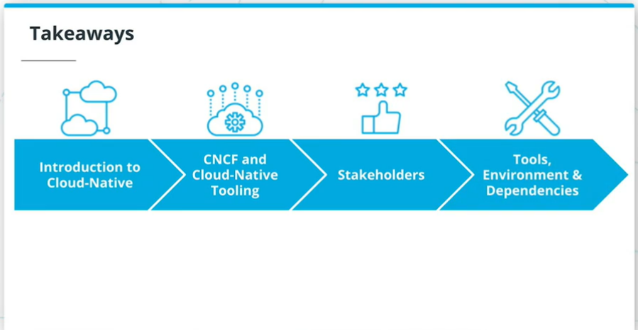

**Summary**

In the first lesson, we went through:

* Introduction to Cloud Native
* CNCF and Cloud Native tooling
* Stakeholders
* Tools, Environment & Dependencies

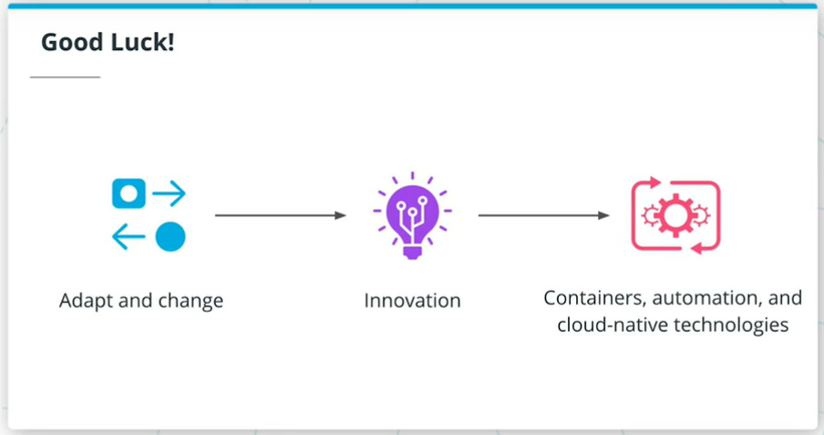

## Summary

Every organization aims to succeed! This is represented by providing customer value and the ability to be responsive to the surrounding ecosystem. Coincidentally, this is closely correlated with technological innovation, which translates into the adoption of containers, automation, and usage of cloud-native tooling.

By completing this course you will be equipped to lead the adoption of cloud-native tooling and principles within an organization.

Hope you will enjoy the course and **GOOD LUCK**!

**SOME USEFUL DOCKER COMMANDS:**

* + docker version
  + clear
  + docker images
  + docker ps
  + docker pull hello-world
  + docker pull mysql
  + docker run hello-world
  + docker-compose
  + exit

You can also run these commands from the cmd:

**26/09/2021 HERE**

**LESSON 2 Architecture Considerations for Cloud Native Applications**

# Introduction

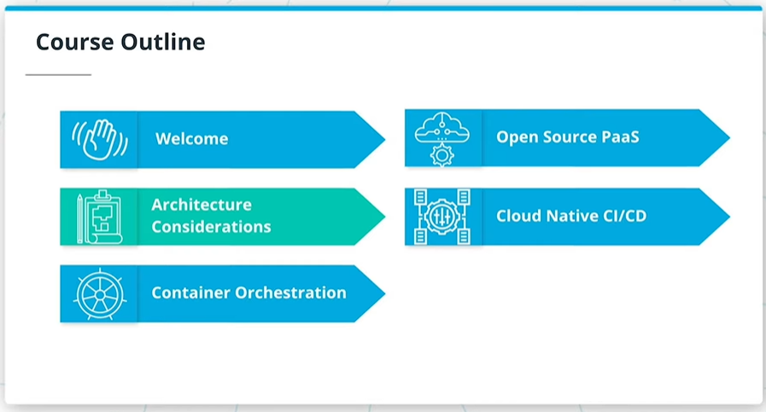

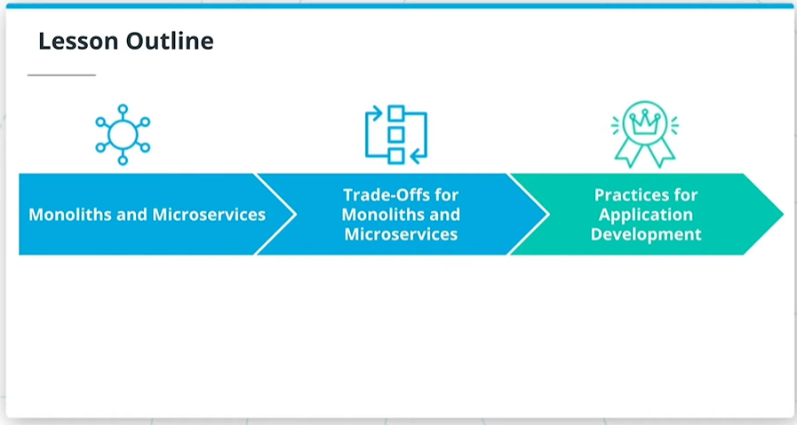

## Summary

Welcome to the Cloud Native Fundamentals course!

Before building an application, it is common to go through a design phase to identify the main requirements and structure of an application. In correlation with the available resources, a team will choose the most suitable project architecture.

In the industry, usually, the two main approaches that are usually referenced are **monoliths and microservices**. In this lesson, we will explore each architectural model and the implied trade-offs. As well, we will cover good development practices to be considered if an application is targeted for containerization. These practices are valid for both monolith and microservice architectures.

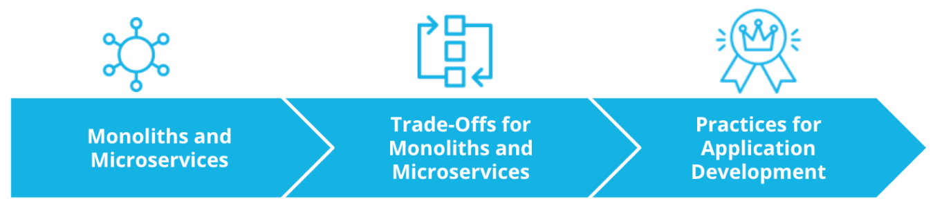

In this lesson, we will cover:

* Monoliths and Microservices
* Trade-offs for Monoliths and Microservices
* Practices for Application Development

# Design Considerations for Cloud-Native Applications

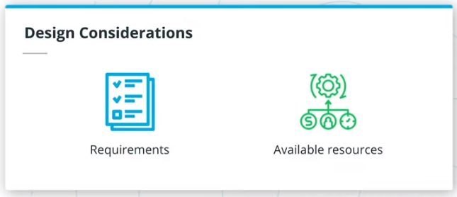

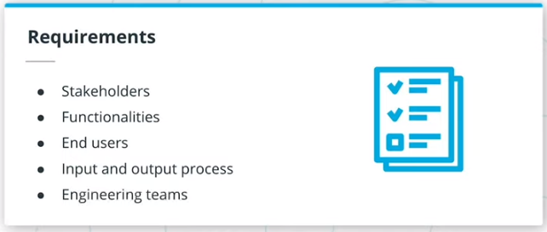

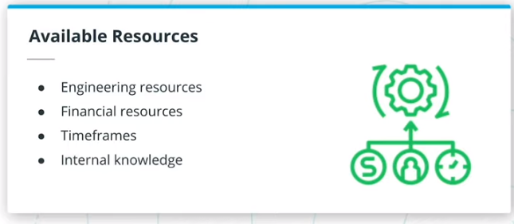

**Summary**

When building an application it is important to allocate time for context discovery. This includes listing all necessary functionalities of the application and enumerating any resources that can enable its buildout. This phase sets the fundamentals of the project. If properly implemented, it can enable the creation of services that are scalable, resilient, and extensible.

The first step in the context discovery process is to list the **functional requirements**, or what application capabilities should deliver to the end-users. For example, a good starting point is to expand on the following:

* Stakeholders
* Functionalities
* End users
* Input and output process
* Engineering teams

The second step is to enumerate the **available resources** that facilitates the implementation of the project. For example, a good starting point is to list available:

* Engineering resources
* Financial resources
* Timeframes
* Internal knowledge

Having a good understanding of functional requirements and available resources can lead to a simpler choice between monolithic and microservice-based architectures.

# Monoliths and Microservices

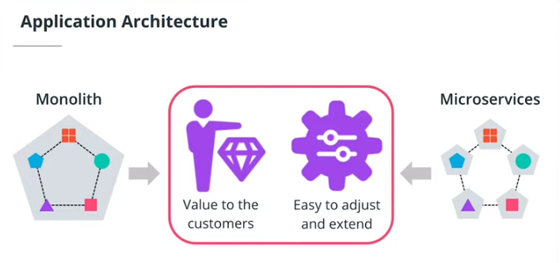

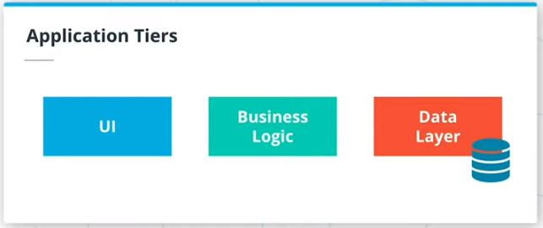

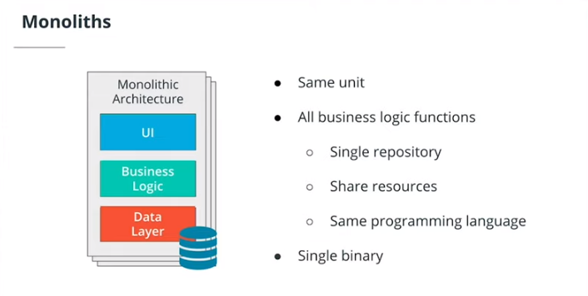

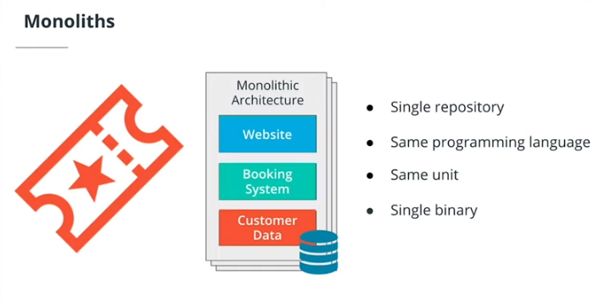

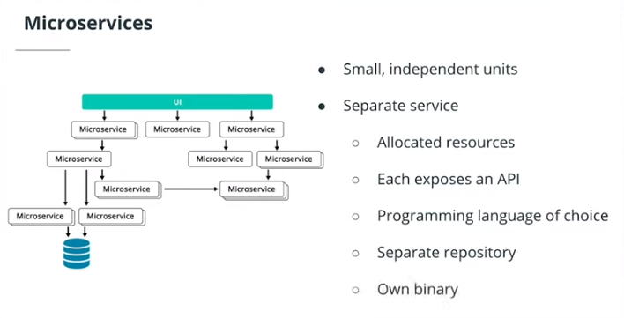

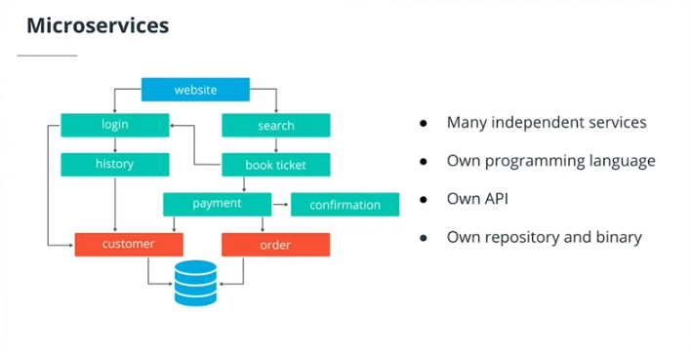

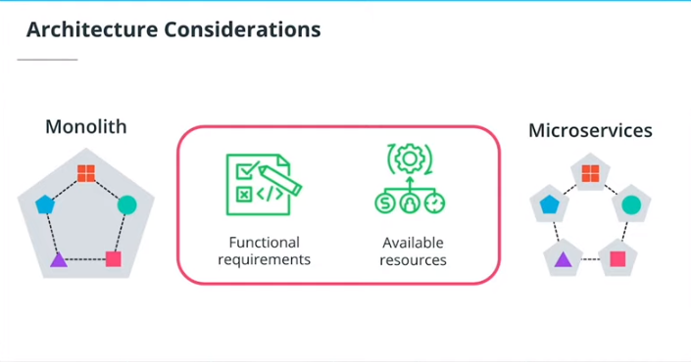

## Summary

Prior to an organization delivers a product, the engineering team needs to decide on the most suitable application architecture. In most of the cases 2 distinct models are referenced: monoliths and microservices. Regardless of the adopted structure, the main goal is to design an application that delivers value to customers and can be easily adjusted to accommodate new functionalities.

Also, each architecture encapsulates the 3 main tires of an application:

* UI (User Interface) - handles HTTP requests from the users and returns a response
* Business logic - contained the code that provides a service to the users
* Data layer - implements access and storage of data objects

### Monoliths

In a monolithic architecture, application tiers can be described as:

* part of the same unit
* managed in a single repository
* sharing existing resources (e.g. CPU and memory)
* developed in one programming language
* released using a single binary

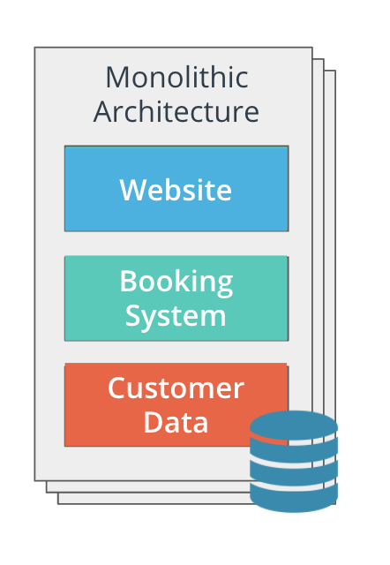

Imagine a team develops a booking application using a monolithic approach. In this case, the UI is the website that the user interacts with. The business logic contains the code that provides the booking functionalities, such as search, booking, payment, and so on. These are written using one programming language (e.g. Java or Go) and stored in a single repository. The data layer contains functions that store and retrieve customer data. All of these components are managed as a unit, and the release is done using a single binary.

### Microservices

In a microservice architecture, application tiers are managed independently, as different units. Each unit has the following characteristics:

* managed in a separate repository
* own allocated resources (e.g. CPU and memory)
* well-defined API (Application Programming Interface) for connection to other units
* implemented using the programming language of choice
* released using its own binary

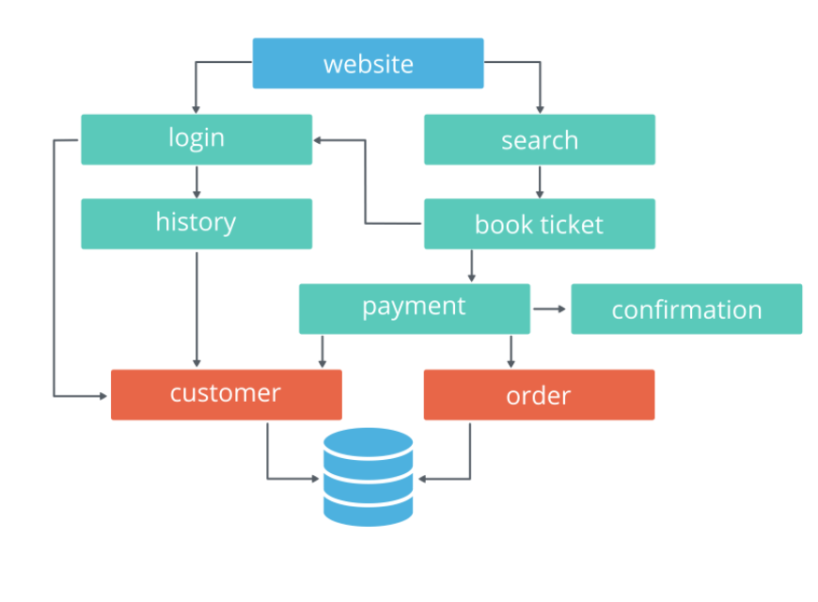

Now, let's imagine the team develops a booking application using a microservice approach.

In this case, the UI remains the website that the user interacts with. However, the business logic is split into smaller, independent units, such as login, payment, confirmation, and many more. These units are stored in separate repositories and are written using the programming language of choice (e.g. Go for the payment service and Python for login service). To interact with other services, each unit exposes an API. And lastly, the data layer contains functions that store and retrieve customer and order data. As expected, each unit is released using its own binary.

**New terms**

* **Monolith**: application design where all application tiers are managed as a single unit
* **Microservice**: application design where application tiers are managed as independent, smaller units

**Further reading**

* [What’s the Difference Between Monolith and Microservices?](https://nordicapis.com/whats-the-difference-between-monolith-and-microservices/)
* [Microservices vs Monolithic Architecture](https://www.mulesoft.com/resources/api/microservices-vs-monolithic)

# Quizzes: Monoliths and Microservices

### 

### 

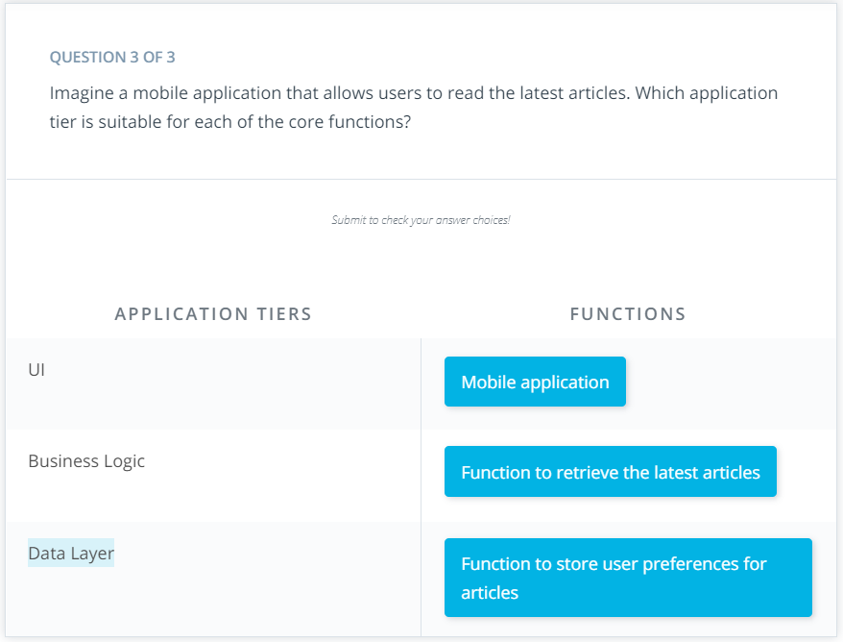

# Trade-offs for Monoliths and Microservices

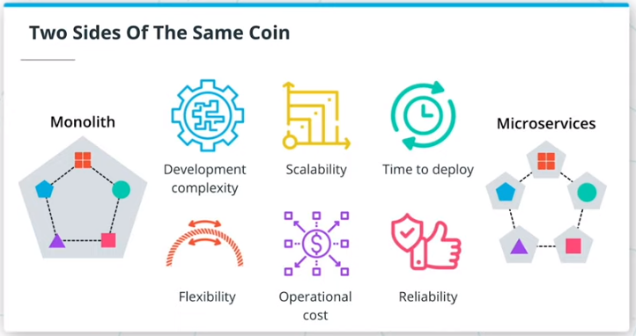

## Summary

An application can be designed using both, monolithic or microservice-based architectures. So far, we have looked at how the structure of an application is contoured by functional requirements and available resources. However, each architecture has a set of trade-offs, that need to be thoroughly examined before deciding on the final structure of the application.

These trade-offs cover development complexity, scalability, time to deploy, flexibility, operational cost, and reliability. Let's examine each trade-off in more detail!

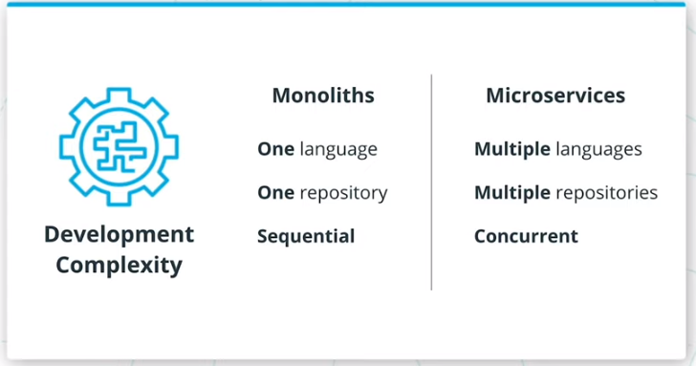

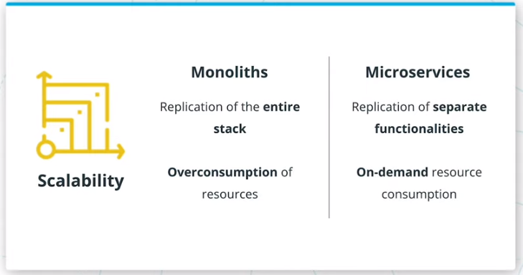

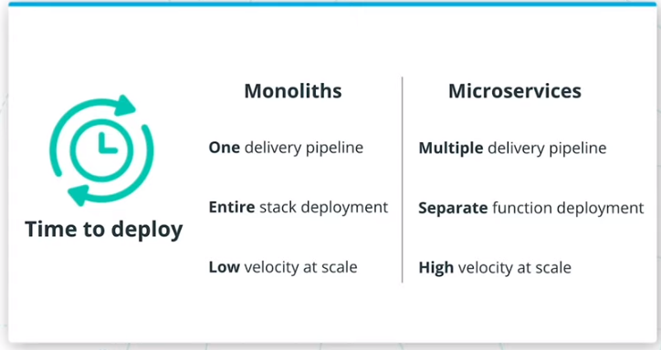

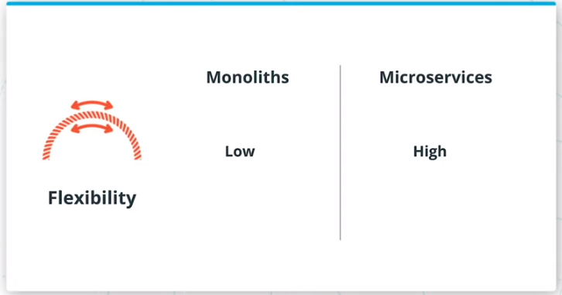

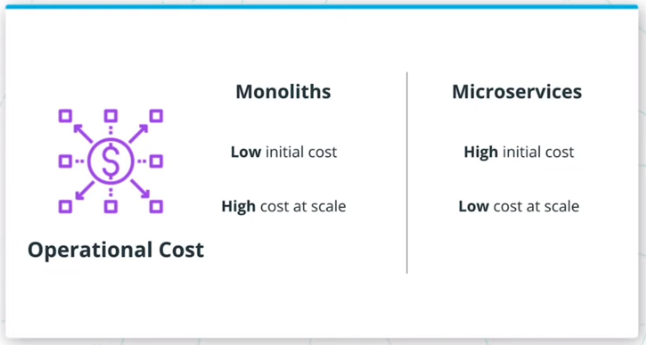

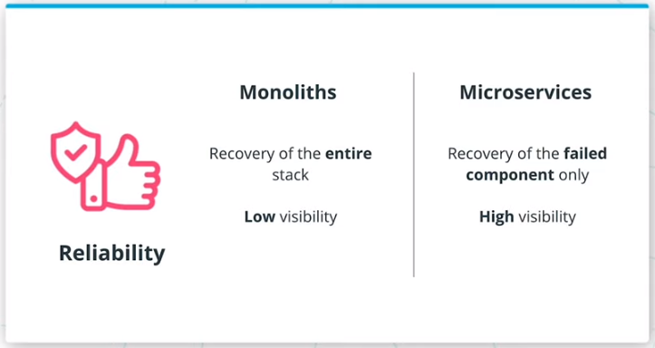

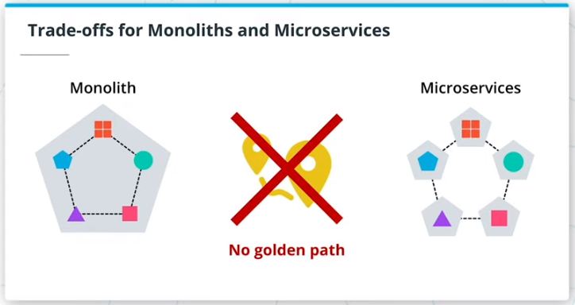

## Summary

#### Development Complexity

Development complexity represents the effort required to deploy and manage an application.

* **Monoliths** - one programming language; one repository; enables sequential development
* **Microservice** - multiple programming languages; multiple repositories; enables concurrent development

#### Scalability

Scalability captures how an application is able to scales up and down, based on the incoming traffic.

* **Monoliths** - replication of the entire stack; hence it's heavy on resource consumption
* **Microservice** - replication of a single unit, providing on-demand consumption of resources

#### Time to Deploy

Time to deploy encapsulates the build of a delivery pipeline that is used to ship features.

* **Monoliths** - one delivery pipeline that deploys the entire stack; more risk with each deployment leading to a lower velocity rate
* **Microservice** - multiple delivery pipelines that deploy separate units; less risk with each deployment leading to a higher feature development rate

#### Flexibility

Flexibility implies the ability to adapt to new technologies and introduce new functionalities.

* **Monoliths** - low rate, since the entire application stack might need restructuring to incorporate new functionalities
* **Microservice** - high rate, since changing an independent unit is straightforward

#### Operational Cost

Operational cost represents the cost of necessary resources to release a product.

* **Monoliths** - low initial cost, since one code base and one pipeline should be managed. However, the cost increases exponentially when the application needs to operate at scale.
* **Microservice** - high initial cost, since multiple repositories and pipelines require management. However, at scale, the cost remains proportional to the consumed resources at that point in time.

#### Reliability

Reliability captures practices for an application to recover from failure and tools to monitor an application.

* **Monoliths** - in a failure scenario, the entire stack needs to be recovered. Also, the visibility into each functionality is low, since all the logs and metrics are aggregated together.
* **Microservice** - in a failure scenario, only the failed unit needs to be recovered. Also, there is high visibility into the logs and metrics for each unit.

Each application architecture has a set of trade-offs that need to be considered at the genesis of a project. But more importantly, it is paramount to understand how the application will be maintained in the future e.g. at scale, under load, supporting multiple releases a day, etc.

There is no "golden path" to design a product, but a good understanding of the trade-offs will provide a clear project roadmap. Regardless if a monolith or microservice architecture is chosen, as long as the project is coupled with an efficient delivery pipeline, the ability to adopt new technologies, and easily add features, the path to could-native deployment is certain.

# Quizzes: Trade-offs for Monoliths and Microservices

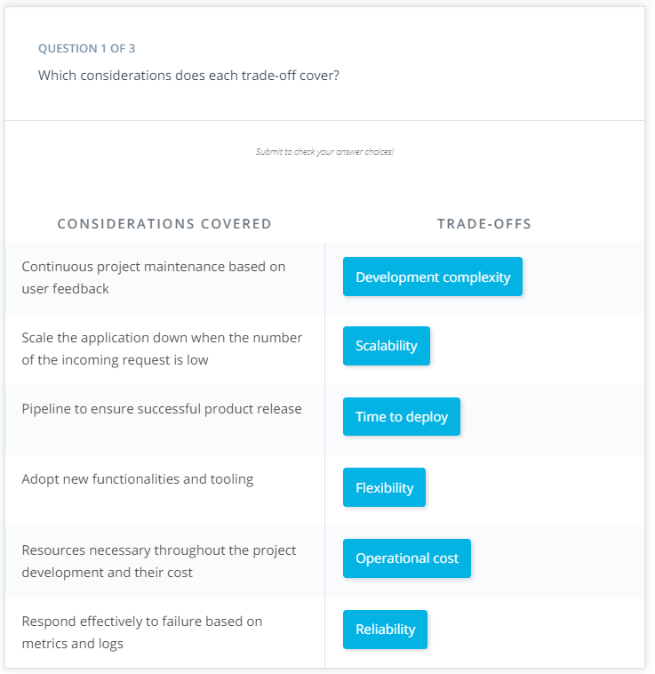

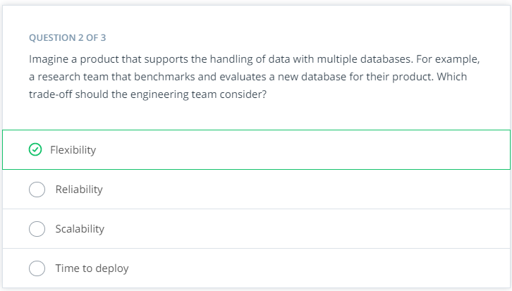

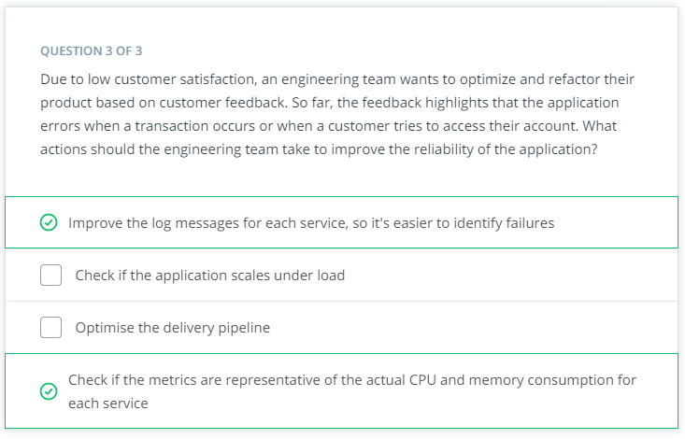

# Exercise: Trade-offs for Monoliths and Microservices

## Outline the architecture of an application

From the early stages of application development, it is fundamental to understand the requirements and available resources. Overall, these will contour the architecture decisions.

Imagine this scenario: you are part of the team that needs to outline the structure of a centralized system to book flight tickets for different airlines. At this stage, the clients require the front-end(UI), payment, and customer functionalities to be designed. Also, these are the individual requirements of each airline:

* Airline A - payments should be allowed only through PayPal
* Airline B - payments should be disabled (bookings will be exclusively in person or via telephone)
* Airline C - payments should be allowed to use PayPal and debit cards

Using the above requirements, outline the application architecture. Also, elaborate your reasoning on choosing a microservice or monolith based approach.

## Application Design

Input your answer

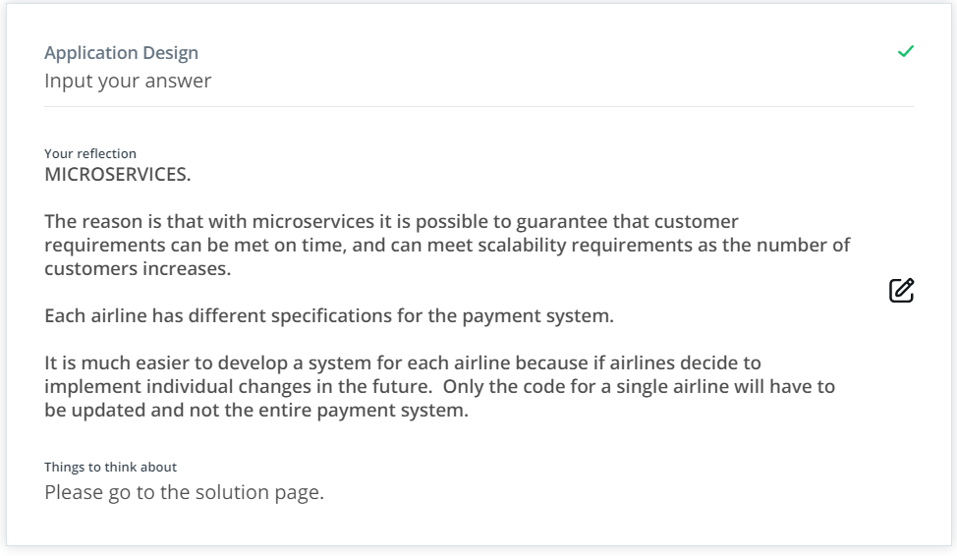

# Solution: Monoliths and Microservices

## Summary

Given the scenario, it is paramount to choose an architecture that would be **replicable and scalable**. For example, if thousands of customers access the payment service in the same timeframe, then this particular service should be scaled up. In a monolith architecture, scaling up creates a replica of everything, including front-end and customer services, in addition to the payment service. This will also consume more resources on the platform, such as CPU and memory, and takes longer to spin up.

On the other side, a microservice is a lightweight component that requires fewer resources (CPU and memory) and less time for provisioning.

For this example, a microservice-based architecture is chosen, based on considerations that the application is a central booking system for multiple airlines, that implies a high load. The main components are:

* Front-end - entry-point for the user, where they will choose their airline or choice
* Customer - requires a database (MySQL or Mongo) to store the customer details
* Payments - to implement PayPal and Debit based operations

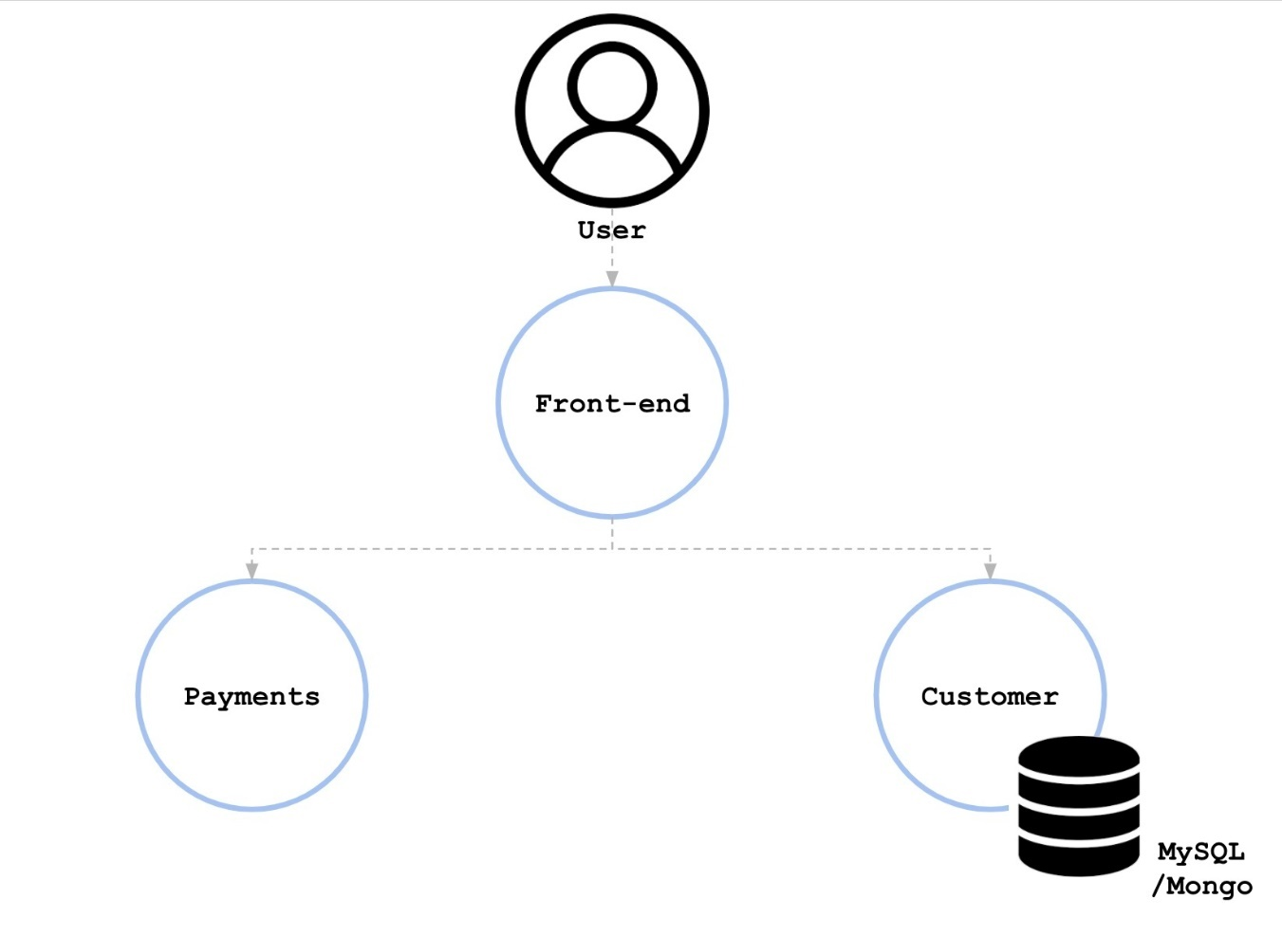

Additionally, the "payments" microservice is capable of handling multiple payment systems. Interaction with the PayPal interface and management of debit card APIs are fundamentally different. The "payments" component is a monolith that can be divided into multiple parts.

Payments:

* PayPal - handling all the PayPal payments
* Debit - handling all the debit card payments

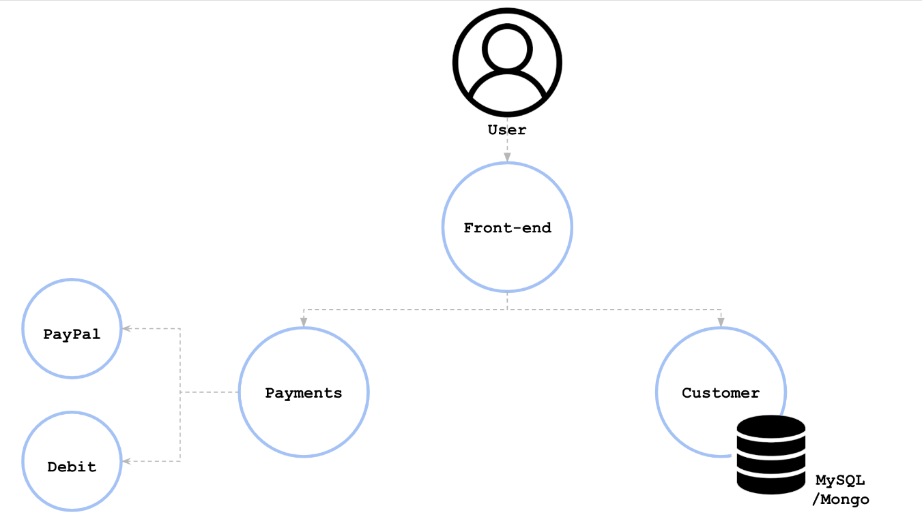

# Best Practices For Application Deployment

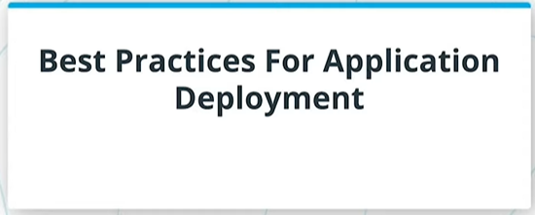

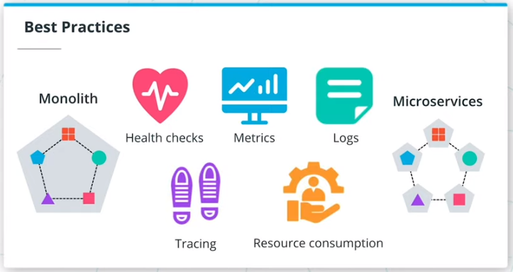

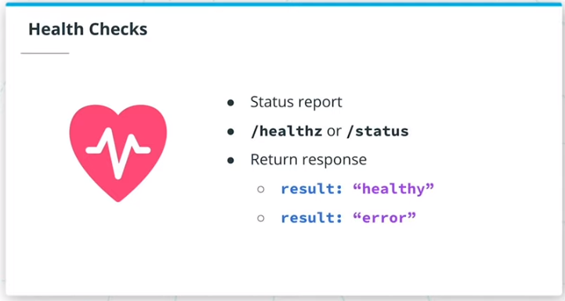

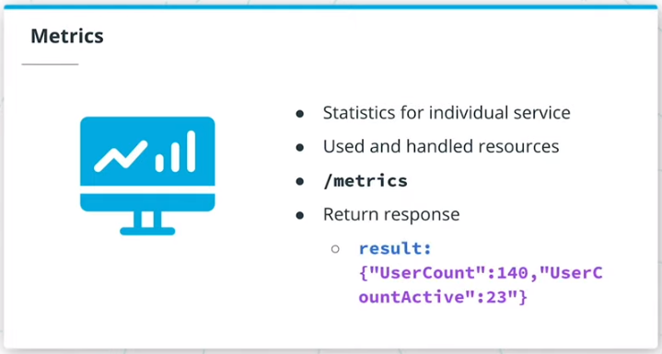

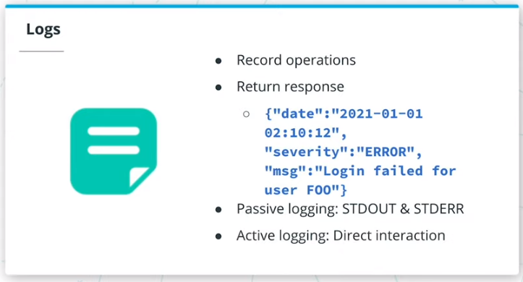

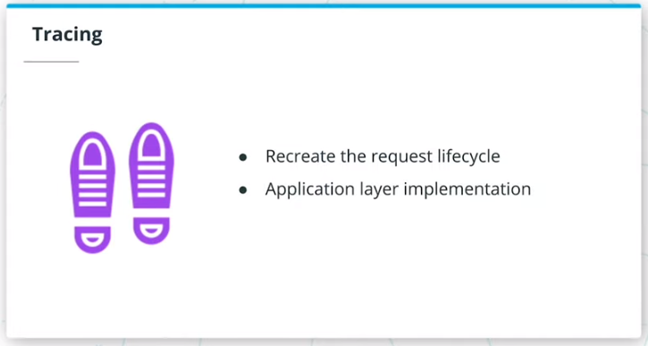

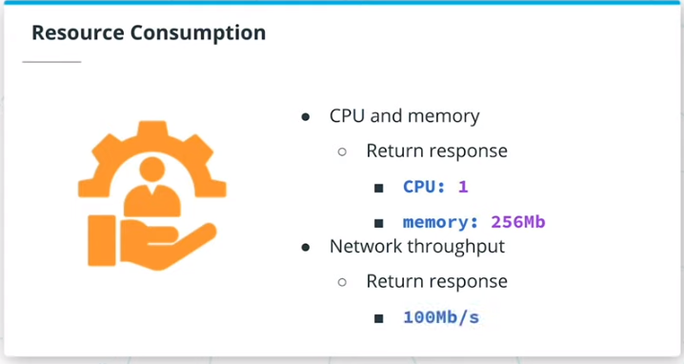

## Summary

Using the knowledge acquired so far, you should be able to choose the most suitable architecture for an application, based on requirements, available resources, and involved trade-offs. The next stage consists of building the application. Regardless of the chosen architecture, a set of good development practices can be applied to improve the application lifecycle throughout the release and maintenance phases. Adopting these practices increases resiliency, lowers the time to recovery, and provides transparency of how a service handles incoming requests.

These practices are focused on health checks, metrics, logs, tracing, and resource consumption.

#### **Health Checks**

Health checks are implemented to showcase the status of an application. These checks report if an application is running and meets the expected behavior to serve incoming traffic. Usually, health checks are represented by an HTTP endpoint such as /healthz or /status. These endpoints return an HTTP response showcasing if the application is healthy or in an error state.

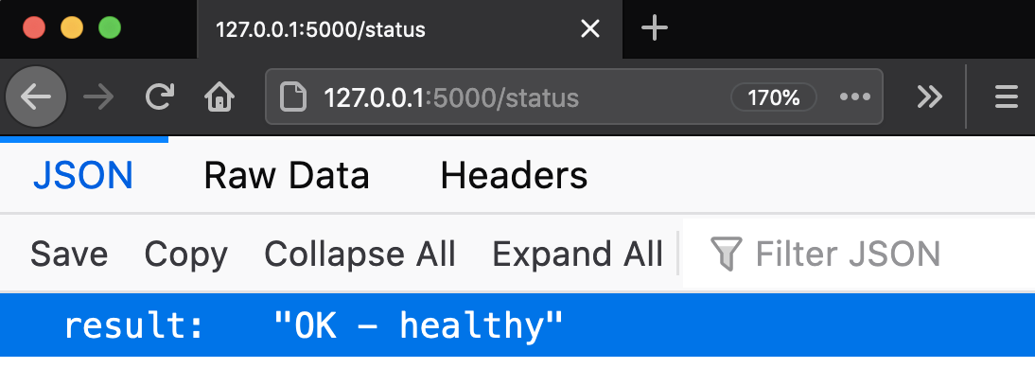

#### **Metrics**

Metrics are necessary to quantify the performance of the application. To fully understand how a service handles requests, it is mandatory to collect statistics on how the service operates. For example, the number of active users, handled requests, or the number of logins. Additionally, it is paramount to gather statistics on resources that the application requires to be fully operational. For example, the amount of CPU, memory, and network throughput. Usually, the collection of metrics are returned via an HTTP endpoint such as /metrics, which contains the internal metrics such as the number of active users, consumed CPU, network throughput, etc.

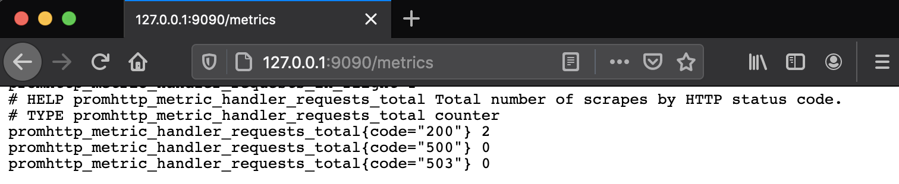

#### **Logs**

Log aggregation provides valuable insights into what operations a service is performing at a point in time. It is the nucleus of any troubleshooting and debugging process. For example, it is essential to record if a user logged in successfully into a service, or encountered an error while performing a payment.

Usually, the logs are collected from STDOUT (standard out) and STDERR (standard error) through a passive logging mechanism. This means that any output or errors from the application are sent to the shell. Subsequently, these are collected by a logging tool, such as Fluentd or Splunk, and stored in backend storage. However, the application can send the logs directly to the backend storage. In this case, an active logging technique is used, as the log transmission is handled directly by the application, without a logging tool required.

There are multiple logging levels that can be attributed to an operation. Some of the most widely used are:

* **DEBUG** - record fine-grained events of application processes
* **INFO** - provide coarse-grained information about an operation
* **WARN** - records a potential issue with the service
* **ERROR** - notifies an error has been encountered, however, the application is still running
* **FATAL** - represents a critical situation, when the application is not operational

As well, it is common practice to associate each log line with a **timestamp**, that will exactly record when an operation was invoked.

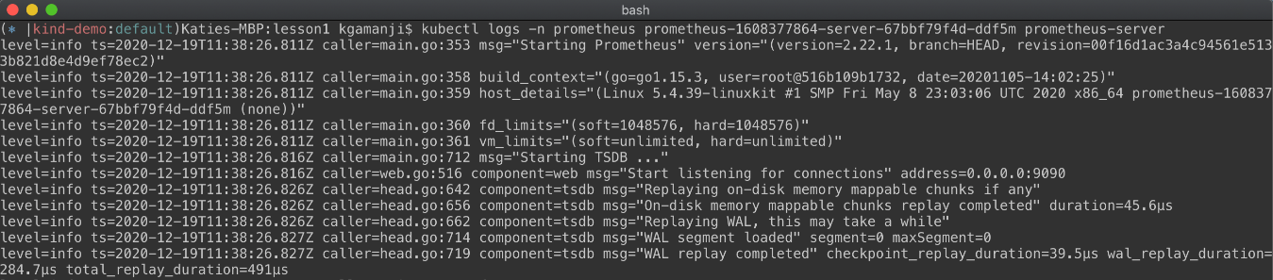

#### **Tracing**

Tracing is capable of creating a full picture of how different services are invoked to fulfill a single request. Usually, tracing is integrated through a library at the application layer, where the developer can record when a particular service is invoked. These records for individual services are defined as spans. A collection of spans define a trace that recreates the entire lifecycle of a request.

#### **Resource Consumption**

Resource consumption encapsulates the resources an application requires to be fully operational. This usually refers to the amount of CPU and memory that is consumed by an application during its execution. Additionally, it is beneficial to benchmark the network throughput, or how many requests can an application handle concurrently. Having awareness of resource boundaries is essential to ensure that the application is up and running 24/7.

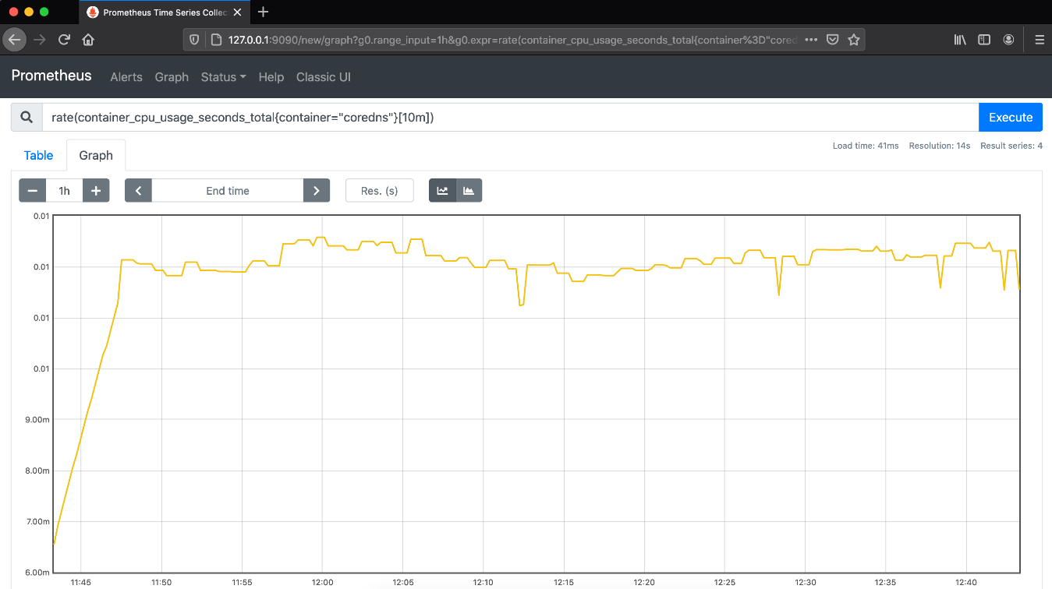

## Further reading

* [Health Checks](https://microservices.io/patterns/observability/health-check-api.html) - explore the core reasons to introduce health checks and implementations examples
* [Prometehus Best Practices on Metrics Naming](https://prometheus.io/docs/instrumenting/writing_exporters/#metrics) - explore how to name, label, and define the type of metrics
* [Application Logging Best Practices](https://logz.io/blog/logging-best-practices/) - read more on how to define what logs should be collected by an application
* [Logging Levels](https://www.tutorialspoint.com/log4j/log4j_logging_levels.htm) - explore possible logging levels and when they should be enabled
* [Enabling Distributed Tracing for Microservices With Jaeger in Kubernetes](https://containerjournal.com/topics/container-ecosystems/enabling-distributed-tracing-for-microservices-with-jaeger-in-kubernetes/) - learn what tools can be used to implement tracing in a Kubernetes cluster

# Quizzes: Best Practices For Application Deployment

# 

# cise: Endpoints for

# 

# Application Status

# Exercise: Endpoints for Application Status

# Exercise: Endpoints for Application Status

This exercise aims to extend a Python Flask web application with status and metrics endpoints.

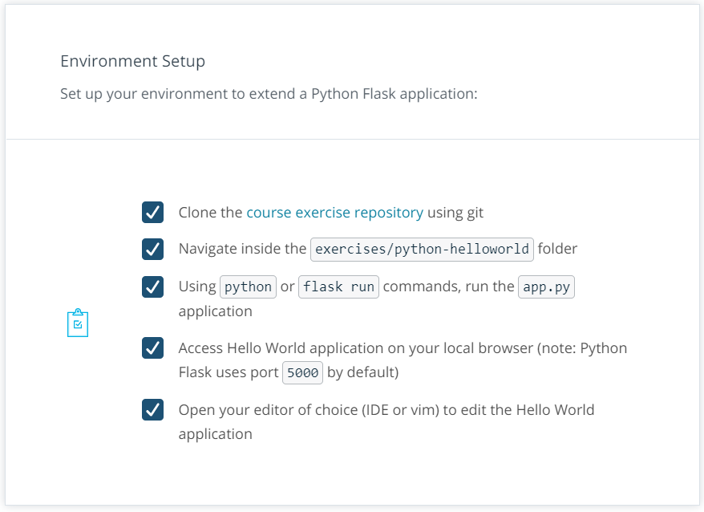

Once all the pre-requisites are completed, you can get started on developing endpoints to describe the application state.

**Exercise**

Extend the Python Flask application with /status and /metrics endpoints,

@app.route('/status')

@app.route('/metrics')

considering the following requirements:

Both endpoints should return an HTTP 200 status code

@app.route('/status')

**def** **status**():

response = app.response_class(

response=json.dumps({"result":"OK - healthy"}),

status=200,

mimetype='application/json'

)

**return** response

@app.route('/metrics')

**def** **metrics**():

response = app.response_class(

response=json.dumps({"status":"success","code":0,"data":{"UserCount":140,"UserCountActive":23}}),

status=200,

mimetype='application/json'

)

**return** response

* Both endpoints should return a JSON response e.g. {"user": "admin"}. (Note: the JSON response can be hardcoded at this stage)

from flask import json

* The /status endpoint should return a response similar to this example: result: OK - healthy
* The /metrics endpoint should return a response similar to this example: data: {UserCount: 140, UserCountActive: 23}

Tips: If you get stuck, feel free to check the solution video where detailed operations are demonstrated.

# Solution: Endpoints for Application Status

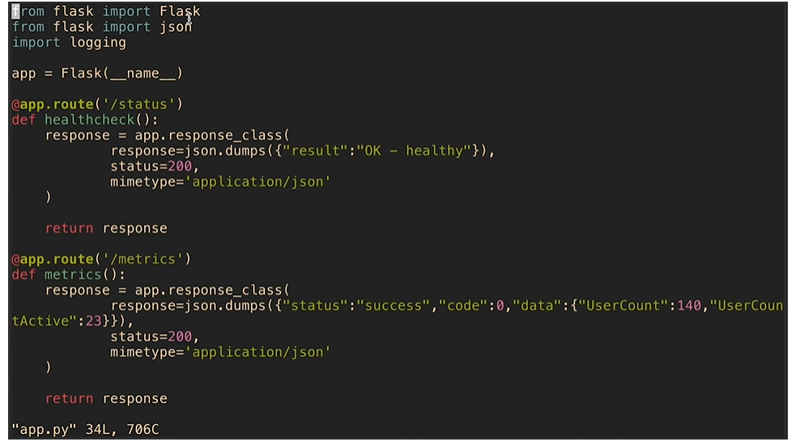

The following snippet showcases an example of a Python Flask application, with /metrics, /status and main page (/) endpoints:

**from** flask **import** Flask

**from** flask **import** json

app = Flask(__name__)

@app.route('/status')

**def** **status**():

response = app.response_class(

response=json.dumps({"result":"OK - healthy"}),

status=200,

mimetype='application/json'

)

**return** response

@app.route('/metrics')

**def** **metrics**():

response = app.response_class(

response=json.dumps({"status":"success","code":0,"data":{"UserCount":140,"UserCountActive":23}}),

status=200,

mimetype='application/json'

)

**return** response

@app.route("/")

**def** **hello**():

**return** "Hello World!"

**if** __name__ == "__main__":

app.run(host='0.0.0.0')

**28/09/2021 HERE**

# **Exercise: Application Logging**

Logging is a core factor in increasing the visibility and transparency of an application. When in troubleshooting or debugging scenarios, it is paramount to pin-point the functionality that impacted the service. This exercise will focus on bringing the logging capabilities to an application.

At this stage, you have extended the Hello World application to handle different endpoints. Once an endpoint is reached, a log line should be recorded showcasing this operation.

In this exercise, you need to further develop the Hello World application collect logs, with the following requirements:

* A log line should be recorded the timestamp and the requested endpoint e.g. "{{TIMESTAMP}}, {{ ENDPOINT_NAME}} endpoint was reached"
* The logs should be stored in a file with the name app.log. Refer to the [logging Python module](https://docs.python.org/3/library/logging.html#logging.basicConfig) for more details.
* Enable the collection of Python logs at the DEBUG level. Refer to the [logging Python module](https://docs.python.org/3/library/logging.html#logging.basicConfig) for more details.

Note: For the environment setup, follow the instructions in the previous exercise.

Tips: If you get stuck, feel free to check the solution video where detailed operations are demonstrated.

**SOLUTION:**

**from** flask **import** Flask

**from** flask **import** json

**import** logging

app = Flask(__name__)

@app.route('/status')

**def** **healthcheck**():

response = app.response_class(

response=json.dumps({"result":"OK - healthy"}),

status=200,

mimetype='application/json'

)

*## log line*

app.logger.info('Status request successfull')

**return** response

@app.route('/metrics')

**def** **metrics**():

response = app.response_class(

response=json.dumps({"status":"success","code":0,"data":{"UserCount":140,"UserCountActive":23}}),

status=200,

mimetype='application/json'

)

*## log line*

app.logger.info('Metrics request successfull')

**return** response

@app.route("/")

**def** **hello**():

*## log line*

app.logger.info('Main request successfull')

**return** "Hello World!"

**if** __name__ == "__main__":

*## stream logs to app.log file*

logging.basicConfig(filename='app.log',level=logging.DEBUG)

app.run(host='0.0.0.0')

## Reflection on Design Consideration for an Application

What are your opinions on the core considerations for choosing a microservice vs monolith methodology?

### Your reflection

**I think it is extremely important to take into account these considerations from the beginning of the design stage of the application because it allows to optimize resources (depending on the characteristics of the application), allows to plan the future use of resources, the future response of the application to user requirements and allows to implement better communication practices between developers and operations personnel of the company.**

### Things to think about

Contouring the architecture for an application is not a simple task. It requires a thorough understanding of the requirements and available resources.

# **Edge Case: Amorphous Applications**

In the previous sections, we have explored how to choose a suitable architecture for an application and how to apply some of the best development practices. However, this is only the start of the application lifecycle. After an engineering team has successfully released a product, with both monolith and microservices, the next phase in the application lifecycle is **maintenance**. In this edge case, we will explore commonly used maintenance operations after a product is released.

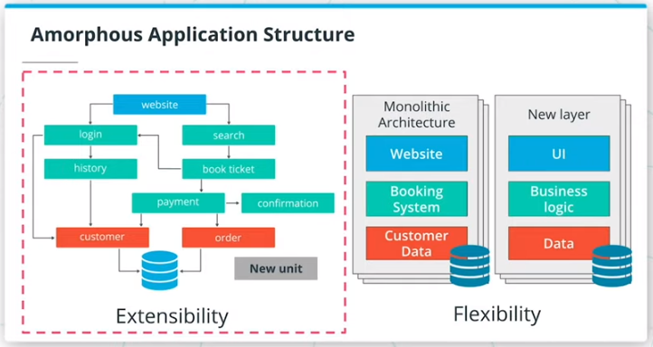

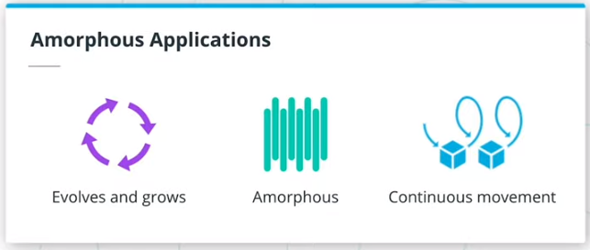

## Summary

Throughout the maintenance stage, the application structure and functionalities can change, and this is expected! The architecture of an application is not static, it is amorphous and in constant movement. This represents the organic growth of a product that is responsive to customer feedback and new emerging technologies.

Both monolith and microservice-based applications transition in the maintenance phase after the production release. When considering adding new functionalities or incorporating new tools, it is always beneficial to focus on **extensibility rather than flexibility**. Generally speaking, it is more efficient to manage multiple services with a well-defined and simple functionality (as in the case of microservices), rather than add more abstraction layers to support new services (as we’ve seen with the monoliths). However, to have a well-structured maintenance phase, it is essential to understand the reasons an architecture is chosen for an application and involved trade-offs.

Some of the most encountered operations in the maintenance phase are listed below:

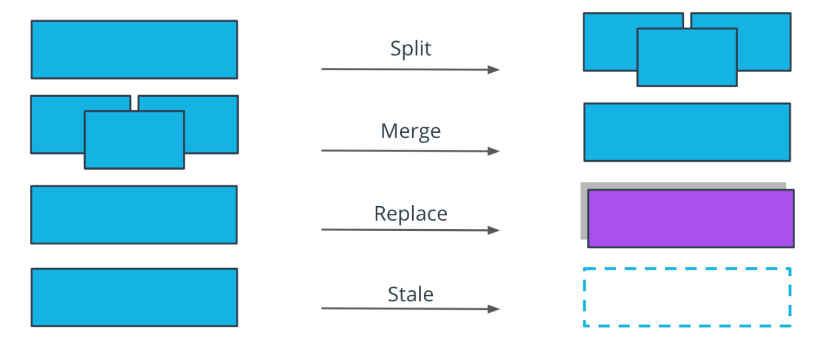

* A **split** operation - is applied if a service covers too many functionalities and it's complex to manage. Having smaller, manageable units is preferred in this context.
* A **merge** operation- is applied if units are too granular or perform closely interlinked operations, and it provides a development advantage to merge these together. For example, merging 2 separate services for log output and log format in a single service.
* A **replace** operation - is adopted when a more efficient implementation is identified for a service. For example, rewriting a Java service in Go, to optimize the overall execution time.
* A **stale** operation - is performed for services that are no longer providing any business value, and should be archived or deprecated. For example, services that were used to perform a one-off migration process.

Performing any of these operations increases the longevity and continuity of a project. Overall, the end goal is to ensure the application is providing value to customers and is easy to manage by the engineering team. But more importantly, it can be observed that the structure of a project is not static. It amorphous and it evolves based on new requirements and customer feedback.

# **Lesson Conclusion**

**Summary**

In this lesson, we have covered how to build an application using monolith and microservice-based architecture. The choice of an application structure is highly impacted by available resources, requirements, and involved trade-offs. But more importantly, we have covered development practices that should be considered to optimize an application's resilience, time to recovery, and traceability.

Overall, in this lesson, we covered:

* Monoliths and Microservices
* Trade-offs for Monoliths and Microservices
* Practices for Application Development

**Glossary**

* **Monolith**: application design where all application tiers are managed as a single unit
* **Microservice**: application design where application tiers are managed as independent, smaller units

**LESSON 3 CONTAINER ORCHESTRATION WITH KUBERNETES**

**INTRODUCTION**

## Summary

Welcome to the Container Orchestration lesson!

Once a team has developed an application, the next phase is represented by the release process. This includes techniques for service packaging, containerization, and distribution. The end result of a product release is represented by a service that is deployed in a production environment and can be accessed by consumers.

In this lesson, we will discuss how an application can be packaged using Docker and released to a Kubernetes cluster.

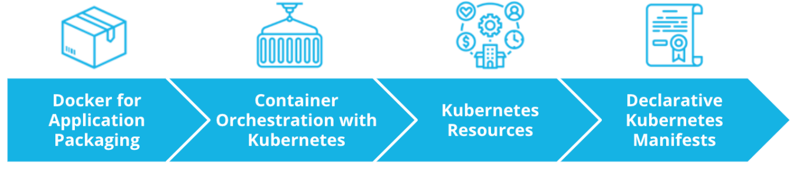

Overall, in this lesson we will explore:

* Docker for Application Packaging
* Container Orchestration with Kubernetes
* Kubernetes Resources
* Declarative Kubernetes Manifests

# **Transitions from VMs to Containers**

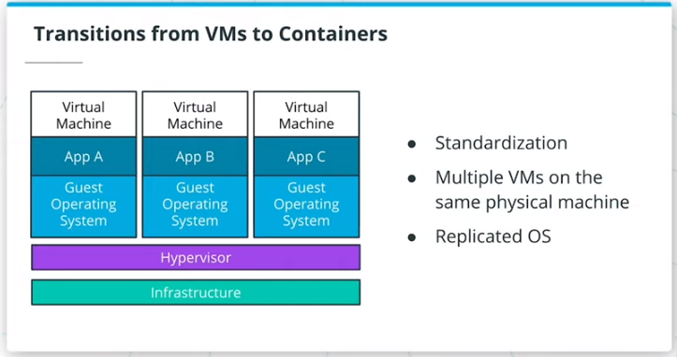

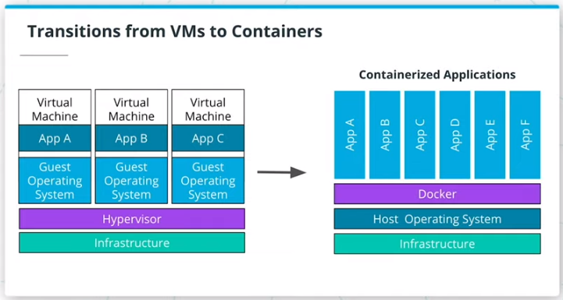

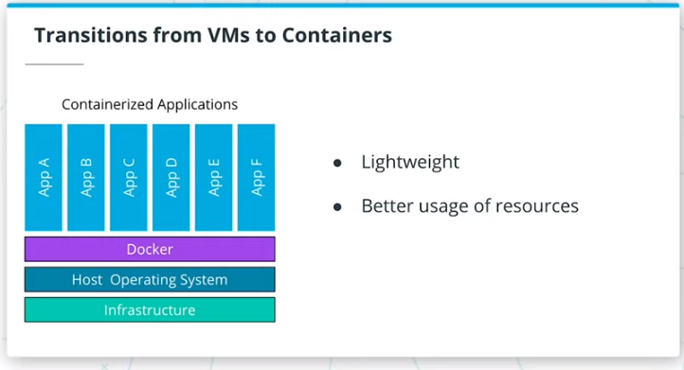

## Summary

#### VMs

In the past years, VMs (Virtual Machines) were the main mechanism to host an application. VMs encapsulate the code, configuration files, and dependencies necessary to execute the application.

In essence, a VM is composed of an **operating system** (OS) with a set of pre-installed libraries and packages. During execution, an **application** utilizes an OS filesystem, resources, and packages.

A set of VMs is managed through a **hypervisor**. A hypervisor provides the virtualization of the **infrastructure** which is composed of physical servers. As a result, a hypervisor is capable of creating, configuring, and managing multiple VMs on the available servers. For example, we are able to running applications A, B, and C on 3 separate VMs.

The utilization of VMs introduced standardization in infrastructure provisioning, in association with efficient use of available infrastructure. Instead of running an application per server, a hypervisor enables multiple VMs to run at the same time to host multiple applications. However, there is one downside to this mechanism: it is not efficient enough. For example, applications A, B, and C uses the same Operating System. Replicating an OS consumes a lot of resources, and the more applications we run the more space we allocate to the replication of the operating systems alone.

#### Containers

There was a clear need to optimize the usage of the available infrastructure. As a result, the virtualization of the Operating System was introduced. This prompted the appearance of **containers**, which represent the bare minimum an application requires for a successful execution e.g. code, config files, and dependencies. By default, there is a better usage of available infrastructure.

Multiple VMs on a hypervisor are replaced by multiple containers running on a single host operating system. The processes in the containers are completely isolated but are able to access the OS filesystem, resources, and packages. The creation and execution of containers is delegated to a container management tool, such as Docker.

The appearance of containers is unlocked by OS-level virtualization and as a result, multiple applications can run on the same OS. By nature, containers are lightweight, as these encapsulate only the application code and essential dependencies. Consequently, there is a better usage of available infrastructure and a more efficient pathway to release a product to consumers.

# **Docker for Application Packaging**

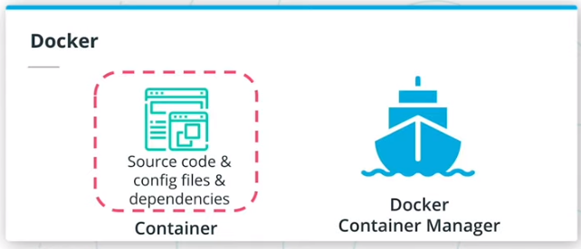

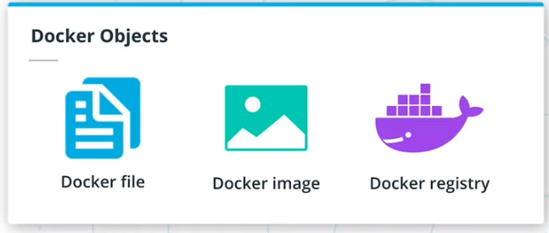

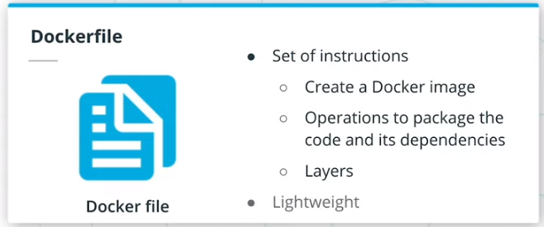

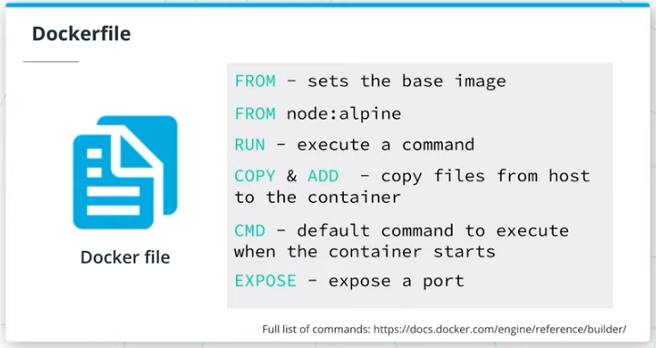

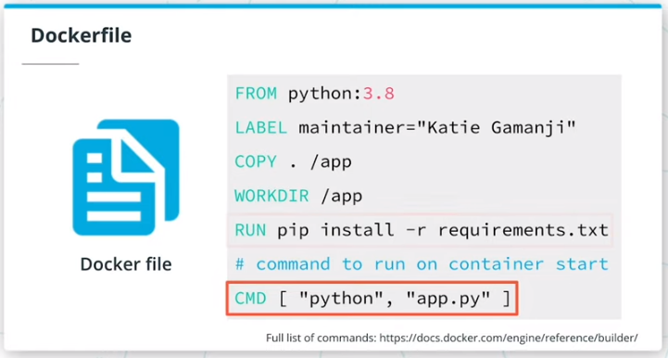

## Summary

The appearance of containers enabled organizations to ship products using a lightweight mechanism, that would make the most of available infrastructure. There are plenty of tools used to containerize services, however, Docker has set the industry standards for many years.

To containerize an application using Docker, 3 main components are distinguished: Dockerfiles, Docker images, and Docker registries. Let's explore each component in a bit more detail!

## Dockerfile

A Dockerfile is a set of instructions used to create a Docker image. Each instruction is an operation used to package the application, such as installing dependencies, compile the code, or impersonate a specific user. A Docker image is composed of multiple layers, and each layer is represented by an instruction in the Dockerfile. All layers are cached and if an instruction is modified, then during the build process only the changed layer will be rebuild. As a result, building a Docker image using a Dockerfile is a lightweight and quick process.

To construct a Dockerfile, it is necessary to use the pre-defined instructions, such as:

FROM - to set the base image

RUN - to execute a command

COPY & ADD - to copy files from host to the container

CMD - to set the default command to execute when the container starts

EXPOSE - to expose an application port

*# set the base image. Since we're running*

*# a Python application a Python base image is used*

FROM python:3.8

*# set a key-value label for the Docker image*

LABEL maintainer="Katie Gamanji"

*# copy files from the host to the container filesystem.*

*# For example, all the files in the current directory*

*# to the `/app` directory in the container*

COPY . /app

*# defines the working directory within the container*

WORKDIR /app

*# run commands within the container.*

*# For example, invoke a pip command*

*# to install dependencies defined in the requirements.txt file.*

RUN pip install -r requirements.txt

*# provide a command to run on container start.*

*# For example, start the `app.py` application.*

CMD [ "python", "app.py" ]

## Docker Image

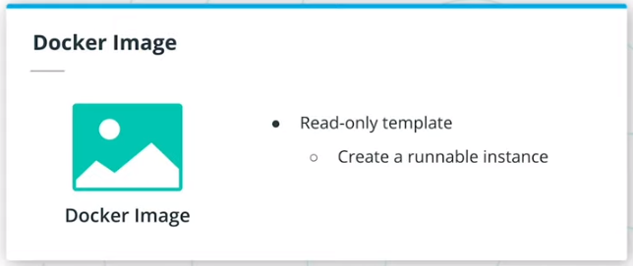

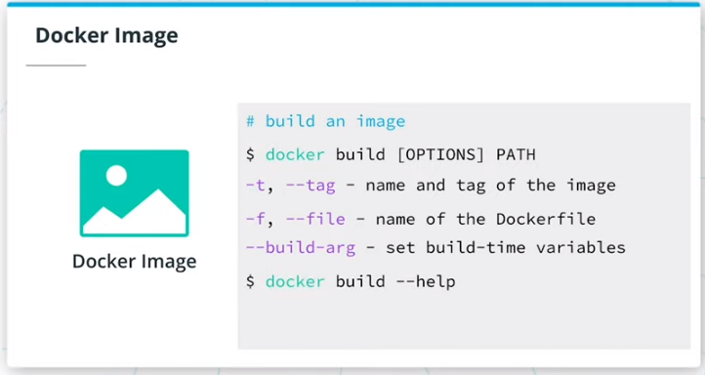

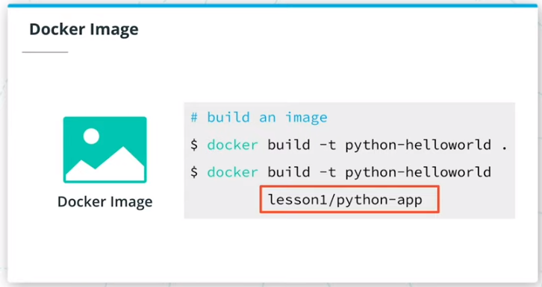

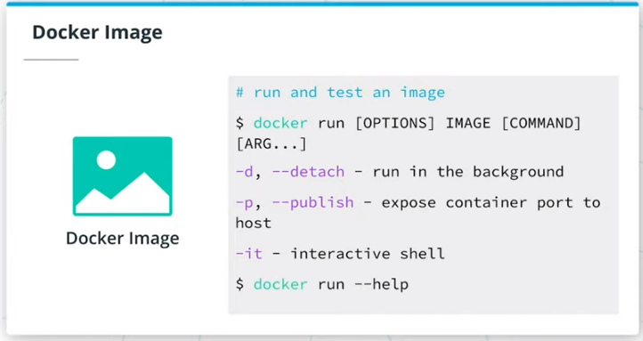

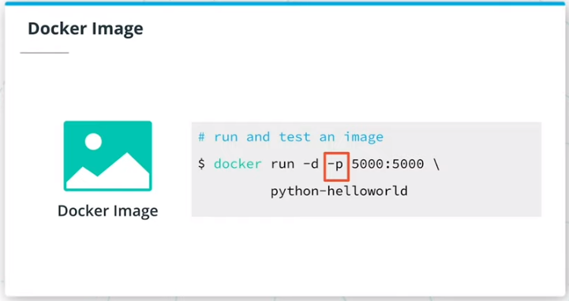

Once a Dockerfile is constructed, these instructions are used to build a **Docker image**. A Docker image is a read-only template that enables the creation of a runnable instance of an application. In a nutshell, a Docker image provides the execution environment for an application, including any essential code, config files, and dependencies.

A Docker image can be built from an existing Dockerfile using the docker build command. Below is the syntax for this command:

*# build an image*

*# OPTIONS - optional; define extra configuration*

*# PATH - required; sets the location of the Dockefile and any referenced files*

docker build [OPTIONS] PATH

*# Where OPTIONS can be:*

-t, --tag - set the name and tag of the image

-f, --file - set the name of the Dockerfile

--build-arg - set build-time variables

*# Find all valid options for this command*

docker build --help

For example, to build the image of the Python hello-world application from the Dockerfile, the following command can be used:

*# build an image using the Dockerfile from the current directory*

docker build -t python-helloworld .

*# build an image using the Dockerfile from the `lesson1/python-app` directory*

docker build -t python-helloworld lesson1/python-app

Before distributing the Docker image to a wider audience, it is paramount to test it locally and verify if it meets the expected behavior. To create a container using an available Docker image, the docker run command is available. Below is the syntax for this command:

*# execute an image*

*# OPTIONS - optional; define extra configuration*

*# IMAGE - required; provides the name of the image to be executed*

*# COMMAND and ARGS - optional; instruct the container to run specific commands when it starts*

docker run [OPTIONS] IMAGE [COMMAND] [ARG...]

*# Where OPTIONS can be:*

-d, --detach - run **in** the background

-p, --publish - expose container port to host

-it - start an interactive shell

*# Find all valid options for this command*

docker run --help

For example, to run the Python hello-world application, using the created image, the following command can be used:

***Note:*** To access the application in a browser, we need to bind the Docker container port to a port on the host or local machine. In this case, 5111 is the host port that we use to access the application e.g. http://127.0.0.1:5111/. The 5000 is the container port that the application is listening to for incoming requests.

*# run the `python-helloworld` image, in detached mode and expose it on port `5111`*

docker run -d -p 5111:5000 python-helloworld

To retrieve the Docker container logs use the docker logs {{ CONTAINER_ID }} command. For example:

docker logs 95173091eb5e

*## Example output from a Flask application*

* Serving Flask app "app" (lazy loading)

* Environment: production

WARNING: This is a development server. Do not use it **in** a production deployment.

Use a production WSGI server instead.

* Debug mode: off

## Docker Registry

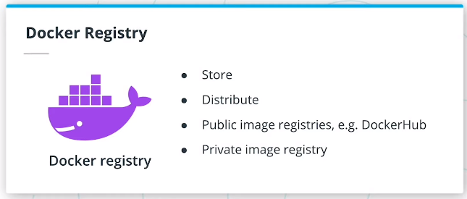

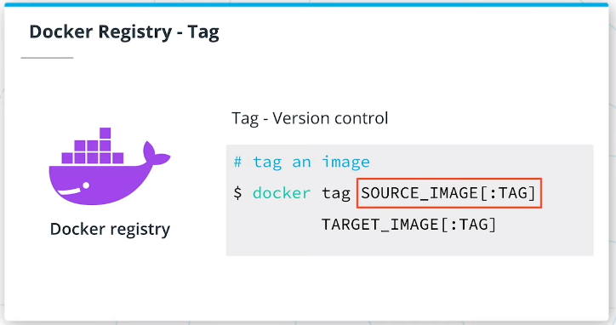

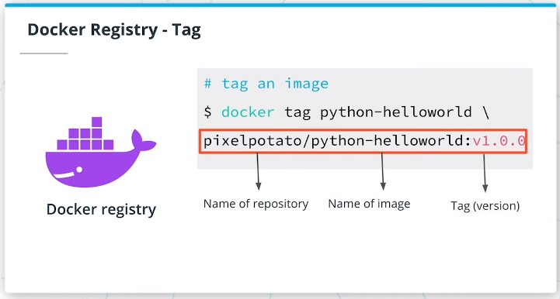

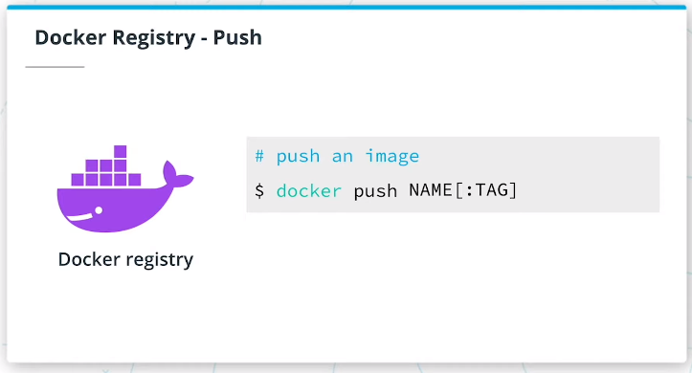

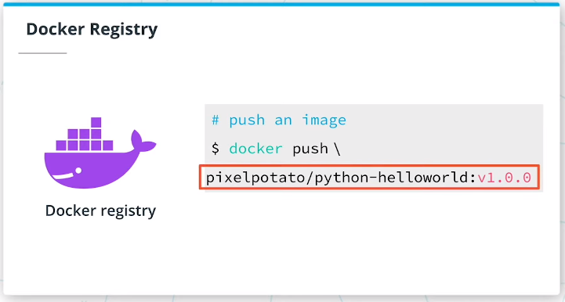

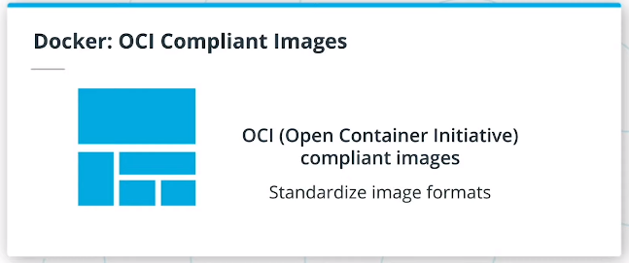

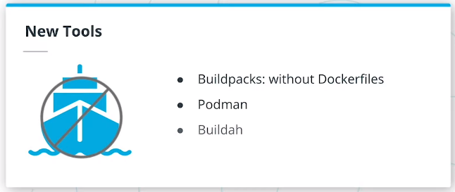

The last step in packaging an application using Docker is to store and distribute it. So far, we have built and tested an image on the local machine, which does not ensure that other engineers have access to it. As a result, the image needs to be pushed to a **public Docker image registry**, such as DockerHub, Harbor, Google Container Registry, and many more. However, there might be cases where an image should be private and only available to trusted parties. As a result, a team can host private image registries, which provides full control over who can access and execute the image.

Before pushing an image to a Docker registry, it is highly recommended to tag it first. During the build stage, if a tag is not provided (via the -t or --tag flag), then the image would be allocated an ID, which does not have a human-readable format (e.g. 0e5574283393). On the other side, a defined tag is easily scalable by the human eye, as it is composed of a registry repository, image name, and version. Also, a tag provides version control over application releases, as a new tag would indicate a new release.

To tag an existing image on the local machine, the docker tag command is available. Below is the syntax for this command:

*# tag an image*

*# SOURCE_IMAGE[:TAG] - required and the tag is optional; define the name of an image on the current machine*

*# TARGET_IMAGE[:TAG] - required and the tag is optional; define the repository, name, and version of an image*

docker tag SOURCE_IMAGE[:TAG] TARGET_IMAGE[:TAG]

For example, to tag the Python hello-world application, to be pushed to a repository in DockerHub, the following command can be used:

*# tag the `python-helloworld` image, to be pushed*

*# in the `pixelpotato` repository, with the `python-helloworld` image name*

*# and version `v1.0.0`*

docker tag python-helloworld pixelpotato/python-helloworld:v1.0.0

Once the image is tagged, the final step is to push the image to a registry. For this purpose, the docker push command can be used. Below is the syntax for this command:

*# push an image to a registry*

*# NAME[:TAG] - required and the tag is optional; name, set the image name to be pushed to the registry*

docker push NAME[:TAG]

For example, to push the Python hello-world application to DockerHub, the following command can be used:

*# push the `python-helloworld` application in version v1.0.0*

*# to the `pixelpotato` repository in DockerHub*

docker push pixelpotato/python-helloworld:v1.0.0

## New terms

* **Dockerfile** - set of instructions used to create a Docker image
* **Docker image** - a read-only template used to spin up a runnable instance of an application
* **Docker registry** - a central mechanism to store and distribute Docker images

## Further reading

Explore Dockerfiles best practices and valid list of instructions:

* [Dockerfile reference](https://docs.docker.com/engine/reference/builder/#from)
* [Best practices for writing Dockerfiles](https://docs.docker.com/develop/develop-images/dockerfile_best-practices/)

Explore how to build and run a Docker image, with a list of all available options:

* [Docker Build command](https://docs.docker.com/engine/reference/commandline/build/)
* [Docker Run command](https://docs.docker.com/engine/reference/commandline/run/)

Explore Docker registries, alternatives to package an application, and OCI standards:

* [Introduction to Docker registry](https://docs.docker.com/registry/introduction/)
* [Docker Tag command](https://docs.docker.com/engine/reference/commandline/tag/)
* [Docker Push command](https://docs.docker.com/engine/reference/commandline/push/)
* [Demystifying the Open Container Initiative (OCI) Specifications](https://www.docker.com/blog/demystifying-open-container-initiative-oci-specifications/)
* [Buildpacks: An App’s Brief Journey from Source to Image](https://buildpacks.io/docs/app-journey/)

# Docker Walkthrough

This demo provides a step-by-step walkthrough of how to package, build, run, tag, and push a Docker image. You can follow this demo by referencing the [Dockerfile](https://github.com/udacity/nd064_course_1/blob/main/solutions/python-helloworld/Dockerfile) from the course repository.

# Useful Docker Commands

## Summary

Docker provides a rich set of actions that can be used to build, run, tag, and push images. Below is a list of handy Docker commands used in practice.

***Note:*** In the following commands the following arguments are used:

* **OPTIONS** - define extra configuration through flags
* **IMAGE** - sets the name of the image
* **NAME**- set the name of the image
* **COMMAND** and **ARG** - instruct the container to run specific commands associated with a set of arguments

#### Build Images

To build an image, use the following command, where PATH sets the location of the Dockerfile and referenced application files:

docker build [OPTIONS] PATH

#### Run Images

To run an image, use the following command:

docker run [OPTIONS] IMAGE [COMMAND] [ARG...]

#### Get Logs

To get the logs from a Docker container, use the following command:

docker logs CONTAINER_ID

Where the CONTAINER_ID is the ID of the Docker container that runs an application.

#### List Images

To list all available images, use the following command:

docker images

#### List Containers

To list all running containers, use the following command:

docker ps

#### Tag Images

To tag an image, use the following command, where SOURCE_IMAGE defines the name of an image on the current machine and TARGET_IMAGE defines the repository, name, and version of an image:

docker tag SOURCE_IMAGE[:TAG] TARGET_IMAGE[:TAG]

#### Login to DockerHub

To login into DockerHub, use the following command:

docker login

#### Push Images

To push an image to DockerHub, use the following command:

docker push NAME[:TAG]

#### Pull Images

To pull an image from DockerHub, use the following command:

docker pull NAME[:TAG]

NEXT

# Quizzes: Docker for Application Packaging

### QUESTION 1 OF 3

Match the following Docker components with their main functionality:

### ***Submit to check your answer choices!***

**DOCKER COMPONENT**

**PURPOSE**

Dockerfile

Set of instructions to create a Docker image

Docker image

A read-only template that is used spin up a container

Docker container

A runnable instance of the Docker image

Docker registry

A tool used to store and distribute Docker images

SUBMIT

### QUESTION 2 OF 3

By default, Docker will create OCI (Open Container Initiative) compliant images. What is the reason for using OCI guidelines?

* 

To ensure everyone uses Docker

* To standardise the image formats
* To ensure that images can execute on OCI compliant runtimes
* 

To ensure Dockerfiles are used as a standard component

SUBMIT

### QUESTION 3 OF 3

What is the Docker command used to get the following output?

### ***Submit to check your answer choices!***

**DOCKER COMMAND**

**OUTPUT**

Build a Docker image using Dockerfile.staging file in the app/backend folder

docker build \

-f Dockerfile.staging app/backend

Create an interactive shell to a busybox container

docker run -it busybox

Tag the new image ID as the front-end application in versionv4.5.2

docker tag f10f0a406345 \

pixelpotato/frontend:v4.5.2

Push the new front-end application to DockerHub

docker push \

pixelpotato/frontend:v4.5.2

Login into the DockerHub using valid credentials

docker login

SUBMIT

NEXT

# Exercise: Docker for Application Packaging

Package a Go web application using Docker capabilities. This exercise will involve the creation of a Docker image and pushing it to a public image registry, such as [DockerHub](https://hub.docker.com/).

Note: You will require a valid DockerHub account.

### **Environment Setup**

Set up your environment to create a Docker image for an application:

Task List

* 

Clone the [course exercise repository](https://github.com/udacity/nd064_course_1) using git

* 

Navigate inside exercises/go-helloworld directory

* 

Follow the README.md instructions to run and access the application

Once you can access the application through the local browser, the next steps are to package the application using Docker.

# Exercise

Create the Docker image for the Go web application and push it to DockerHub, considering the following requirements:

Dockerfile:

* use the golang:alpine base image
* set the working directory to /go/src/app
* make sure to copy all the files from the current directory to the container working directory (e.g. /go/src/app)
* to build the application, use go build -o helloworld command, where -o helloworld will create the binary of the application with the name helloworld
* the application should be accessible on port 6111
* and lastly, the command to start the container is to invoke the binary created earlier, which is ./helloworld

Docker image:

* should have the name go-helloworld
* should have a valid tag, and a version with a major, minor, and patch included
* should be available in DockerHub, under your username e.g. pixelpotato/go-helloworld

Docker container:

* should be running on your local machine, by referencing the image from the DockerHub with a valid tag e.g. pixelpotato/go-helloworld:v5.12.3

***Note:*** You will need to use *docker login* to login into Docker before pushing images to DockerHub.

TO RUN A PYTHON APP: pip install -r requirements.txt AND THEN: python app.py

In Dockerfile please add-

EXPOSE 5000

In app.py (your python file)

app.run(host='0.0.0.0', port=5000)

Build

docker build -t python-helloworld:latest .

Run

docker run -p 5000:5000 python/helloworld

Now, Run below command

docker-machine env

Check what IP you got for DOCKER_HOST after running the above command(default is 192.168.99.100:2376)  
In browser type whatever IP you got for DOCKER_HOST along with port 5000 Ex: [http://192.168.99.100:5000](http://192.168.99.100:5000/)  --> THIS WAS THE PROBLEM.  P A Y  A T T E N T I O N  T O  T H I S!!!

For GO APPS:

RUN go mod init

Yeah just above the RUN go build command.

docker run go-helloworld -p 3000:3000

# Kubernetes - The Container Orchestrator Framework

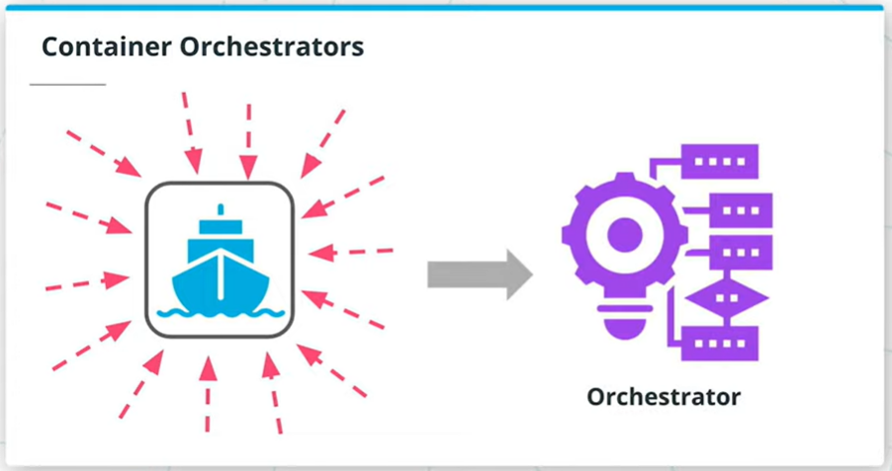

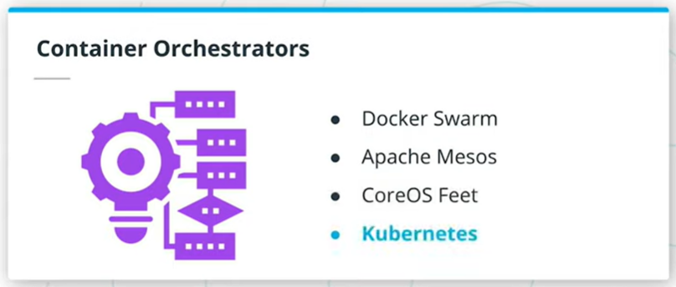

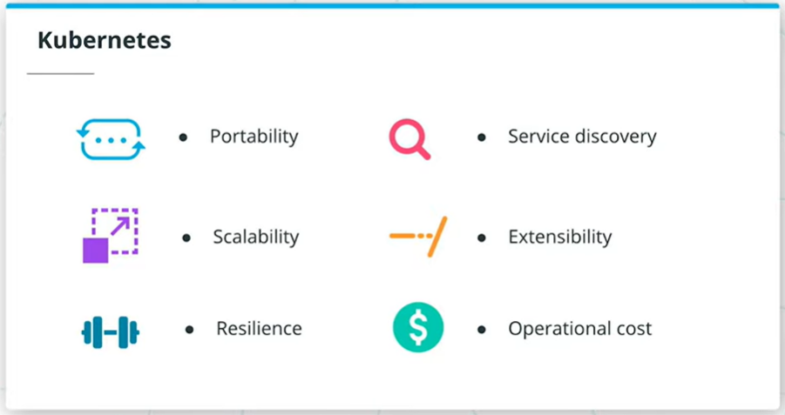

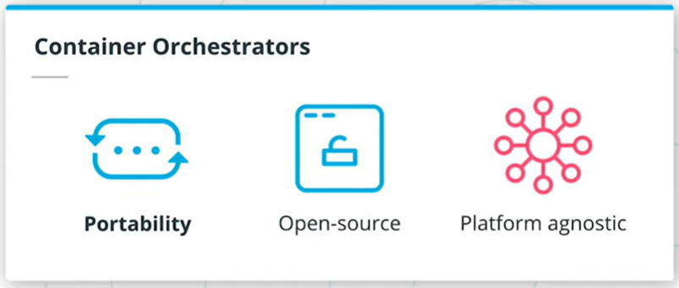

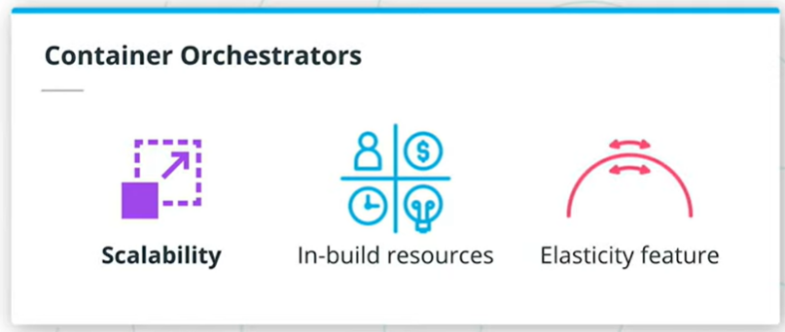

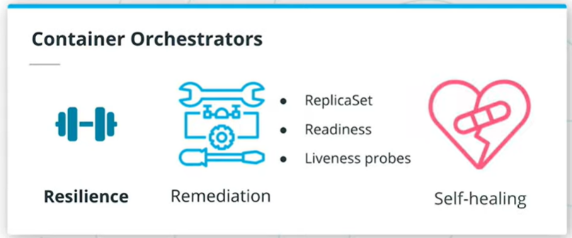

## Summary

So far, in this lesson, we have traversed the packaging of an application using Docker and its distribution through DockerHub. The next phase in the release process is the deployment of the service. However, running an application in production implies that thousands and millions of customers might consume the product at the same time. For this reason, it is paramount to build for scale. It is impossible to manually manage thousands of containers, keeping these are up to date with the latest code changes, in a healthy state, and accessible. As a result, a **container orchestrator framework** is necessary.

A container orchestrator framework is capable to create, manage, configure thousands of containers on a set of distributed servers while preserving the connectivity and reachability of these containers. In the past years, multiple tools emerged within the landscape to provide these capabilities, including Docker Swarm, Apache Mesos, CoreOS Fleet, and many more. However, **Kubernetes** took the lead in defining the principles of how to run containerized workloads on a distributed amount of machines.

Kubernetes is widely adopted in the industry today, with most organizations using it in production. Kubernetes currently is a graduated CNCF project, which highlights its maturity and reported success from end-user companies. This is because Kubernetes solutionizes portability, scalability, resilience, service discovery, extensibility, and operational cost of containers.

#### Portability

Kubernetes is a highly portable tool. This is due to its open-source nature and vendor agnosticism. As such, Kubernetes can be hosted on any available infrastructure, including public, private, and hybrid cloud.

#### Scalability

Building for scale is a cornerstone of any modern infrastructure, enabling an application to scale based on the amount of incoming traffic. Kubernetes has in-build resources, such as HPA (Horizontal Pod Autoscaler), to determine the required amount of replicas for a service. Elasticity is a core feature that is highly automated within Kubernetes.

#### Resilience

Failure is expected on any platform. However, it is more important to be able to recover from failure fast and build a set of playbooks that minimizes the downtime of an application. Kubernetes uses functionalities like ReplicaSet, readiness, and liveness probes to handle most of the container failures, which enables powerful self-healing capability.

#### Service Discovery

Service discovery encapsulates the ability to automatically identify and reach new services once these are available. Kubernetes provide cluster level DNS (or Domain Name System), which simplifies the accessibility of workloads within the cluster. Additionally, Kubernetes provides routing and load balancing of incoming traffic, ensuring that all requests are served without application overload.

#### Extensibility

Kubernetes is a highly extensible mechanism that uses the building-block principle. It has a set of basic resources that can be easily adjusted. Additionally, it provides a rich API interface, that can be extended to accommodate new resources or CRDs (Custom Resource Definitions).

#### Operational Cost

Operational cost refers to the efficiency of resource consumption within a Kubernetes cluster, such as CPU and memory. Kubernetes has a powerful scheduling mechanism that places an application on the node with sufficient resources to ensure the successful execution of the service. As a result, most of the available infrastructure resources are allocated on-demand. Additionally, it is possible to automatically scale the size of the cluster based on the current incoming traffic. This capability is provisioned by the cluster-autoscaler, which guarantees that the cluster size is directly proportional to the traffic that it needs to handle.

## Kubernetes Architecture

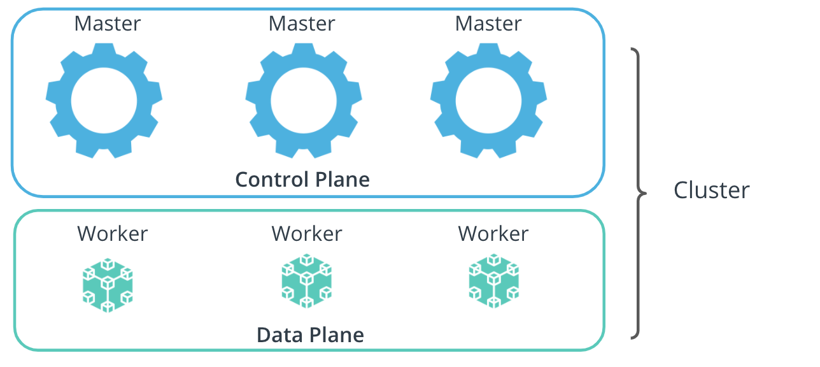

Kubernetes architecture, composed of control and data planes

A Kubernetes cluster is composed of a collection of distributed physical or virtual servers. These are called **nodes**. Nodes are categorized into 2 main types: master and worker nodes. The components installed on a node, determine the functionality of a node, and identifies it as a master or worker node.

The suite of master nodes, represents the **control plane**, while the collection of worker nodes constructs the **data plane**.

### Control Plane

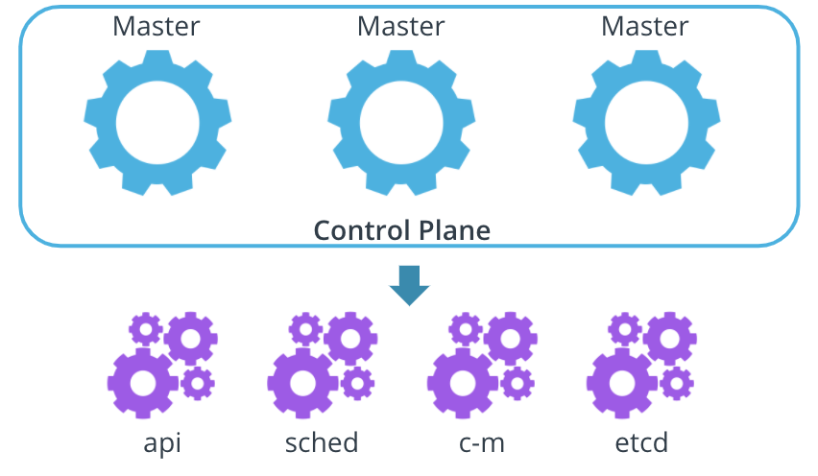

Control Plane components

The control plane consists of components that make global decisions about the cluster. These components are the:

* **kube-apiserver** - the nucleus of the cluster that exposes the Kubernetes API, and handles and triggers any operations within the cluster
* **kube-scheduler** - the mechanism that places the new workloads on a node with sufficient satisfactory resource requirements
* **kube-controller-manager** - the component that handles controller processes. It ensures that the desired configuration is propagated to resources
* **etcd** - the key-value store, used for backs-up and keeping manifests for the entire cluster

There are two additional components on the control plane, they are **kubelet** and **k-proxy**. These two are special and important as they are installed on **all** node. You can see the Data Plane below for more details.

### Data Plane

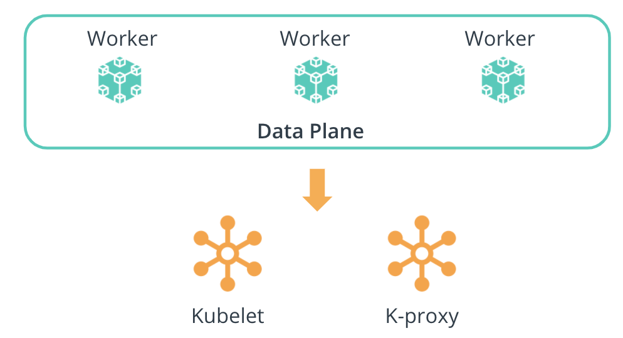

Data Plane conponents

The data plane consists of the compute used to host workloads. The components installed on a worker node are the:

* **kubelet** - the agent that runs on **every** node and notifies the kube- apiserver that this node is part of the cluster
* **kube-proxy**- a network proxy that ensures the reachability and accessibility of workloads places on this specific node

**Important Note:** The **kubelet** and **kube-proxy** components are installed on **all** the nodes in the cluster (**master and worker** nodes). These components keep the kube-apiserver up-to-date with a list of nodes in the cluster and manages the connectivity and reachability of the workloads.

## New terms

* **CRD** - Custom Resource Definition provides the ability to extend Kubernetes API and create new resources
* **Node** - a physical or virtual server
* **Cluster** - a collection of distributed nodes that are used to manage and host workloads
* **Master node** - a node from the Kubernetes control plane, that has installed components to make global, cluster-level decisions
* **Worker node** - a node from the Kubernetes data plane, that has installed components to host workloads

## Further Reading

Explore Kubernetes features:

* [Kubernetes DNS for Services and Pods](https://kubernetes.io/docs/concepts/services-networking/dns-pod-service/)
* [Kubernetes CRDs](https://kubernetes.io/docs/concepts/extend-kubernetes/api-extension/custom-resources/)
* [Kubernete Cluster Autoscaler](https://kubernetes.io/blog/2016/07/autoscaling-in-kubernetes/)
* [Kubernetes Architecture and Components](https://kubernetes.io/docs/concepts/overview/components/)

# Quizzes: Kubernetes

### QUESTION 1 OF 2

The **control plane** makes the global decisions on the actions within a cluster. Which components are installed on a node to mark it as part of the **control plane**, but at the same time to ensure that this node is part of the Kubernetes cluster?

* 

api-server

* 

etcd

* 

kubelet

* 

kube-proxy

* 

controller-manager

* 

scheduler

SUBMIT

### QUESTION 2 OF 2

The **data plane** is used to host workloads onto the cluster. Which components are installed on a node to mark it as part of the **data plane** in a Kubernetes cluster?

* 

api-server

* kube-proxy
* 

controller-manager

* 

etcd

* kubelet
* 

scheduer

SUBMIT

NEXT

# Deploy Your First Kubernetes Cluster

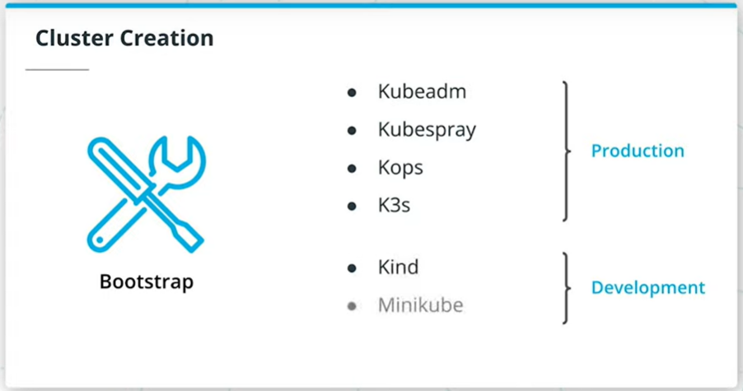

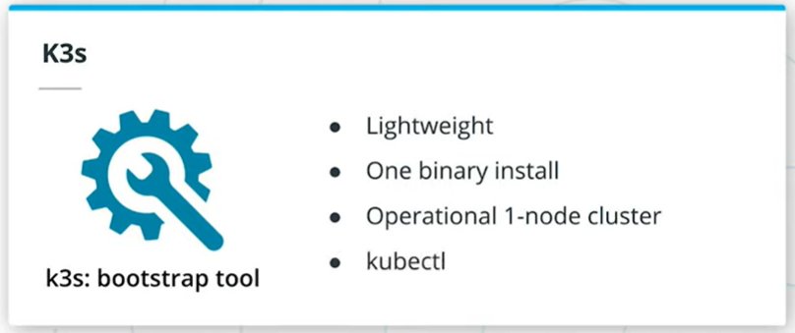

## Summary

Provisioning a Kubernetes cluster is known as the bootstrapping process. When creating a cluster, it is essential to ensure that each node had the necessary components installed. It is possible to manually provision a cluster, however, this implied the distribution and execution of each component independently (e.g. kube-apiserver, kube-scheduler, kubelet, etc.). This is a highly tedious task that has a higher risk of misconfiguration.

As a result, multiple tools emerged to handle the bootstrapping of a cluster automatically. For example:

* Production-grade clusters
  + [kubeadm](https://kubernetes.io/docs/setup/production-environment/tools/kubeadm/install-kubeadm/)
  + [Kubespray](https://github.com/kubernetes-sigs/kubespray)
  + [Kops](https://github.com/kubernetes/kops)
  + [K3s](https://k3s.io/)
* Developmnet-grade clusters
  + [kind](https://kind.sigs.k8s.io/docs/user/quick-start/)
  + [minikube](https://minikube.sigs.k8s.io/docs/start/)
  + [k3d](https://classroom.udacity.com/nanodegrees/nd064-1/parts/30cb07da-8fd4-4438-a209-b3457adb5d82/modules/7b21dfa4-aac8-4d24-82c5-65325e6dc691/lessons/d9fa86b3-301d-4966-86f8-a2f34a5a7ca3/concepts/link%20to%20https:/k3d.io/)

A good introduction to k3d, written by k3d's creator Thorsten Klein, can be found [here](https://www.suse.com/c/introduction-k3d-run-k3s-docker-src/)

A comprehensive overview of currently existing lightweight kubernetes distros can be found [here](https://www.suse.com/c/running-a-local-kubernetes-cluster-k3s-src)

## Create Vagrant Box And Install Kubernetes with k3s

## Create Vagrant Box And Install Kubernetes with k3s

This demo is a step-by-step guide on how to create a vagrant box and install a Kubernetes cluster using [k3s](https://k3s.io/). To follow this demo, reference the [Vagrantfile](https://github.com/udacity/nd064_course_1/blob/main/exercises/Vagrantfile) from the course repository.

A nice introduction to Vagrant can be found in [this article](https://community.suse.com/posts/vagrant-never-gets-old)

Before following the demo:

1. Make sure to have [VirtualBox](https://www.virtualbox.org/wiki/Downloads) 6.1.16 or higher installed.
2. You also need to install [vagrant](https://www.vagrantup.com/) on your machine.

Throughout the demo, the following kubectl commands are used:

*# Inspect available vagrant boxes*

vagrant status

*# create a vagrant box using the Vagrantfile in the current directory*

vagrant up

*# SSH into the vagrant box*

*# Note: this command uses the .vagrant folder to identify the details of the vagrant box*

vagrant ssh

## New terms

* **Bootstrap** - the process of provisioning a Kubernetes cluster, by ensuring that each node has the necessary components to be fully operational

## Further reading

* [Bootstrapping clusters with kubeadm](https://kubernetes.io/docs/setup/production-environment/tools/kubeadm/) - a step-by-step guide on how to use kubeadm to provision a cluster

# Kubeconfig

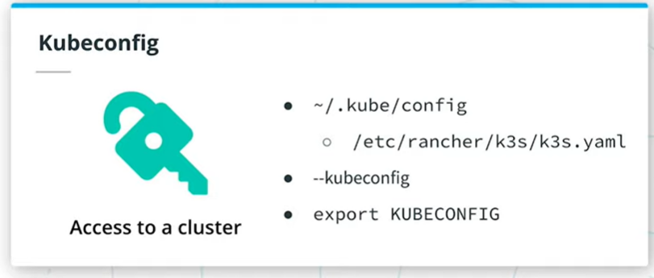

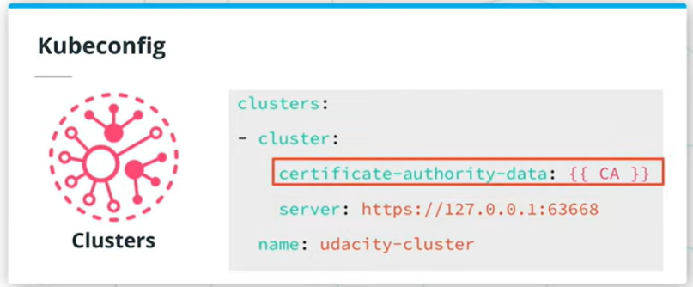

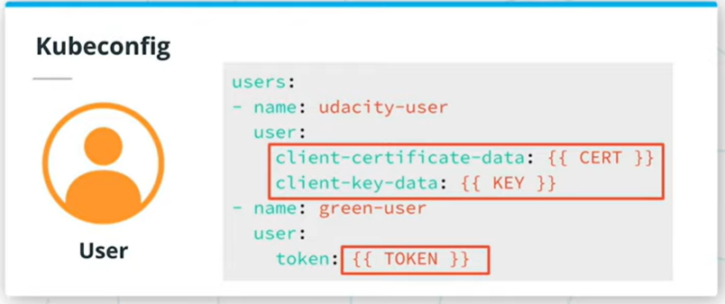

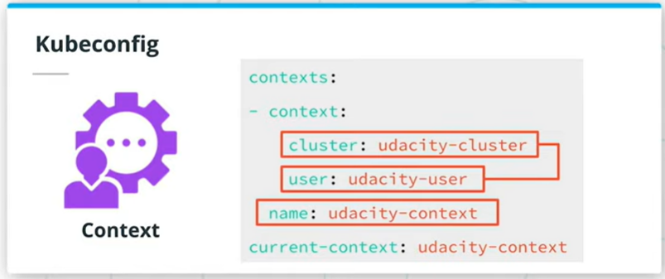

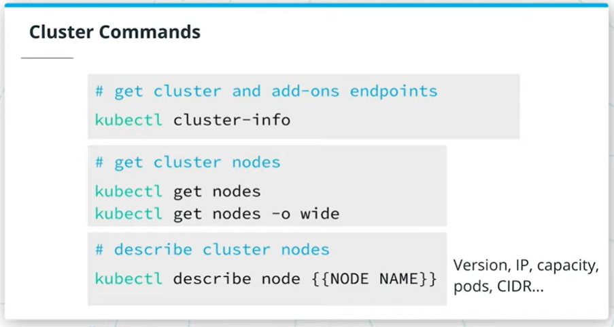

## Summary

To access a Kubernetes cluster a **kubeconfig** file is required. A kubeconfig file has all the necessary cluster metadata and authentication details, that grants the user permission to query the cluster objects. Usually, the kubeconfig file is stored locally under the ~/.kube/config file. However, k3s places the kubeconfig file within /etc/rancher/k3s/k3s.yaml path. Additionally, the location of a kubeconfig file can be set through the --kubeconfig kubectl flag or via the KUBECONFIG environmental variable.

A Kubeconfig file has 3 main distinct sections:

* **Cluster** - encapsulates the metadata for a cluster, such as the name of the cluster, API server endpoint, and certificate authority used to check the identity of the user.
* **User** - contains the user details that want access to the cluster, including the user name, and any authentication metadata, such as username, password, token or client, and key certificates.
* **Context** - links a user to a cluster. If the user credentials are valid and the cluster is up, access to resources is granted. Also, a current-context can be specified, which instructs which context (cluster and user) should be used to query the cluster.

Here is an example of a kubeconfig file:

apiVersion: v1

# define the cluster metadata

clusters:

- cluster:

certificate-authority-data: {{ CA }}

server: https://127.0.0.1:63668

name: udacity-cluster

# define the user details

users:

# `udacity-user` user authenticates using client and key certificates

- name: udacity-user

user:

client-certificate-data: {{ CERT }}

client-key-data: {{ KEY }}

# `green-user` user authenticates using a token

- name: green-user

user:

token: {{ TOKEN }}

# define the contexts

contexts:

- context:

cluster: udacity-cluster

user: udacity-user

name: udacity-context

# set the current context

current-context: udacity-context

Once you start handling multiple clusters, you'll find a lot of useful information in [this article](https://community.suse.com/posts/scheduled/cluster-this-is-your-admin-do-you-read)

## Kubeconfig Walkthrough

In this demo, the instructor uses a cluster bootstrapped with [kind](https://kind.sigs.k8s.io/docs/user/quick-start/). Throughout this course, the students will use k3s to provision a cluser. However, in this demo kind is used to highlight how different tools provision the kubeconfig files.

If the students chose to follows this demo, these are the instructions to create a cluster using kind:

Note: kind can be installed directly on your local machine

* Ensure Docker is installed and running. Use the docker --version command to verify if Docker is installed.
* Install kind by using the [official installation documentation](https://kind.sigs.k8s.io/docs/user/quick-start/#installation)
* Create a kind cluster using the kind create cluster --name demo command

Throughout the demo, the following kubectl commands are used:

*# Inspect the endpoints for the cluster and installed add-ons*

kubectl cluster-info

*# List all the nodes in the cluster.*

*# To get a more detailed view of the nodes, the `-o wide` flag can be passed*

kubectl get nodes [-o wide]

*# Describe a cluster node.*

*# Typical configuration: node IP, capacity (CPU and memory), a list of running pods on the node, podCIDR, etc.*

kubectl describe node {{ NODE NAME }}

## New terms

* **Kubeconfig**- a metadata file that grants a user access to a Kubernetes cluster

## Further reading

* [Organizing Cluster Access Using kubeconfig Files](https://kubernetes.io/docs/concepts/configuration/organize-cluster-access-kubeconfig/)

# Quizzes: Deploy Your First Kubernetes Cluste

# Quizzes: Deploy Your First Kubernetes Cluster

### QUESTION 1 OF 2

What bootstrap tools can be used to provision a production-grade Kubernetes cluster?

* 

Minikube

* Kops
* Kubeadm
* 

Kind

* Kubespray
* K3s

SUBMIT

### QUESTION 2 OF 2

What are the 3 main sections of a kubeconfig file?

* Contexts
* Users
* 

Tokens

* Clusters

SUBMIT

NEXT

# Exercise: Deploy Your First Kubernetes Cluster

So far, you have learned that Kubernetes is a mechanism to manage containers at scale and that there are more than 160+ certified providers to bootstrap a cluster.

Now it's time for you to deploy your first Kubernetes cluster.

This exercise will focus on provisioning a vagrant box and installing a Kubernetes cluster using k3s.

### **Environment Setup**

Provision a Vagrant box locally and install Kubernetes with k3s.

***Note:*** Make sure to have [*VirtualBox*](https://www.virtualbox.org/wiki/Downloads) *6.1.16* or higher installed .

Task List

* 

Install [vagrant](https://www.vagrantup.com/) on your machine

* 

Clone the [course repository](https://github.com/udacity/nd064_course_1) using git commands

* 

Navigate inside the exercises directory and examine the Vagrantfile

* 

Crete a vagrant box by using vagrant up command (Note: you need to be in the same repository as the Vagrantfile for this command to work)

* 

SSH into the vagrant box by using vagrant ssh command

* 

Deploy a Kubernetes cluster using [k3s](https://k3s.io/)

* 

Examine your cluster using kubectl command (Note: you need to be root to access the kubeconfig file, use sudo su - before using kubectl commands)

# Exercise

Now you should have a Kubernetes cluster up and running. Examine the cluster and identity of the following details.

Use the blank space to record your answer if necessary,

## Reflect

From the kubeconfig, identify:

* the IP and port of the API server
* authentication mechanism

***Note:*** Refer to the main [*k3s installation guide*](https://rancher.com/docs/k3s/latest/en/quick-start/#install-script), to find the location of the kubeconfig file.

### Your reflection

**IP and port of the API server: https://127.0.0.1:6443 Authentication mechanism: certificate-authority-data**

### Things to think about

See the solution page for details.

## Reflect

From the cluster using kubectl commands to identify:

* endpoints of the control plane and add-ons
* amount of nodes
* node internal IP
* the pod CIDR allocate to the node

***Note:*** To access kubectl commands you need to become root by using *sudo su -* command.

### Your reflection

**ENDPOINT OF THE CONTROL PLANE AND ADD-ONS: Kubernetes control plane is running at https://127.0.0.1:6443 CoreDNS is running at https://127.0.0.1:6443/api/v1/namespaces/kube-system/services/kube-dns:dns/proxy Metrics-server is running at https://127.0.0.1:6443/api/v1/namespaces/kube-system/services/https:metrics-server:/proxy AMOUNT OF NODES: 1 NAME STATUS ROLES AGE VERSION localhost Ready control-plane,master 20m v1.21.2+k3s1 NODE INTERNAL IP: 10.0.2.15 (Whole output here):NAME STATUS ROLES AGE VERSION INTERNAL-IP EXTERNAL-IP OS-IMAGE KERNEL-VERSION CONTAINER-RUNTIME localhost Ready control-plane,master 21m v1.21.2+k3s1 10.0.2.15 <none> openSUSE Leap 15.2 5.3.18-lp152.81-default containerd://1.4.4-k3s2 THE POD CIDR ALLOCATE TO THE NODE: PodCIDR: 10.42.0.0/24 PodCIDRs: 10.42.0.0/24**

### Things to think about

See the solution page for details.

NEXT

# Solution: Deploy Your First Kubernetes Cluster

The kubeconfig file and kubectl commands are the 2 main components that permits the interaction with a Kubernetes cluster.

Let's take a closer look at cluster configuration details.

* kubeconfig
  + K3s stores the kubeconfig file under /etc/rancher/k3s/k3s.yaml path
  + API server - https://127.0.0.1:6443
  + authentication mechanism - username (admin) and password
* kubectl commands
  + kubectl cluster-info to get the control plane and add-ons endpoints
  + Kubernetes master is running at https://127.0.0.1:6443
  + CoreDNS is running at https://127.0.0.1:6443/api/v1/namespaces/kube-system/services/kube-dns:dns/proxy
  + Metrics-server is running at https://127.0.0.1:6443/api/v1/namespaces/kube-system/services/https:metrics-server:/proxy
  + kubectl get nodes - to get all the nodes in the cluster
  + NAME STATUS ROLES AGE VERSION
  + localhost Ready master 74m v1.18.9+k3s1
  + kubectl get nodes -o wide - to get extra details about the nodes, including internal IP
  + NAME STATUS ROLES AGE VERSION INTERNAL-IP EXTERNAL-IP OS-IMAGE KERNEL-VERSION CONTAINER-RUNTIME
  + localhost Ready master 74m v1.18.9+k3s1 10.0.2.15 <none> openSUSE Leap 15.2 5.3.18-lp152.47-default containerd://1.3.3-k3s2
  + kubectl describe node node-name - to get all the configuration details about the node, including the allocated pod CIDR
  + kubectl describe node localhost | grep CIDR
  + PodCIDR: 10.42.0.0/24
  + PodCIDRs: 10.42.0.0/24

NEXT

# Kubernetes Resources Part 1

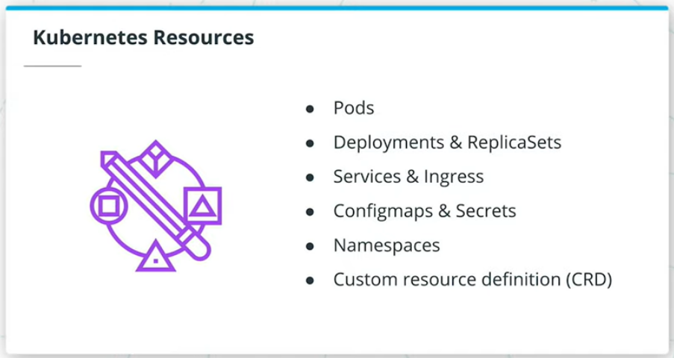

**Summary**

Up to this stage, we have explored how to package an application using Docker and how to bootstrap a cluster using k3s. In the next phase, we need to deploy the packaged application to a Kubernetes cluster.

Kubernetes provides a rich collection of resources that are used to deploy, configure, and manage an application. Some of the widely used resources are:

* Pods - the atomic element within a cluster to manage an application
* Deployments & ReplicaSets - oversees a set of pods for the same application
* Services & Ingress - ensures connectivity and reachability to pods
* Configmaps & Secrets - pass configuration to pods
* Namespaces - provides a logical separation between multiple applications and their resources
* Custom Resource Definition (CRD) - extends Kubernetes API to support custom resources

**Application Deployment**

## Summary

A **pod** is the anatomic element within a cluster that provides the execution environment for an application. Pods are the smallest manageable units in a Kubernetes cluster. Every pod has a container within it, that executes an application from a Docker image (or any OCI-compliant image). There are use cases where 2-3 containers run within the same pod, however, it is highly recommended to keep the 1:1 ratio between your pods and containers.

All the pods are placed on the cluster nodes. A note can host multiple pods for different applications.

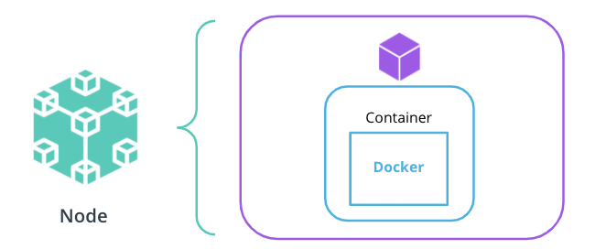

### Deployments and ReplicaSets

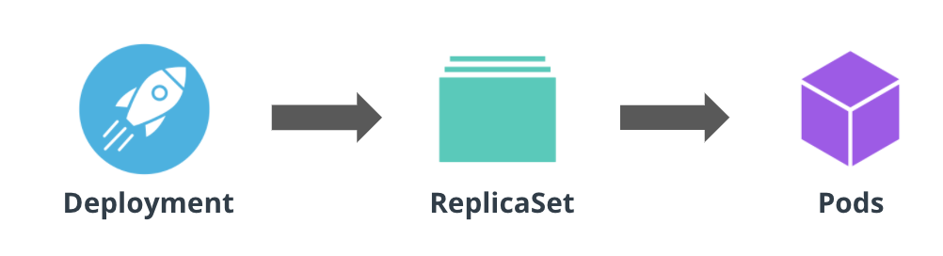

Application management using a Deployment and ReplicaSet

To deploy an application to a Kubernetes cluster, a **Deployment** resource is necessary. A Deployment contains the specifications that describe the desired state of the application. Also, the Deployment resource manages pods by using a **ReplicaSet**. A ReplicaSet resource ensures that the desired amount of replicas for an application are up and running at all times.

To create a deployment, use the kubectl create deployment command, with the following syntax:

*# create a Deployment resource*

*# NAME - required; set the name of the deployment*

*# IMAGE - required; specify the Docker image to be executed*

*# FLAGS - optional; provide extra configuration parameters for the resource*

*# COMMAND and args - optional; instruct the container to run specific commands when it starts*

kubectl create deploy NAME --image=image [FLAGS] -- [COMMAND] [args]

*# Some of the widely used FLAGS are:*

-r, --replicas - set the number of replicas

-n, --namespace - set the namespace to run

--port - expose the container port

For example, to create a Deployment for the Go hello-world application, the following command can be used:

*# create a go-helloworld Deployment in namespace `test`*

kubectl create deploy go-helloworld --image=pixelpotato/go-helloworld:v1.0.0 -n test

It is possible to create headless pods or pods that are not managed through a ReplicaSet and Deployment. Though it is not recommended to create standalone pods, these are useful when creating a testing pod.

To create a headless pod, the kubectl run command is handy, with the following syntax:

*# create a headless pod*

*# NAME - required; set the name of the pod*

*# IMAGE - required; specify the Docker image to be executed*

*# FLAGS - optional; provide extra configuration parameters for the resource*

*# COMMAND and args - optional; instruct the container to run specific commands when it starts*

kubectl run NAME --image=image [FLAGS] -- [COMMAND] [args...]

*# Some of the widely used FLAGS are:*

--restart - set the restart policy. Options [Always, OnFailure, Never]

--dry-run - dry run the command. Options [none, client, server]

-it - open an interactive shell to the container

For example, to create a busybox pod, the following command can be used:

*# example: create a busybox pod, with an interactive shell and a restart policy set to Never*

kubectl run -it busybox-test --image=busybox --restart=Never

### Rolling Out Strategy

The Deployment resource comes with a very powerful rolling out strategy, which ensures that no downtime is encountered when a new version of the application is released. Currently, there are 2 rolling out strategies:

* RollingUpdate - updates the pods in a rolling out fashion (e.g. 1-by-1)
* Recreate - kills all existing pods before new ones are created

For example, in this case, we upgrade a Go hello-world application from version 1.0.0 to version 2.0.0:

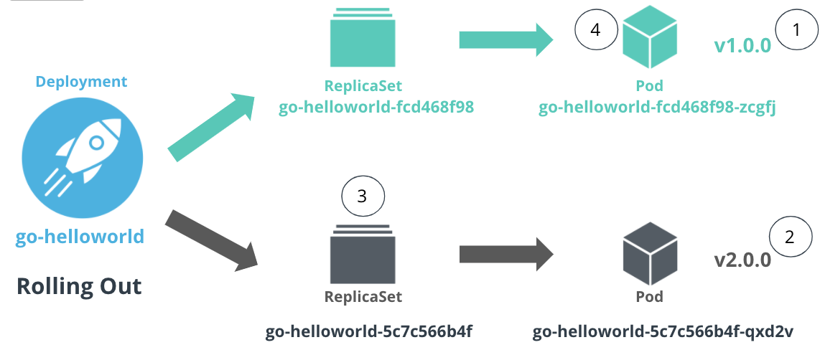

Rolling update of an application, between different versions

Where:

1. The Go hello-world application is running version v1.0.0 in a pod managed by a ReplicaSet
2. The version of Go hello-world application is set to v2.0.0
3. A new ReplicaSet is created that controls a new pod with the application running in version v2.0.0
4. The traffic is directed to the pod running v2.0.0 and the pod with the old configuration (v1.0.0) is removed

## Application Development Demo

## Summary

This demo showcases how an application can be deployed, configured, and managed within a Kubernetes cluster using Deployment, ReplicaSet, and pod resources.

The instructor uses the Go hello-world application in version v1.0.0 and v2.0.0. The difference between these 2 versions is the exposed port by the application. Below are the code snippets for both application versions (you can also refer to the [go-hellowolrd](https://github.com/udacity/nd064_course_1/tree/main/exercises/go-helloworld) application from the course repository):

# Application version: v1.0.0

# port exposed: 6111

**package** main

**import** (

"fmt"

"net/http"

)

**func** helloWorld(w http.ResponseWriter, r *http.Request){

fmt.Fprintf(w, "Hello World")

}

**func** main() {

http.HandleFunc("/", helloWorld)

http.ListenAndServe(":6111", nil)

}

# Application version: v2.0.0

# port exposed: 6112

**package** main

**import** (

"fmt"

"net/http"

)

**func** helloWorld(w http.ResponseWriter, r *http.Request){

fmt.Fprintf(w, "Hello World")

}

**func** main() {

http.HandleFunc("/", helloWorld)

http.ListenAndServe(":6112", nil)

}

## New terms

* **Pod** - smallest manageable uint within a cluster that provides the execution environment for an application
* **ReplicaSet** - a mechanism to ensure a number of pod replicas are up and running at all times
* **Deployment** - describe the desired state of the application to be deployed

## Further reading

Explore the Kubernetes resources in more detail:

* [Kubernetes Pods](https://kubernetes.io/docs/concepts/workloads/pods/)
* [Kubernetes Deployments](https://kubernetes.io/docs/concepts/workloads/controllers/deployment/)
* [Kubernetes ReplicaSets](https://kubernetes.io/docs/concepts/workloads/controllers/replicaset/)
* [Kubernetes RollingOut Strategies](https://kubernetes.io/docs/concepts/workloads/controllers/deployment/#strategy)

# Kubernetes Resources Part 2

## Application Reachability

## Summary

Within a cluster, every pod is allocated 1 unique IP which ensures connectivity and reachability to the application inside the pod. This IP is only routable inside the cluster, meaning that external users and services will not be able to connect to the application.

For example, we can connect a workload within the cluster to access a pod directly via its IP. However, if the pod dies, all future requests will fail, as these are routes to an application that is not running. The remediation step is to configure the workload to communicate with a different pod IP. This is a highly manual process, which brings complexity to the accessibility of an application. To automate the reachability to pods, a Service resource is necessary.

### Services

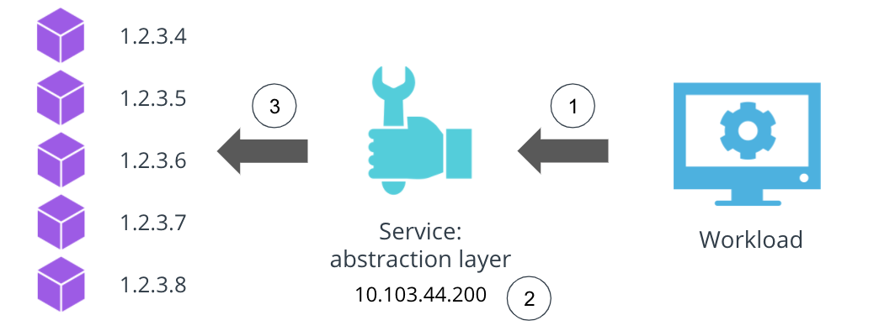

Pods accessibility through a Service resource

A **Service** resource provides an abstraction layer over a collection of pods running an application. A Service is allocated a cluster IP, that can be used to transfer the traffic to any available pods for an application.

As such, as shown in the above image, instead of accessing each pod independently, the workload (1) should access the service IP (2), which routes the requests to available pods (3).

There are 3 widely used Service types:

* **ClusterIP** - exposes the service using an internal cluster IP. If no service type is specified, a ClusterIP service is created by default.
* **NodePort** - expose the service using a port exposed on all nodes in the cluster.
* **LoadBalancer** - exposes the service through a load balancer from a public cloud provider such as AWS, Azure, or GCP. This will allow the external traffic to reach the services within the cluster securely.

To create a service for an existing deployment, use the kubectl expose deployment command, with the following syntax:

*# expose a Deployment through a Service resource*

*# NAME - required; set the name of the deployment to be exposed*

*# --port - required; specify the port that the service should serve on*

*# --target-port - optional; specify the port on the container that the service should direct traffic to*

*# FLAGS - optional; provide extra configuration parameters for the service*

kubectl expose deploy NAME --port=port [--target-port=port] [FLAGS]

*# Some of the widely used FLAGS are:*

--protocol - set the network protocol. Options [TCP|UDP|SCTP]

--type - set the type of service. Options [ClusterIP, NodePort, LoadBalancer]

For example, to expose the Go hello-world application through a service, the following command can be used:

**# expose the `go-helloworld` deployment on port 8111**

**# note: the application is serving requests on port 6112**

kubectl expose deploy go-helloworld --port=8111 --target-port=6112

### Ingress

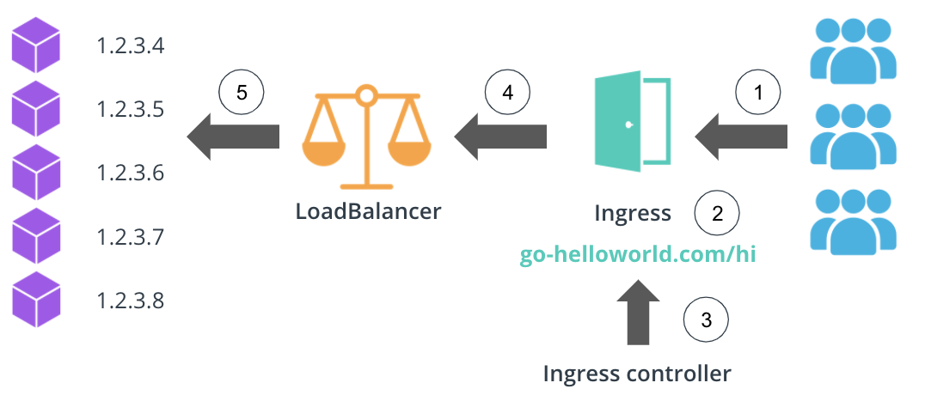

Ingress resources enabling access from the external users to services within the cluster

To enable the external user to access services within the cluster an **Ingress** resource is necessary. An Ingress exposes HTTP and HTTPS routes to services within the cluster, using a load balancer provisioned by a cloud provider. Additionally, an Ingress resource has a set of rules that are used to map HTTP(S) endpoints to services running in the cluster. To keep the Ingress rules and load balancer up-to-date an Ingress Controller is introduced.

For example, as shown in the image above, the customers will access the go-helloworld.com/hi HTTP route (1), which is managed by an Ingress (2). The Ingress Controller (3) examines the configured routes and directs the traffic to a LoadBalancer (4). And finally, the LoadBalancer directs the requests to the pods using a dedicated port (5).

## Application Reachability Demo

## Summary

This demo provides a step-by-step guide on how to expose the Go hello-world application through a ClusterIP service. Additionally, an alpine pod is used to showcase how a workload can connect to the Go hello-world application through the service IP and port from within the cluster.

## New terms

* **Service** - an abstraction layer over a collection of pods running an application
* **Ingress** - a mechanism to manage the access from external users and workloads to the services within the cluster

## Further reading

Explore Kubernetes resources used to connect to an application:

* [Kubernetes Services](https://kubernetes.io/docs/concepts/services-networking/service/)
* [Kubernetes Ingress](https://kubernetes.io/docs/concepts/services-networking/ingress/)

# Kubernetes Resources Part 3

## Application Configuration And Context

## Summary

In the implementation phase, a good development practice is to separate the configuration from the source code. This increased the portability of an application as it can cover multiple customer use cases. Kubernetes has 2 resources to pass data to an application: Configmaps and Secrets.

### ConfigMaps

ConfigMaps are objects that store non-confidential data in key-value pairs. A Configmap can be consumed by a pod as an environmental variable, configuration files through a volume mount, or as command-line arguments to the container.

To create a Configmap use the kubectl create configmap command, with the following syntax:

*# create a Configmap*

*# NAME - required; set the name of the configmap resource*

*# FLAGS - optional; define extra configuration parameters for the configmap*

kubectl create configmap NAME [FLAGS]

*# Some of the widely used FLAGS are:*

--from-file - set path to file with key-value pairs

--from-literal - set key-value pair from command-line

For example, to create a Configmap to store the background color for a front-end application, the following command can be used:

*# create a Configmap to store the color value*

kubectl create configmap test-cm --from-literal=color=yellow

### Secrets

Secrets are used to store and distribute sensitive data to the pods, such as passwords or tokens. Pods can consume secrets as environment variables or as files from the volume mounts to the pod. It is noteworthy, that Kubernetes will encode the secret values using base64.

To create a Secret use the kubectl create secret generic command, with the following syntax:

*# create a Secret*

*# NAME - required; set the name of the secret resource*

*# FLAGS - optional; define extra configuration parameters for the secret*

kubectl create secret generic NAME [FLAGS]

*# Some of the widely used FLAGS are:*

--from-file - set path to file with the sensitive key-value pairs

--from-literal - set key-value pair from command-line

For example, to create a Secret to store the secret background color for a front-end application, the following command can be used:

*# create a Secret to store the secret color value*

kubectl create secret generic test-secret --from-literal=color=blue

### Namespaces

A Kubernetes cluster is used to host hundreds of applications, and it is required to have separate execution environments across teams and business verticals. This functionality is provisioned by the **Namespace** resources. A Namespace provides a logical separation between multiple applications and associated resources. In a nutshell, it provides the **application context**, defining the environment for a group of Kubernetes resources that relate to a project, such as the amount of CPU, memory, and access. For example, a project-green namespace includes any resources used to deploy the Green Project. These resources construct the application context and can be managed collectively to ensure a successful deployment of the project.

Each team or business vertical is allocated a separate Namespace, with the desired amount of CPU, memory, and access. This ensures that the application is managed by the owner team and has enough resources to execute successfully. This also eliminates the "noisy neighbor" use case, where a team can consume all the available resources in the cluster if no Namespace boundaries are set.

To create a Namespace we can use the kubectl create namespace command, with the following syntax:

*# create a Namespace*

*# NAME - required; set the name of the Namespace*

kubectl create ns NAME

For example, to create a test-udacity Namespace, the following command can be used:

*# create a `test-udacity` Namespace*

kubectl create ns test-udacity

*# get all the pods in the `test-udacity` Namespace*

kubectl get po -n test-udacity

## Demo - Application Configuration

## Summary

This demo showcases how Configmap and Secret resources can be created using literal values from the command line.

## Demo - Application Context

## Summary

This demo is a step-by-step guide on how to create a Namespace resource and retrieve resources from a specific Namespace.

## New terms

* **Configmap** - a resource to store non-confidential data in key-value pairs.
* **Secret** - a resource to store confidential data in key-value pairs. These are base64 encoded.
* **Namespace** - a logical separation between multiple applications and associated resources.

## Further reading

Explore Kubernetes resources to pass configuration to pods:

* [Kubernetes Configmap](https://kubernetes.io/docs/concepts/configuration/configmap/)
* [Kubernetes Secrets](https://kubernetes.io/docs/concepts/configuration/secret/)
* [Kuebrnetes Namespaces](https://kubernetes.io/docs/concepts/overview/working-with-objects/namespaces/)

# Useful kubectl Commands

Kubectl provides a rich set of actions that can be used to interact, manage, and configure Kubernetes resources. Below is a list of handy kubectl commands used in practice.

***Note:*** In the following commands the following arguments are used:

* **RESOURCE** is the Kubernetes resource type
* **NAME** sets the name of the resource
* **FLAGS** are used to provide extra configuration
* **PARAMS** are used to provide the required configuration to the resource

#### Create Resources

To create resources, use the following command:

kubectl create RESOURCE NAME [FLAGS]

#### Describe Resources

To describe resources, use the following command:

kubectl describe RESOURCE NAME

#### Get Resources

To get resources, use the following command, where -o yaml instructs that the result should be YAML formated.

kubectl get RESOURCE NAME [-o yaml]

#### Edit Resources

To edit resources, use the following command, where -o yaml instructs that the edit should be YAML formated.

kubectl edit RESOURCE NAME [-o yaml]

#### Label Resources

To label resources, use the following command:

kubectl label RESOURCE NAME [PARAMS]

#### Port-forward to Resources

To access resources through port-forward, use the following command:

kubectl port-forward RESOURCE/NAME [PARAMS]

#### Logs from Resources

To access logs from a resource, use the following command:

kubectl logs RESOURCE/NAME [FLAGS]

#### Delete Resources

To delete resources, use the following command:

kubectl delete RESOURCE NAME

NEXT

# Quizzes: Kubernetes Resources

# Quizzes: Kubernetes Resources

### QUESTION 1 OF 3

What Kubernetes resources are used to ensure the following functionalities?

Secrets

Ingress

Pods

**FUNCTIONALITY**

**KUBERNETES RESOURCES**

Application management

Deployments, ReplicaSets, and Pods

Application reachability

Services and Ingress

Application configuration

Secrets and ConfigMaps

Application context

Namespaces

SUBMIT

### QUESTION 2 OF 3

What Kubernetes resources should be used to direct the external traffic to services within the cluster?

* 

Pods

* 

Services

* Ingress
* 

Load balancers

SUBMIT

### QUESTION 3 OF 3

What kubectl commands should be used to achieve the following output?

### ***Submit to check your answer choices!***

**OUTPUT**

**KUBECTL COMMANDS**

Expose the backend deployment using a service on port 7633

kubectl expose deploy backend --port=7633

Create a busybox deployment with 10 replicas, exposed on port 9090

kubectl create deploy busybox \

--image=busybox -r=10 --port=9090

Label a configmap with the tier=networking key-value pair

kubectl label configmap app-cm tier=networking

Delete the sandbox namespace

kubectl delete ns sandbox

Describe the secret with the name team-token

kubectl describe secret team-token

SUBMIT

NEXT

# Exercise: Kubernetes Resources

Now you have learned many Kubernetes recourses, in this exercise, you will deploy the following resources using the kubectl command.

* a namespace
  + name: demo
  + label: tier: test
* a deployment:
  + image: nginx:alpine
  + name:nginx-apline
  + namespace: demo
  + replicas: 3
  + labels: app: nginx, tag: alpine
* a service:
  + expose the above deployment on port 8111
  + namespace: demo
* a configmap:
  + name: nginx-version
  + containing key-value pair: version=alpine
  + namespace: demo

**Note:** Nginx is one of the public Docker images, that you can access and use for your exercises or testing purposes.

# Solution: Kubernetes Resources

Below is a snippet creating a namespace and labeling it, a deployment, a service, and a configmap using the kubectl operations.

*# create the namespace*

*# note: label option is not available with `kubectl create`*

kubectl create ns demo

*# label the namespace*

kubectl label ns demo tier=test

*# create the nginx-alpine deployment*

kubectl create deploy nginx-alpine --image=nginx:alpine --replicas=3 --namespace demo

*# label the deployment*

kubectl label deploy nginx-alpine app=nginx tag=alpine --namespace demo

*# expose the nginx-alpine deployment, which will create a service*

kubectl expose deployment nginx-alpine --port=8111 --namespace demo

*# create a config map*

kubectl create configmap nginx-version --from-literal=version=alpine --namespace demo

Spoiler alert: in the next section, you will learn and practice how to deploy Kubernetes resources using a different approach.

# Declarative Kubernetes Manifests

## Summary

Kubernetes is widely known for its support for imperative and declarative management techniques. The **imperative** approach enables the management of resources using kubectl commands directly on the live cluster. For example, all the commands you have practiced so far (e.g. kubectl create deploy [...]) are using the imperative approach. This technique is best suited for development stages only, as it presents a low entry-level bar to interact with the cluster.

On the other side, the **declarative** approach uses manifests stored locally to create and manage Kubertenest objects. This approach is recommended for production releases, as we can version control the state of the deployed resources. However, this technique presents a high learning curve, as an in-depth understanding of the YAML manifest structure is required. Additionally, using YAML manifests unlocks the possibility of configuring more advanced options, such as volume mounts, readiness and liveness probes, etc.

### YAML Manifest structure

A YAML manifest consists of 4 obligatory sections:

* **apiversion** - API version used to create a Kubernetes object
* **kind** - object type to be created or configured
* **metadata** - stores data that makes the object identifiable, such as its name, namespace, and labels
* **spec** - defines the desired configuration state of the resource

To get the YAML manifest of any resource within the cluster, use the kubectl get command, associated with the -o yaml flag, which requests the output in YAML format. Additionally, to explore all configurable parameters for a resource it is highly recommended to reference the official [Kubernetes documentation](https://kubernetes.io/docs/home/).

#### Deployment YAML manifest

In addition to the required sections of a YAML manifest, a Deployment resource covers the configuration of ReplicaSet, RollingOut strategy, and containers. Bellow is a full manifest of a Deployment explaining each parameter:

## Set the API endpoint used to create the Deployment resource.

apiVersion: apps/v1

## Define the type of the resource.

kind: Deployment

## Set the parameters that make the object identifiable, such as its name, namespace, and labels.

metadata:

annotations:

labels:

app: go-helloworld

name: go-helloworld

namespace: default

## Define the desired configuration for the Deployment resource.

spec:

## Set the number of replicas.

## This will create a ReplicaSet that will manage 3 pods of the Go hello-world application.

replicas: 3

## Identify the pods managed by this Deployment using the following selectors.

## In this case, all pods with the label `go-helloworld`.

selector:

matchLabels:

app: go-helloworld

## Set the RollingOut strategy for the Deployment.

## For example, roll out only 25% of the new pods at a time.

strategy:

rollingUpdate:

maxSurge: 25%

maxUnavailable: 25%

type: RollingUpdate

## Set the configuration for the pods.

template:

## Define the identifiable metadata for the pods.

## For example, all pods should have the label `go-helloworld`

metadata:

labels:

app: go-helloworld

## Define the desired state of the pod configuration.

spec:

containers:

## Set the image to be executed inside the container and image pull policy

## In this case, run the `go-helloworld` application in version v2.0.0 and

## only pull the image if it's not available on the current host.

- image: pixelpotato/go-helloworld:v2.0.0

imagePullPolicy: IfNotPresent

name: go-helloworld

## Expose the port the container is listening on.

## For example, exposing the application port 6112 via TCP.

ports:

- containerPort: 6112

protocol: TCP

## Define the rules for the liveness probes.

## For example, verify the application on the main route `/`,

## on application port 6112. If the application is not responsive, then the pod will be restarted automatically.

livenessProbe:

httpGet:

path: /

port: 6112

## Define the rules for the readiness probes.

## For example, verify the application on the main route `/`,

## on application port 6112. If the application is responsive, then traffic will be sent to this pod.

readinessProbe:

httpGet:

path: /

port: 6112

## Set the resource requests and limits for an application.

resources:

## The resource requests guarantees that the desired amount

## CPU and memory is allocated for a pod. In this example,

## the pod will be allocated with 64 Mebibytes and 250 miliCPUs.

requests:

memory: "64Mi"

cpu: "250m"

## The resource limits ensure that the application is not consuming

## more than the specified CPU and memory values. In this example,

## the pod will not surpass 128 Mebibytes and 500 miliCPUs.

limits:

memory: "128Mi"

cpu: "500m"

#### Service YAML manifest

In addition to the required sections of a YAML manifest, a Service resource covers the configuration of service type and ports the service should configure. Bellow is a full manifest of a Service explaining each parameter:

## Set the API endpoint used to create the Service resource.

apiVersion: v1

## Define the type of the resource.

kind: Service

## Set the parameters that make the object identifiable, such as its name, namespace, and labels.

metadata:

labels:

app: go-helloworld

name: go-helloworld

namespace: default

## Define the desired configuration for the Service resource.

spec:

## Define the ports that the service should serve on.

## For example, the service is exposed on port 8111, and

## directs the traffic to the pods on port 6112, using TCP.

ports:

- port: 8111

protocol: TCP

targetPort: 6112

## Identify the pods managed by this Service using the following selectors.

## In this case, all pods with the label `go-helloworld`.

selector:

app: go-helloworld

## Define the Service type, here set to ClusterIP.

type: ClusterIP

### Useful command

Kubernetes YAML manifests can be created using the kubectl apply command, with the following syntax:

*# create a resource defined in the YAML manifests with the name manifest.yaml*

kubectl apply -f manifest.yaml

To delete a resource using a YAML manifest, the kubectl delete command, with the following syntax:

*# delete a resource defined in the YAML manifests with the name manifest.yaml*

kubectl delete -f manifest.yaml

Kubernetes documentation is the best place to explore the available parameters for YAML manifests. However, a support YAML template can be constructed using kubectl commands. This is possible by using the --dry-run=client and -o yamlflags which instructs that the command should be evaluated on the client-side only and output the result in YAML format.

*# get YAML template for a resource*

kubectl create RESOURCE [REQUIRED FLAGS] --dry-run=client -o yaml

For example, to get the template for a Deployment resource, we need to use the create command, pass the required parameters, and associated with the --dry-run and -o yaml flags. This outputs the base template, which can be used further for more advanced configuration.

*# get the base YAML templated for a demo Deployment running a nxing application*

kubectl create deploy demo --image=nginx --dry-run=client -o yaml

## Declarative Kubernetes Manifests Walkthrough

## Summary

This demo showcases how a Namespace and Deployment resource can be deployed using YAML manifests.

## New terms

* **Imperative configuration** - resource management technique, that operates and interacts directly with the live objects within the cluster.
* **Declarative configuration** - resource management technique, that operates and manages resources using YAML manifests stored locally.

## Further reading

Explore more details about different management techniques and advanced configuration for Deployment resources:

* [Managing Kubernetes Objects Using Imperative Commands](https://kubernetes.io/docs/tasks/manage-kubernetes-objects/imperative-command/)
* [Declarative Management of Kubernetes Objects Using Configuration Files](https://kubernetes.io/docs/tasks/manage-kubernetes-objects/declarative-config/)
* [Configure Liveness, Readiness Probes for a Deployment](https://kubernetes.io/docs/tasks/configure-pod-container/configure-liveness-readiness-startup-probes/)
* [Managing Resources for Containers](https://kubernetes.io/docs/concepts/configuration/manage-resources-containers/)

# Quizzes: Declarative Kubernetes Manifests

### QUESTION 1 OF 2

What resource would be created with the following declarative manifest?

apiVersion: v1

data:

token: YWJjZA==

kind: Secret

metadata:

creationTimestamp: null

name: team-token

* 

ConfigMap

* 

Deployment

* 

Pod

* Secret

SUBMIT

### QUESTION 2 OF 2

What properties are set in the following manifest for a pod?

[...]

spec:

containers:

- image: alpine

name: test-pod

ports:

- containerPort: 5777

resources:

requests:

cpu: 100m

memory: 256Mi

livenessProbe:

httpGet:

path: /

port: 5777

* CPU request of 100 millicpus
* 

Exposed on port 7555

* A liveness probe to check the application on port 5777
* Running the alpine image
* 

Memory limit of 256 Mebibytes

SUBMIT

NEXT

# Exercise: Declarative Kubernetes Manifests

Kubernetes is widely known for its imperative and declarative management techniques. In the previous exercise, you have deployed the following resources using the **imperative** approach. Now deploy them using the **declarative** approach.

* a namespace
  + name: demo
  + label: tier: test
* a deployment:
  + image: nginx:alpine
  + name:nginx-apline
  + namespace: demo
  + replicas: 3
  + labels: app: nginx, tag: alpine
* a service:
  + expose the above deployment on port 8111
  + namespace: demo
* a configmap:
  + name: nginx-version
  + containing key-value pair: version=alpine
  + namespace: demo

***Note:*** Nginx is one of the public Docker images, that you can access and use for your exercises or testing purposes.

Make sure the following tasks are completed:

Task List

* 

Use the **declarative** approach to create a namespace

* 

Use the **declarative** approach to create a deployment

* 

Use the **declarative** approach to create a service

* 

Use the **declarative** approach to create a configmap

NEXT

# Solution: Declarative Kubernetes Manifests

## Declarative Approach

The declarative approach consists of using a full YAML definition of resources. As well, with this approach, you can perform directory level operations.

Examine the manifests for all of the resources in the [exercises/manifests](https://github.com/udacity/nd064_course_1/tree/main/exercises/manifests).

To create the resources, use the following command:

kubectl apply -f exercises/manifests/

To inspect all the resources within the namespace, use the following command:

kubectl get all -n demo

NAME READY STATUS RESTARTS AGE

pod/nginx-alpine-798fb5b8bb-8rzq9 1/1 Running 0 12s

pod/nginx-alpine-798fb5b8bb-ms28l 1/1 Running 0 12s

pod/nginx-alpine-798fb5b8bb-qgqb2 1/1 Running 0 12s

NAME TYPE CLUSTER-IP EXTERNAL-IP PORT(S) AGE

service/nginx-alpine ClusterIP 10.109.197.180 <none> 8111/TCP 18s

NAME READY UP-TO-DATE AVAILABLE AGE

deployment.apps/nginx-alpine 3/3 3 3 12s

NAME DESIRED CURRENT READY AGE

replicaset.apps/nginx-alpine-798fb5b8bb 3 3 3 12s

NEXT

# Edge Case: Failing Control Plane for Kubernetes

**Summary**

Failure is expected in any technology stack. However, it is more important to have efficient remediations steps rather than plan for no-failure scenarios. Kubernetes provides methods to handle some of the low-level failures and ensure the application is healthy and accessible. Some of these resources are:

* ReplicaSets - to ensure that the desired amount of replicas is up and running at all times
* Liveness probes - to check if the pod is running, and restart it if it is in an errored state
* Readiness probes - ensure that traffic is routed to that pods that are ready to handle requests
* Services - to provide one entry point to all the available pods of an application

These services, prompt the automatic recovery of an application if an error is encountered. However, failure can happen at the cluster-level, for example, a control plane failure. In this case, a subset or all control plane components are compromised. While the situation is disastrous, the applications are still running and handling traffic. The downside of the control plane failure is that no new workloads can be deployed and no changes can be applied to the existing workloads.

The engineering team needs to recover the control plane components as a critical priority. However, they should not worry about recovering applications, as these will be intact and still handling requests.

# Lesson Review

## Summary

In this lesson, we have covered how to package an application using Docker and store it in DockerHub. Then, we practiced how to bootstrap a cluster using k3s and deploy an application using Kubernetes resources. For more advanced configurations, we have evaluated Kubernetes YAML manifests that are the basis of declarative management techniques.

Overall, in this lesson, we covered:

* Docker for Application Packaging
* Container Orchestration with Kubernetes
* Kubernetes Resources
* Declarative Kubernetes Manifests

## Glossary

* **Dockerfile** - set of instructions used to create a Docker image
* **Docker image** - a read-only template used to spin up a runnable instance of an application
* **Docker registry** - a central mechanism to store and distribute Docker images
* **CRD** - Custom Resource Definition provides the ability to extend Kubernetes API and create new resources
* **Node** - a physical or virtual server
* **Cluster** - a collection of distributed nodes that are used to manage and host workloads
* **Master node** - a node from the Kubernetes control plane, that has installed components to make global, cluster-level decisions
* **Worker node** - a node from the Kubernetes data plane, that has installed components to host workloads
* **Bootstrap** - the process of provisioning a Kubernetes cluster, by ensuring that each node has the necessary components to be fully operational
* **Kubeconfig**- a metadata file that grants a user access to a Kubernetes cluster
* **Pod** - smallest manageable uint within a cluster that provides the execution environment for an application
* **ReplicaSet** - a mechanism to ensure a number of pod replicas are up and running at all times
* **Deployment** - describe the desired state of the application to be deployed
* **Service** - an abstraction layer over a collection of pods running an application
* **Ingress** - a mechanism to manage the access from external users and workloads to the services within the cluster
* **Configmap** - a resource to store non-confidential data in key-value pairs.
* **Secret** - a resource to store confidential data in key-value pairs. These are base64 encoded.
* **Namespace** - a logical separation between multiple applications and associated resources.
* **Imperative configuration** - resource management technique, that operates and interacts directly with the live objects within the cluster.
* **Declarative configuration** - resource management technique, that operates and manages resources using YAML manifests stored locally.

## Further Reading

[Kubernetes kubectl cheetsheet](https://kubernetes.io/docs/reference/kubectl/cheatsheet/)

**LESSON 4 OPEN SOURCE PAAS**

# Introduction

Welcome to Open Source PaaS lesson!

Throughout the release process, the development team has to collaborate closely with the infrastructure team. This is necessary to ensure that the application requirements can be fulfilled by the platform capabilities. However, this is a use case where an organization has enough resources to hire a development and infrastructure team. Small organizations, consists of small teams that focus fully on application development. In these circumstances, it is only a natural movement to delegate the management of platform components to a 3rd party.

In this lesson, we will explore the Platform as a Service (PaaS) mechanism as a way to deploy a service without underlying infrastructure knowledge.

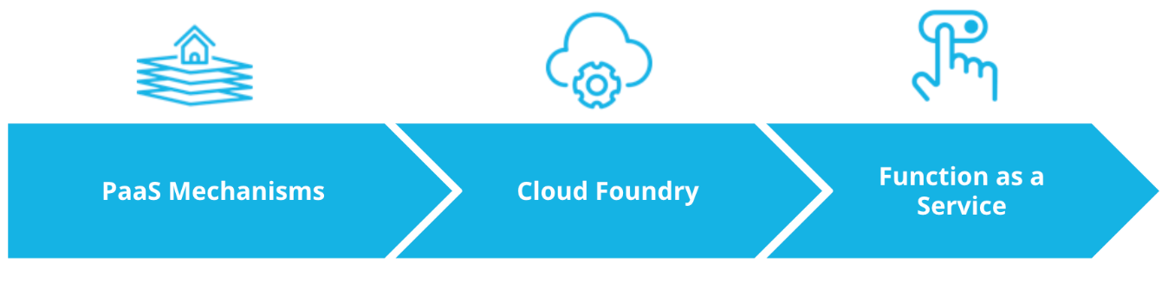

Open Source PaaS lesson outline

Throughout this lesson we will explore:

* PaaS Mechanisms
* Cloud Foundry
* Function as a Service

# Cluster Management

## Summary

Kubernetes offers a wide range of functionalities that form the principles of any modern infrastructure. These capabilities revolve around automation, portability, extensibility, flexibility, self-healing, and many more. However, managing Kubernetes at scale is challenging, especially when the clusters are self-hosted in datacenters or private clouds. In this case, a team has to keep up-to-date with the latest Kubernetes releases, to ensure the platform is updated, upgraded, managed, and configured to meet the production-grade standards.

Within any organization, a release process consists of releasing the application to multiple environments, such as sandbox, staging, and production. In this case, each environment is represented by a separate Kubernetes cluster, with a total of 3 clusters. However, the number of clusters grows exponentially if the platform is replicated across different regions. This is usually required to keep market proximity and deliver a service to consumers with minimal latency. As a result, if the infrastructure is distributed across the US, Europe, and the Asia Pacific, a team ends up operating 9 clusters. Configuring, managing, upgrading, updating, and deploying to all of these clusters is a herculean task and often requires a dedicated team.

In these circumstances, if an organization does not have sufficient engineering resources, delegating the platform management to a 3rd party provider is a more suitable solution. This is covered by a PaaS or Platform as a Service solution.

# PaaS Mechanisms

## Summary

The industry is abundant with cloud-computing offerings that offer variate level of attraction of services. Some of the widely used cloud-computing services are:

* **On-premise** - where an engineering team has full control over the platform, including the physical servers
* **IaaS** or **Infrastructure as a Service** - where a team consumes compute, network, and storage resources from a vendor
* **PaaS** or **Platform as a Service** - where the infrastructure is fully managed by a provider, and the team is focused on application deployment

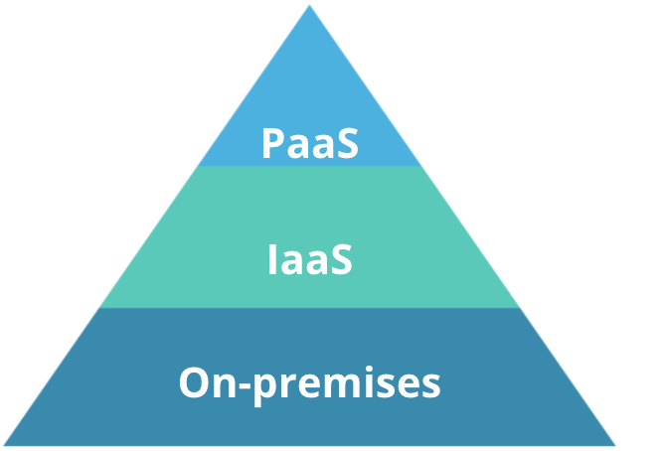

Widely used cloud-computing offerings

Releasing a product to a production environment implies that a platform has been build to host this particular product. A platform consists of multiple services that need to be configured, wired, and maintained together. These services are:

* **Networking** - establish communication between internal and external systems, such as internet connection, firewalls, routers, and cables
* **Storage**- collect and store digital data, such as files, blocks, or objects
* **Servers**- physical machines that provide compute services for a platform
* **Virtualization** - abstracts physical servers, storage, and networking. For example, we have learned that hypervisors are used to virtualize servers.
* **O/S** - operating systems that connect the software to physical resources (e.g. Linux, Ubuntu, Windows, etc)
* **Middleware** - help the developers to build an application by making it easy to consume platform capabilities (e.g. messaging, API, data management)
* **Runtime** - execution context for an application. For example, using JVM (or Java Virtual Machine) as a Java runtime
* **Data** - tools for collection and storage of data that is required by an application during execution(e.g. MySQL, MongoDB, or CockroachDB)
* **Applications** - the business logic for a product

#### On-premise

On-premise represents a cloud-computing offering where the engineering team has full control of the platform services (from networking to applications). This solution is suitable for organizations that have sufficient engineering power and regulations that demand full control of their technology stack and operations within it.

#### IaaS

IaaS solutions provide the abstraction of networking, storage, server, and virtualization layers. As a result, these services are consumed on-demand by the engineering teams. Additionally, IaaS provides a suitable abstraction for the management of self-hosted Kubernetes clusters, which depend on compute, network, and storage components for a successful bootstrap process.

The most common IaaS solutions are delivered by public cloud providers such as AWS, GCP, Microsoft Azure, and many more.

#### PaaS

PaaS is a cloud-computing offering that enables an engineering team to fully focus on application development. It abstracts all services except the application and the data associated with it. As a result, the team is required to manage the code base and any database service that the product needs to be fully operational.

Popular PaaS solutions are App Engine from GCP, Heroku, Cloud Foundry, Beanstalk from AWS, and many more.

**Advantages**:

* Time-efficiency - engineering focus is shifter toward development rather than infrastructure management
* Scalability and high availability - on-demand resource consumption enables an application to easily scale and fail-over
* Rich application catalog - integration of external service (e.g. databases) with minimal effort

**Disadvantages**:

* Vendor lock-in - it is challenging to interchange PaaS providers without service disruption
* Data security - since data is managed by a 3rd party, an extra layer of complexity is added to ensure data confidentiality
* Operational limitations - the service catalog is limited to the services offered by the integrated cloud provider

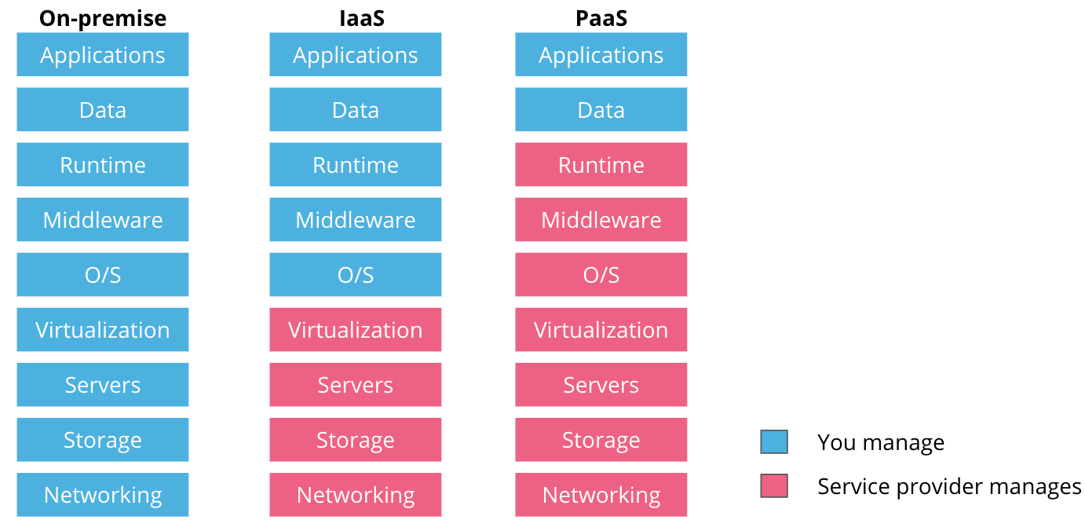

Variate levels of service management from cloud-computing offerings

Throughout its evolution, an organization might use one or a subset of available cloud-computing services. It is essential to select an offering that closely meets business requirements. However, it is important to consider the following traits of cloud-computing services:

* The fewer components are delegated to external providers, the **more control** there is over available functionalities
* The more ownership there is across the stack, the **more complexity** is introduced in managing and delivering the product
* The fewer components are managed by an engineering team, the quicker is the **usability** of the stack. As such, with a PaaS offering the engineering team can deploy their application immediately. While if choosing an on-premise solution, the release of a product is possible only after the platform is built.

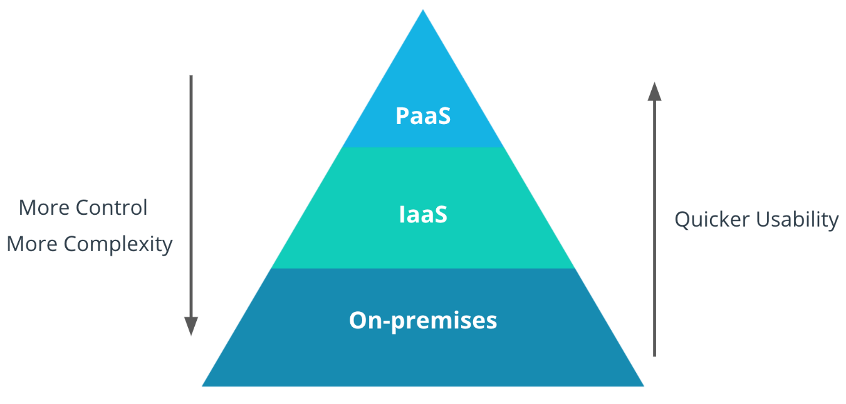

Complexity vs Usability for each cloud-computing offering

## New terms

* **On-premise** - cloud-computing service, where a team owns the entire technology stack.
* **IaaS** - cloud-computing service that offers the abstraction of networking, storage, server, and virtualization layers.
* **PaaS** - cloud-computing service, where the infrastructure components are managed fully by a 3rd party provider, and a team manages only the application and the data associated with it.

## Further Reading

Read more about on-premise, IaaS, and PaaS solutions:

* [On Premise Vs Cloud](https://www.ebcgroup.co.uk/news-insights/on-premises-vs-cloud)
* [Infrastructure as a Service](https://susedefines.suse.com/definition/infrastructure-as-a-service/)
* [Platform as a Service](https://susedefines.suse.com/definition/platform-as-a-service/)
* [Cloud Computing in 2021: What You Should Know about Public, Private, Hybrid, PaaS, SaaS and FaaS](https://www.suse.com/c/cloud-computing-in-2021-what-you-should-know-about-public-private-hybrid-paas-saas-and-faas/)

# Exercise: PaaS Mechanisms

## PaaS Consideration for a web-store

Platform as a Service (PaaS) provides a hosted environment for the efficient development and deployment of a project. Using this service truly allows developers to focus on building functionality instead of managing infrastructure components.

Imagine the following scenario: you are part of the small team that needs to refactor a web-store application. Currently, the application provides an inventory of thousands of products and is actively used by millions of customers daily. As a business, you want to guarantee service availability with minimal disruption during the refactoring/migration process. The application is managed in-house and is composed of front-end and backend microservices and a collection of databases to store the inventory and customer details.

The main reason for the refactoring process is the inability to cope with the high load of requests and poor end-user experience while using the web-store. Due to limited engineering resources, the aim is to introduce a new database solution and outsource the management to a 3rd party vendor. As well, the team desires to increase the visibility of the application by evaluating the monitoring and logging capabilities.

At this stage, you and your team decided that PaaS provides the most suitable solution. Using the above details, describe what PaaS functionalities will be highly beneficial for this project and elaborate on your reasoning.

# Solution: PaaS Mechanisms

By default, the PaaS solutions offer the management of the underlying infrastructure, such as storage, databases, compute, hosting, and many more. Also, the majority of solutions will provide data analytics, security, and advanced scheduling.

As such, the web-store project will benefit from the following PaaS capabilities:

* database - for storing the customer details, orders, and products details
* compute - accessible scalability for the application to serve millions of customers
* networking - hosting and serving the requests with no downtime
* analytics - an add-on to collect data and provide metrics and logs about customer interaction with the web-store

# Cloud Foundry

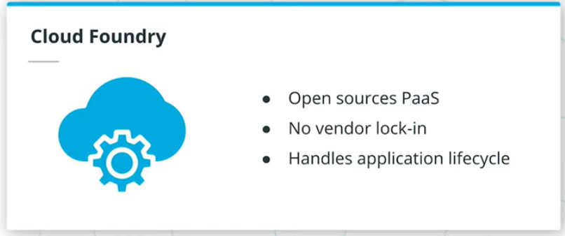

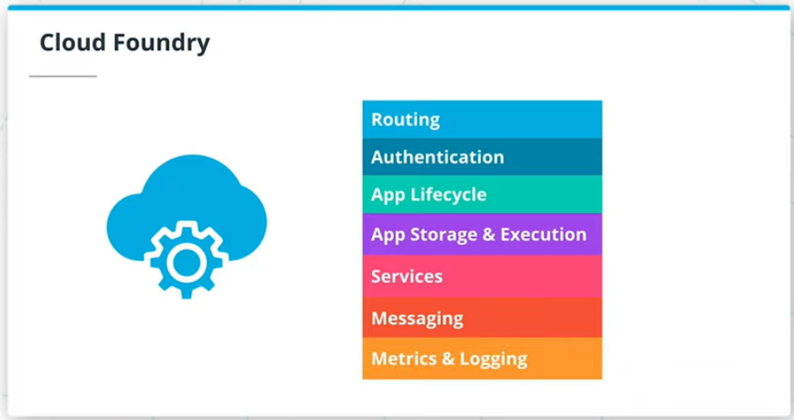

## Summary

Integrating PaaS solutions within an organization shifts the engineering effort from infrastructure management to product development. Additionally, it provides a powerful developer experience throughout the release process of an application, where the main functionalities are consumed through a UI or console. However, there is one major downside with this offering: vendor and application catalog lock-in. If an application is deployed using a PaaS offering from GCP, the application catalog of external services is narrowed down to GCP services mainly. Consequently, the open-source fundamentals were applied to PaaS offerings, resulting in an open-source PaaS such as **Cloud Foundry**.

Cloud Foundry is an open-source PaaS, a stand-alone software package that can be installed on any available infrastructure; private, public, or hybrid cloud. Due to its open-source nature, there is no vendor lock-in and the community can contribute to its future releases and definition of the roadmap. As such, Cloud Foundry offers a production-grade release process through a solid developer experience, that enables any application to be deployed with ease.

Note: some offerings of Cloud Foundry, can be deployed on top of Kubernetes, meaning that its main components are running as pods within a cluster.

Cloud Foundry consists of multiple components that provide these core capabilities:

* **Routing** - handle the incoming external traffic and route it to applications
* **Authentication** - identity management to user accounts
* **Application lifecycle** - controls the application deployments, monitors their status, and reconciles any new changes to reach the desired state of the application.
* **Application storage and execution** - handle the availability of artifacts to applications
* **Service** - use service brokers to provisions on-demand the dependency services for an application, such as a database or third-party APIs
* **Messaging** - ensure the communication between Cloud Foundry components
* **Metrics and logging** - aggregates the system and application metrics and logs

In the following sections, we will explore Cloud Foundry using [SUSE Cloud Application Platform Developer Sandbox](https://developer.suse.com/capsandbox/). However, you can explore Cloud Foundry's functionalities using the following offerings as well:

* [IBM Cloud Foundry](https://www.ibm.com/cloud/cloud-foundry)
* [SAP Cloud Platform](https://www.sap.com/products/cloud-platform/get-started.html)
* [Anynines](https://paas.anynines.com/)

## Could Foundry Walkthrough - Part 1

Let's explore the release of an application using Cloud Foundry!

**Note:** The walkthrough demos aim to highlight the simplified developer experience to release an application without the need to manage infrastructure components. Learning and understanding each Cloud Foundry functionality and implementation details is **not** an objective for this course.

## Summary

This demo showcases the main capabilities of the Stratos console and Cloud Foundry.

Some of the noteworthy sections are:

* Marketplace and Services - research the service catalog and explore any integrated services
* Organizations - used to manage multi-tenancy, quotas, and access to applications
* Routes - list all available endpoints used to access deployed applications
* Build Packs - explore available buildpacks packages used to build an application
* Security groups - configure the endpoints that the application can communicate with

## Could Foundry Walkthrough - Part 2

Note: This demo references the [Python hello-world](https://github.com/udacity/nd064_course_1_cloud_foundry) application.

## Summary

This demo provides a step-by-step guide on how to deploy a simple Python hello-world application to Cloud Foundry.

Noteworthy steps in this demo:

* [Python hello-world](https://github.com/udacity/nd064_course_1_cloud_foundry) is a simple Flask application, serving on port 8080
* Cloud Foundry can use a [manifest.yml](https://github.com/udacity/nd064_course_1_cloud_foundry/blob/main/manifest.yml) file to store the configuration of the application, such as name and quotas
* Routes are used to access the application and can be configured or created randomly

## Further Reading

Explore Cloud Foundry and the Stratos Console in more detail:

* [Cloud Foundry Overview](https://docs.cloudfoundry.org/concepts/overview.html)
* [Introduction to Stratos](https://gettingstarted.cap.explore.suse.dev/stratos/)
* [Cloud Foundry: Deploying with App Manifests](https://docs.cloudfoundry.org/devguide/deploy-apps/manifest.html)
* [Moving a Cloud Foundry Hello World App to Kubernetes - how hard can it be?](https://www.suse.com/c/moving-a-cloud-foundry-hello-world-app-to-kubernetes-src/)

# Quizzes: Cloud Foundry

### QUESTION 1 OF 4

Why an engineering team can avoid vendor lock-in by using Cloud Foundry?

* Cloud Foundry is an open-source PaaS
* 

Cloud Foundry can be deployed only on Kubernetes

* 

Cloud Foundry simplifies developer experience when deploying an application

* Cloud Foundry can be deployed on top of existing cloud providers

SUBMIT

### QUESTION 2 OF 4

Cloud Foundry offers **services** as part of its core functionalities. It will use service brokers to provision on-demand the dependency services for an application. What kind of dependency services does it cover?

* Third-party APIs
* 

Logs

* Databases
* 

Metrics

SUBMIT

### QUESTION 3 OF 4

Which of the following sources you can use to deploy an application using Cloud Foundry?

* Public GitHub repository
* Docker image
* Public GitLab repository
* Upload source code directly

SUBMIT

### QUESTION 4 OF 4

True or False: Cloud Foundry provides routing to applications from external users.

* True
* 

False

SUBMIT

NEXT

# Exercise: Cloud Foundry

So far, you have been exposed to two ways of deploying an application: using a PaaS solution such as Cloud Foundry and using Kubernetes resources. However, both mechanism allows for a variable level of configuration flexibility and abstractions of infrastructure components.

Imagine the following scenario: you are part of the team that needs to assess the benefits and drawbacks of using Cloud Foundry versus Kubernetes.

Considering that the application code is available, reflect on what operations and steps are necessary to adopt each solution (Cloud Foundry and Kubernetes) for a successful application deployment. What are the main drawbacks of each solution?

## Reflect on Cloud Foundry versus Kubernetes adoption - part 1

What are the steps to adopt Kubernetes for a successful application deployment?

### Your reflection

**1) Dockerize the application (Using Docker to create a container). 2) Create a kubernetes cluster. 3) Configure the cluster. (kubeconfig file). 4) Use kubernetes resources to configure aditional characteristics and services. 5) Declare a yaml manifest. 6) Deploy the application.**

### Things to think about

Go to the next solution page.

## Reflect on Cloud Foundry versus Kubernetes adoption - part 2

What are the steps to adopt Cloud Foundry for a successful application deployment?

### Your reflection

**1) Define the parameters of the application. 2) Deploy the application using Cloud Foundry.**

### Things to think about

Go to the solution page.

## Reflect on Cloud Foundry versus Kubernetes adoption - part 3

What are the main drawbacks of each solution?

### Your reflection

**CLOUD FOUNDRY DRAWBACKS: - Lock to a specific vendor. - Less control and less management capabilities over the way how the containers are orchestrated. KUBERNETES DRAWBACKS: - More efforts from the point of view of engineering. - The engineers cannot focus totally in the development of the applications.**

### Things to think about

Go to the solution page.

NEXT

# Solution: Cloud Foundry

It is pivotal to understand the application functionalities and available resources. This is especially the case when a microservice-based design is chosen, and solutions suck as IaaS (Infrastructure as a Service), PaaS (Platform as a Service), SaaS (Software as a Service) are available from a multitude of vendors. Choosing the most suitable deployment tooling will lead to the efficient delivery of the product.

Considering that the application code is available, these are the steps to adopt each proposed solution:

* **Kubernetes**
  + create an OCI (Open Container Initiative) compliant image, usually created by using Docker
  + deploy a Kubernetes cluster with a valid ingress controller for the routing of requests
  + deploy an observability stack, including logs and metrics
  + create the YAML manifests for the application deployment
  + create a CI/CD pipeline to push the Kubernetes resources to the cluster
* **Cloud Foundry**
  + write a manifest file to provide main application deployment parameters
  + deploy Cloud Foundry or use Cloud Foundry PaaS solutions from 3rd part vendors
  + deploy the application to Cloud Foundry (via CLI or UI)
  + ***Note:*** Cloud Foundry will create the OCI compliant image by default, and it will provide the routing capacities as well.

Cloud Foundry provides a better developer experience for application deployment, as it offers a greater level of component abstraction (no need to manage the underlying infrastructure). However, a PaaS solution locks-in the customer to a specific vendor. On the other side, Kubernetes offers full control over the container orchestration, providing more flexible management of the application.

# Edge Case: Function as a Service

## Summary

An organization will always explore the most efficient offering to deploy a product to consumers. PaaS solutions are lightweight on initial setup, as a team can release the code in production within days.

However, there are use cases where customers interact with a service only once a day or for a couple of hours within a day. For example, a service to update a timetable with the new bus schedule once a day. In this case, using a PaaS offering has one major downside: it is not cost-efficient. For example, with Cloud Foundry there will always be an instance of the application up and running, even if the service is used once a day. However, the team is billed for a full day.

For this scenario, a **FaaS** or **Function as a Service** is a more suitable offering. FaaS is an event-driven cloud-computing service that allows the execution of code without any management of the infrastructure and configuration files. As a result, the timetable update service is invoked only once a day, and for the rest of the time, there are no replicas of this service. A team will be billed only for the time the service is executed.

Popular FaaS solutions are AWS Lambda, Azure Functions, Cloud Functions from GCP, and many more.

Throughout the release process, a FaaS solution only requires the application code that is built and executed immediately. In comparison with a PaaS offering, this FaaS has a quicker usability rate, as no data management or configuration files are necessary.

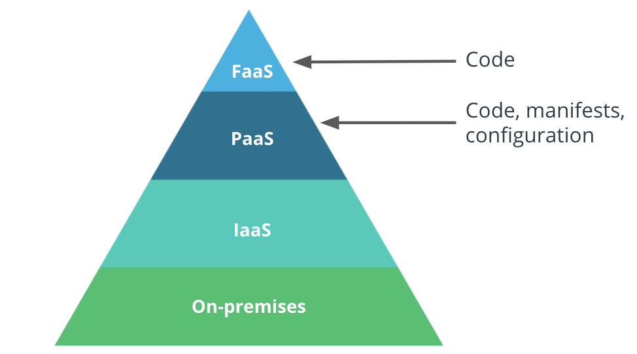

FaaS dependencies to deploy an application

## New Terms

* **FaaS** or **Function as a Service** - event-driven cloud-computing service that requires only the application code to execute successfully.

## Further Reading

Explore FaaS in more detail:

* [What is Function-as-a-Service (FaaS)?](https://www.redhat.com/en/topics/cloud-native-apps/what-is-faas?source=searchresultlisting)

# Exercise: Function as a Service

FaaS (Function as a service) unlocks the ability to solely focus on building an application with no concerns for the underlying infrastructure. However, it is crucial to comprehend its usage within a microservice-based design.

Imagine the following scenario: you are working for a media (newspaper) company and was assigned to develop a microservice responsible for the life-cycle of customer accounts. **The principal operations include account creation and deletion.**

Considering the above, reflect on what mechanisms you would choose to deploy the microservice, PaaS, or FaaS. Elaborate on your reasoning.

## Solution for a microservice

What mechanism would you choose to deploy the customer account management microservice? Explain your reasoning.

### Your reflection

**I would use a FaaS solution. Because I consider that the biggest task in a platform like a newspaper is the creation of content and this service is the one that most interests the users of the platform. I think the microservice of creating and deleting accounts is event-driven. That is to say that the code will only run when users decide to click on the option to create or close an account and for that reason a FaaS is an excellent solution for this scenario.**

### Things to think about

Well done! Go to the solution page.

NEXT

# Solution: Function as a Service

For this particular exercise, choosing either a PaaS or FaaS would reach the end goal: making the service available to customers.

In most cases, in a newspaper context, the readers are more focused on the news content rather than managing their accounts. Also, the number of requests to get an article can be a thousandfold higher than the number of requests to create or delete an account. As such, you can assume that the microservice should not be running at all times consuming available resources, and instead invoke it on demand-only.

Conclusively, a FaaS solution would be more suitable for the management of customer account microservice.

# Lesson Conclusion

**Summary**

Throughout its evolution, an organization needs to periodically evaluate available cloud-computing services, to ensure that the business requirements are always fulfilled. The industry has an abundance of cloud-computing offerings, such as on-premise, IaaS, PaaS, and FaaS, with a rich collection of open-source and vendor managed tools. In this lesson, we analyzed Cloud Foundry, an open-source PaaS, that can be hosted on any available compute and provide a unified and powerful end-user experience. We have also explored, FaaS an event-driven offering, that increases the cost-efficiency of a platform.

Overall, throughout this lesson we explored:

* PaaS Mechanisms
* Cloud Foundry
* Function as a Service

**Glossary**

* **On-premise** - cloud-computing service, where a team owns the entire technology stack.
* **IaaS** or **Infrastructure as a Service** - cloud-computing service that offers the abstraction of networking, storage, server, and virtualization layers.
* **PaaS** or **Platform as a Service** - cloud-computing service, where the infrastructure components are managed fully by a 3rd party provider, and a team manages only the application and the data associated with it.
* **Cloud Foundry**- an open-source PaaS offering, that can be hosted on any available infrastructure
* **FaaS** or **Function as a Service** - event-driven cloud-computing service that requires only the application code to execute successfully.

**LESSON 5 CI/CD WITH CLOUD NATIVE TOOLING**

**INTRODUCTION**

Welcome to the Cloud Native CI/CD lesson!

Once a team has built a product and has structured a release process onto the platform, the next phase is to bring automation. A release process should enable a team to deliver new features to consumers, and it should be highly automated to eliminate misconfiguration scenarios. These functionalities are encapsulated by a CI/CD pipeline, for continuous integration and delivery of the new code changes.

In this lesson, we will explore how to use cloud-native tooling to construct a CI/CD pipeline. As well, we will explore template configuration managers, such as Helm to enable the easy deployment of an application to multiple clusters.

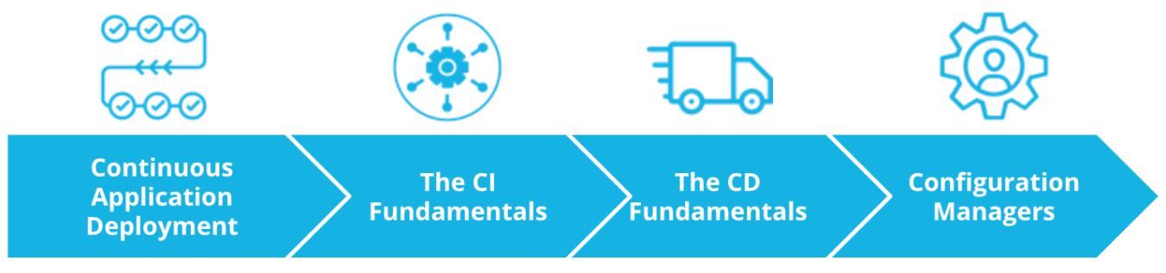

Cloud Native CI/CD lesson outline

Overall, in this lesson we will explore:

* Continuous Application Deployment
* The CI Fundamentals
* The CD Fundamentals
* Configuration Managers

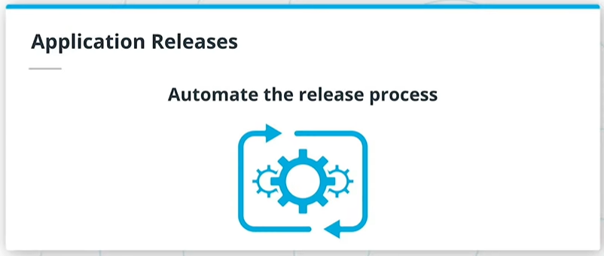

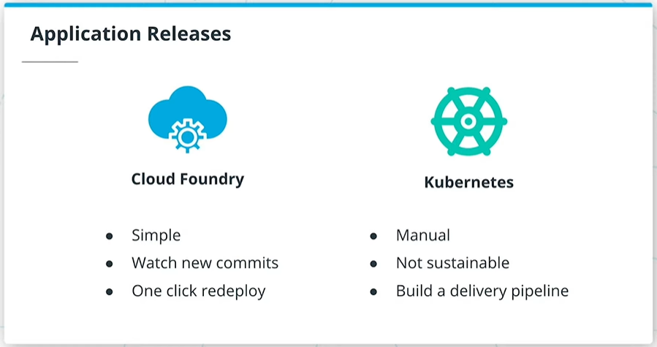

# Big Picture: Application Releases

## Summary

Up to this stage, we have practiced the packaging of an application using Docker and its deployment to a Kubernetes cluster using kubectl commands. As well, we have explored the simplified developer experience of application release with Cloud Foundry. However, in both cases, a user has to manually trigger and complete all the operations. This is not sustainable if tens and hundreds of releases are performed within a day. Automation of the release process is fundamental!

In the case of a PaaS offering, the release of a new feature is managed by the provider. For example, Cloud Foundry monitors the repository with the source code, and when a new commit is identified, the user can easily deploy the latest changes with a click of a button. On the other side, releasing an application to a Kubernetes cluster consists of a series of manually typed docker and kubectl commands. At this stage, this approach has no automation integrated.

In this lesson, we will not cover how a PaaS automates the release process, since this is already solutionized by the 3rd party providers. Instead, we will focus on building a delivery pipeline to automate the deployment to Kubernetes using cloud-native tooling.

# Continuous Application Deployment

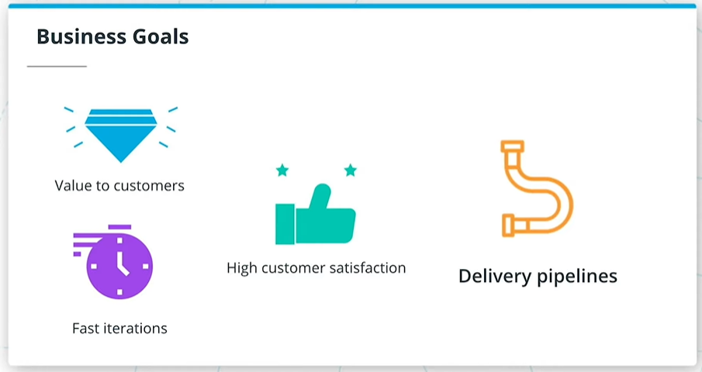

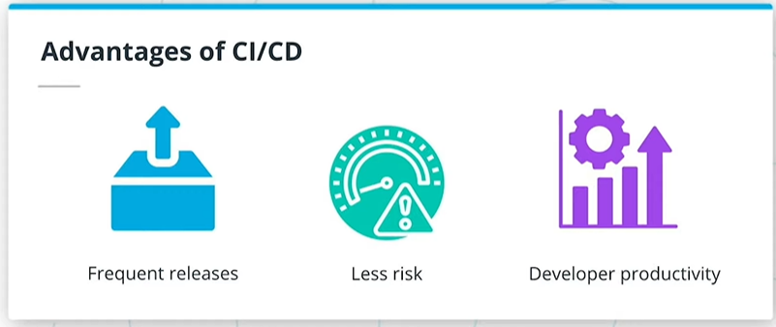

## Summary

Every company has the same goal: to deliver value to customers and maintain customer satisfaction. To achieve this, an organization needs to be fast in integrating customer feedback and release new features.

It is possible to manually deploy every release for a small product. However, this is not viable for a product that has thousands of microservices developed by hundreds of engineers. A delivery pipeline is essential for continuous and automated deployment of new functionalities.

A delivery pipeline includes stages that can test, validate, package, and push new features to a production environment. It is common practice for the main branch commits to proceed through all stages of the pipeline to reach the end-users. Overall, a delivery pipeline is triggered when a new commit is available. The new changes should traverse the following stages:

* **Build** - compile the application source code and its dependencies. If this stage fails the developer should address it immediately as there might be missing dependencies or errors in the code.
* **Test** - run a suite of tests, such as unit testing, integration, UI, smoke, or security tests. These tests aim to validate the behavior of the code. If this stage fails, then developers must correct it to prevent dysfunctional code from reaching the end-users.
* **Package** - create an executable that contains the latest code and its dependencies. This is a runnable instance of the application that can be deployed to end-users.
* **Deploy** - push the packaged application to one or more environments, such as sandbox, staging, and production. Usually, the sandbox and staging deployments are automatic, and the production deployment requires engineering validation and triggering.

It is common practice to push an application through multiple environments before it reaches the end-users. Usually, these are categorized as follows:

* Sandbox - development environment, where new changes can be tested with minimal risk.
* Staging - an environment identical to production, and where a release can be simulated without affecting the end-user experience.
* Production - customer-facing environment and any changes in this environment will affect the customer experience.

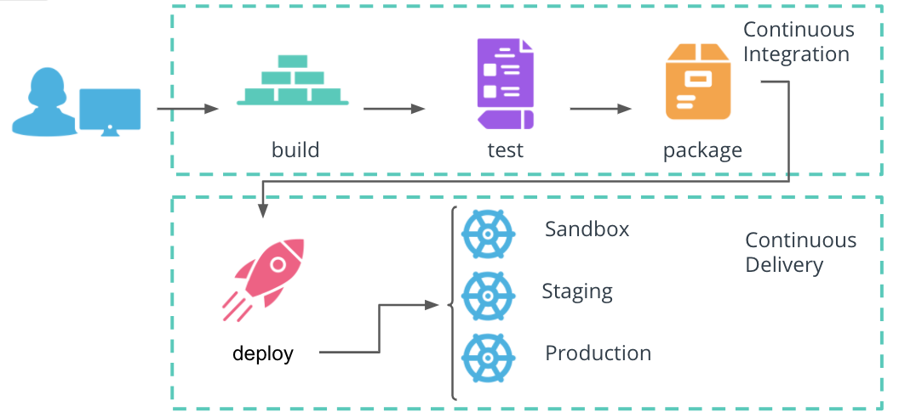

Continuous Deployment pipeline

Overall, a delivery pipeline consists of two phases:

* **Continuous Integration** (or CI) includes the **build**, **test**, and **package** stages.
* **Continuous Delivery** (or CD) handles the **deploy** stage.

#### Advantages of a CI/CD pipeline

* Frequent releases - automation enables engineers to ship new code as soon as it's available and improves responsiveness to customer feedback.
* Less risk - automation of releases eliminates the need for manual intervention and configuration.
* Developer productivity - a structured release process allows every product to be released independently of other components

## New Terms

* **Continuous Integration** - a mechanism that produces the package of an application that can be deployed.
* **Continuous Delivery** - a mechanism to push the packaged application through multiple environments, including production.
* **Continuous Deployment** - a procedure that contains the Continuous Integration and Continuous Delivery of a product.

## Further Reading

Explore the CI/CD mechanism in more detail:

* [CI/CD: Continuous Integration & Delivery Explained](https://semaphoreci.com/cicd)
* [What’s the Difference Between Continuous Integration, Continuous Deployment and Continuous Delivery?](https://semaphoreci.com/blog/2017/07/27/what-is-the-difference-between-continuous-integration-continuous-deployment-and-continuous-delivery.html)

# Quizzes: Continuous Application Deployment

### QUESTION 1 OF 3

What stages are covered by Continuous Integration?

* Build
* 

Deploy

* Test
* Package

SUBMIT

### QUESTION 2 OF 3

What are the main advantages of using a CI/CD pipeline?

* Frequent releases
* Developer productivity
* 

Higher revenue

* Less risk

SUBMIT

### QUESTION 3 OF 3

What stages are covered by Continuous Delivery?

* 

Test

* 

Package

* Deploy
* 

Build

SUBMIT

NEXT

# The CI Fundamentals

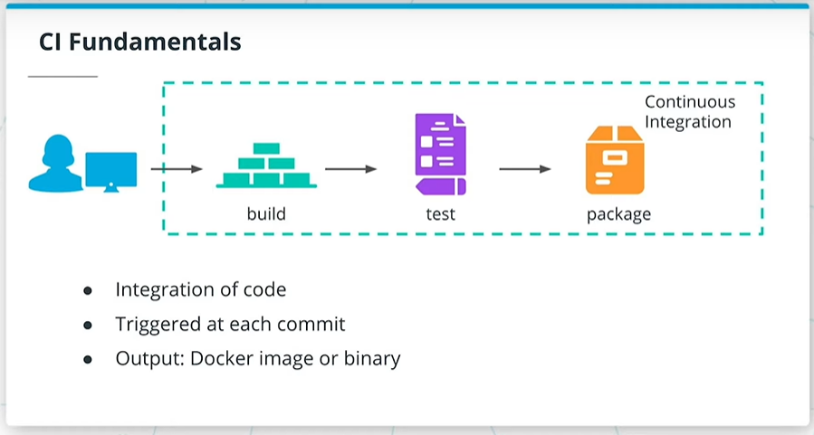

## Summary

Continuous Integration (CI) is a mechanism that produces the package of an application that can be deployed to consumers. As such, every commit to the main branch is built, tested, and packaged, if it meets the expected behavior. Within the cloud-native, the result of Continuous Integration represents a Docker image or an artifact that is OCI compliant.

Let's explore the commands and tools associated with each Continuous Integration stage!

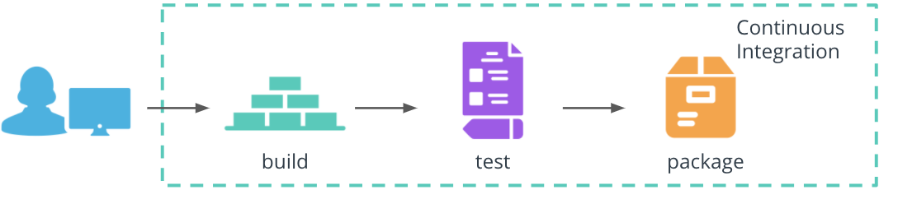

Continuous Integration stages

#### Build

The build stage compiles the application source code and associated dependencies. We have explored this stage as part of the Dockerfile. For example, the Dockerfile for the Python hello-world application instructed the installation of dependencies from requirements.txt file and execution of the app.py at the container start.

*# use pip to install any application dependencies*

RUN pip install -r requirements.txt

*# execute command on the container start*

CMD [ "python", "app.py" ]

#### Test

The technology landscape provides an abundance of frameworks, libraries, and tools to test and validate the behavior of an application. For Python application, some of the well-known frameworks are:

* [pytest](https://docs.pytest.org/en/stable/) - for functional testing of the application
* [pylint](https://pypi.org/project/pylint/) - for static code analysts of the application codebase

#### Package

The result of the package stage is an executable that contains the latest features and their dependencies. With Docker, this stage is implemented using docker build and docker push commands. These create a Docker image using a Dockerfile, and stores the image to a registry, such as DockerHub. For example, to create and store the image for Python hello-world application, the following commands are used:

*# build an image using a Dockerfile*

docker build -t python-helloworld .

*# store and distribute an image using DockerHub*

docker push pixelpotato/python-helloworld:v1.0.0

Note: Buildbacks does not require a Dockerfile to create an OCI compliant image or artifact.

## Github Actions

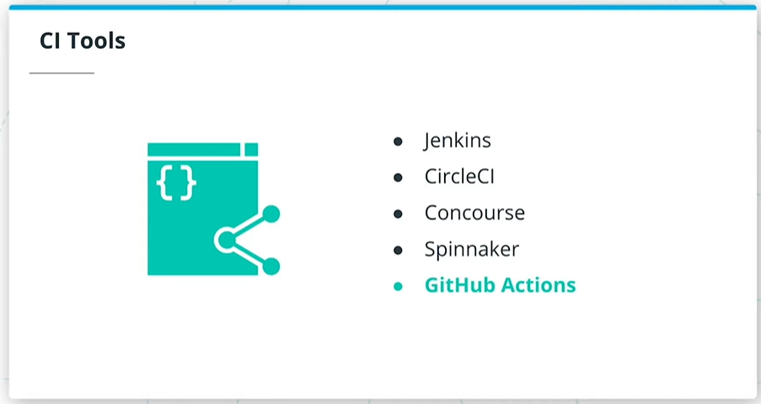

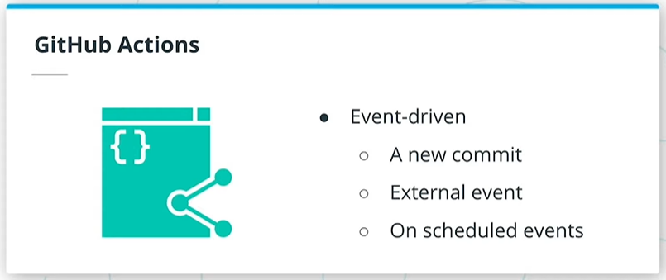

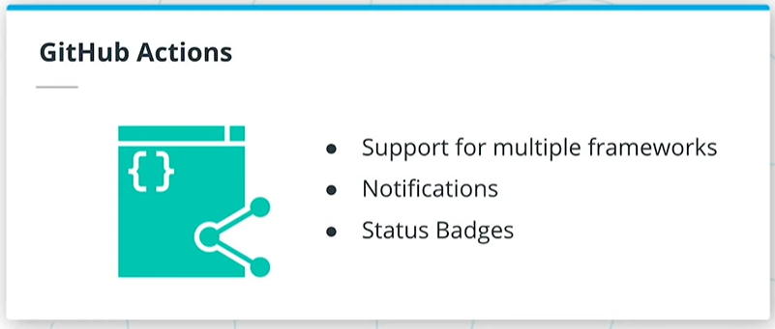

## Summary

There are plenty of tools that automate the Continuous Integration stages, such as Jenkins, CircleCI, Concourse, and Spinnaker. However, in this lesson, we will explore GitHub Actions to build, test, and package an application.

GitHub Actions are event-driven workflows that can be executed when a new commit is available, on external or scheduled events. These can be easily integrated within any repository and provide immediate feedback if a new commit passes the quality check. Additionally, GitHub Actions are supported for multiple programming languages and can offer tailored notifications (e.g. in Slack) and status badges for a project.

A GitHub Action consists of one or more jobs. A job contains a sequence of steps that execute standalone commands, known as actions. When an event occurs, the GitHub Action is triggered and executes the sequence of commands to perform an operation, such as code build or test.

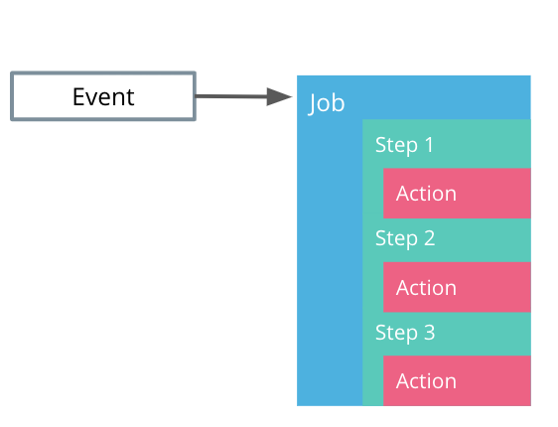

GitHub Actions structure

Let's configure a GitHub Action that prints the Python version!

GitHub Actions are configured using YAML syntax, hence uses the .yaml or .yml file extensions. These files are stored in .github/workflows directory within the code repository. Within this folder, the python-version.yml contains the following sections:

## file location and name: # .github/workflows/python-version.yml

## Named of the workflow.

name: Python version

## Set the trigger policy.

## In this case, the workflow is execute on a `push` event,

## or when a new commit is pushed to the repository

on: [push]

## List the steps to be executed by the workflow

jobs:

## Set the name of the job

check-python-version:

## Configure the operating system the workflow should run on.

## In this case, the job on Ubuntu

runs-on: ubuntu-latest

## Define a sequence of steps to be executed

steps:

## Use the public `checkout` action in version v2

## to checkout the existing code in the repository

- uses: actions/checkout@v2

## Use the public `setup-python` action in version v2

## to install python on the Ubuntu based environment

- uses: actions/setup-python@v2

## Executes the `python --version` command

- run: python --version

On the successful execution of the workflow, the Python version is printed. For example, Python 3.9.0.

## Github Actions Walkthrough

Note: To follow this demo make sure you fork the [course repository](https://github.com/udacity/nd064_course_1) and reference the [python-helloworld application](https://github.com/udacity/nd064_course_1/tree/main/solutions/python-helloworld).

This demo provides a step-by-step guide of how to write a GitHub Action to run a suite of pytests.

Pytest is a framework that is used to write functional testing for an application. In this example, within the [test_with_pytest.py](https://github.com/udacity/nd064_course_1/blob/main/solutions/python-helloworld/test_with_pytest.py) we create a mock test that will always execute successfully.

## Summary

*## Define a test that will always pass successfully*

**def** **test_always_passes**():

**assert** **True**

Once we have completed writing the test, we can construct a GitHub Action that will execute the tests using pytest tool. For this purpose, a new workflow is defined in the [pytest.yml file](https://github.com/udacity/nd064_course_1/blob/main/.github/workflows/pytest.yml) within the .github/workflows directory.

To trigger the workflow a new commit is necessary (e.g. editing the README.md fie). On the successful execution of the GitHub Action, we should see an output mentioning that all the test passed successfully (as expected):

Run pytest

============================= test session starts ==============================

platform linux -- Python 3.8.6, pytest-6.2.1, py-1.10.0, pluggy-0.13.1

rootdir: /home/runner/work/nd064_course_1/nd064_course_1

collected 1 item

solutions/python-helloworld/test_with_pytest.py . [100%]

============================== 1 passed **in** 0.02s ===============================

Also, this demo showcases the "Python version" GitHub Action that was used as an example in the slides.

## Further reading

Explore GitHub Actions in more detail:

* [Introduction to GitHub Actions](https://docs.github.com/en/free-pro-team@latest/actions/learn-github-actions/introduction-to-github-actions)
* [Create an example workflow](https://docs.github.com/en/free-pro-team@latest/actions/learn-github-actions/introduction-to-github-actions#create-an-example-workflow)
* Inspect public workflows on [GitHub Marketplace](https://github.com/marketplace?type=actions)

# Quizzes: The CI Fundamentals

### QUESTION 1 OF 3

You are provided with a Python front-end application. Match each Continuous Integration stage with the commands used to implement the expected operations.

### ***Submit to check your answer choices!***

**STAGES**

**COMMANDS**

Run tests using Python testing frameworks

pytest

Install application dependencies

RUN pip install -r requirements.txt

Build the image of the application

docker build -t python-frontend .

Store the Docker image in a registry

docker push pixelpotato/python-frontend:v4.3.8

SUBMIT

### QUESTION 2 OF 3

What are the characteristics of a typical Continuous Integration implementation?

* Triggered at each commit
* 

The output is always a Docker image

* 

It is only used to test the code

* The output can be an OCI compliant image

SUBMIT

### QUESTION 3 OF 3

What is the most suitable characteristic for **GitHub Actions**?

* 

Can execute only 1 task

* Event-driven workflows
* 

Is limited to run for Python applications

SUBMIT

NEXT

# Exercise: Continuous Application Deployment

Continuous Integration (CI) implies the integration of code into a shared repository, where at each push to the main branch, the code is built and tested. Frequently, the result of CI represents an artifact or a Docker image.

In this exercise, you will use GitHub Actions to automate the packaging of an application. This is a quite challenging exercise because you are provided with all the necessary documents and you will explore some of the actions on your own.

Being able to explore documents and tackle tasks independently is important. Take this opportunity and have fun! However, if you do need some help, feel free to check out the video on the solution page.

### **Environment Setup**

Prepare the GitHub repository and application to test GitHub actions:

Task List

* 

Create a new GitHub repository with the name python-helloworld

* 

Copy the python-helloworld application from the [course repository](https://github.com/udacity/nd064_course_1/tree/main/solutions/lesson1).

* 

Create the repository to store the GitHub Actions using mkdir -p /.github/workflows command

# Exercise

Create a new GitHub Actions in the /.github/workflows/docker-build.yml that will build and push the Docker image for a [Python web application](https://github.com/udacity/nd064_course_1/tree/main/exercises/python-helloworld), with the following requirements:

* Image name: python-helloworld
* Tag: latest
* Platforms: platforms: linux/amd64,linux/arm64

GitHub marketplace has a rich suite of upstream actions that can be easily integrated within a repository. One of the upstream action is [Build and Push Docker images](https://github.com/marketplace/actions/build-and-push-docker-images), which can be used to implement the required CI task.

The above GitHub action uses DockerHub Tokens and encrypted GitHub secrets to login into DockerHub and to push new images. To set up these credentials refer to the following resources:

* Create [DockerHub Tokens](https://www.docker.com/blog/docker-hub-new-personal-access-tokens/)
* Create [GitHub encrypted secrets](https://docs.github.com/en/free-pro-team@latest/actions/reference/encrypted-secrets)

**Note**: you will need a **Dockerfile** to build the image.

# Solution: The CI Fundamentals

GitHub has a rich library of upstream actions that can be easily integrated with any repository. The suite includes a [Build and push Docker images](https://github.com/marketplace/actions/build-and-push-docker-images) action which uses 3 main components:

* **login** - to logging into DockerHub
* **setup-buildx** - to use an extended Docker CLI build capabilities
* **setup-qemu** - to enable the execution of different multi-architecture containers

The following snippet showcases the Docker build and push of the application, under .github/workflows/docker-build.yaml file:

# This is a basic workflow to help you get started with Actions

name: Docker Build and Push

# Controls when the action will run. Triggers the workflow on push or pull request

# events but only for the master branch

on:

push:

branches: [ master ]

pull_request:

branches: [ master ]

# A workflow run is made up of one or more jobs that can run sequentially or in parallel

jobs:

# This workflow contains a single job called "build"

build:

# The type of runner that the job will run on

runs-on: ubuntu-latest

# Steps represent a sequence of tasks that will be executed as part of the job

steps:

-

name: Checkout

uses: actions/checkout@v2

-

name: Set up QEMU

uses: docker/setup-qemu-action@v1

-

name: Set up Docker Buildx

uses: docker/setup-buildx-action@v1

-

name: Login to DockerHub

uses: docker/login-action@v1

with:

username: ${{ secrets.DOCKERHUB_USERNAME }}

password: ${{ secrets.DOCKERHUB_TOKEN }}

-

name: Build and push

uses: docker/build-push-action@v2

with:

context: .

file: ./Dockerfile

platforms: linux/amd64

push: true

tags: {{ YOUR_DOCKERHUB_REPOSITORY }}/python-helloworld:latest

The Docker build and push workflow can be found in [course repository](https://github.com/udacity/nd064_course_1/blob/main/solutions/github-actions/docker-build.yml). Make sure to move this file to .github/workflows/docker-build.yaml location to execute it.

# The CD Fundamentals

## Summary

Once an engineering team has automated the packaging of an application, the next phase is to release it to customers. Before the application is pushed to a production environment, it is important to check the functionality of an application when deployed and integrated with platform components. Only when the application meets the excepted behavior, it is deployed to a customer-facing environment. The process of propagating an application through multiple environments, until it reached the end-users, is known as the **Continuous Delivery** (or CD) stage.

It is common practice to push the code through at least 3 environments: sandbox, staging, and production. A reminder of each environment's purpose :

* Sandbox - development environment, where new changes can be tested with minimal risk.
* Staging - an environment identical to production, and where a release can be simulated without affecting the end-user experience.
* Production - customer-facing environment and any changes in this environment will affect the customer experience.

The sandbox and staging environments are fully automated. As such, if the deployment to sandbox is successful and meets the expected behavior, then the code will be propagated to the staging automatically. However, the push to production requires engineering validation and triggering, as this is the environment that the end-users will interact with. The production deployment can be fully automated, however, doing so implies a high confidence rate that the code will not introduce customer-facing disruptions.

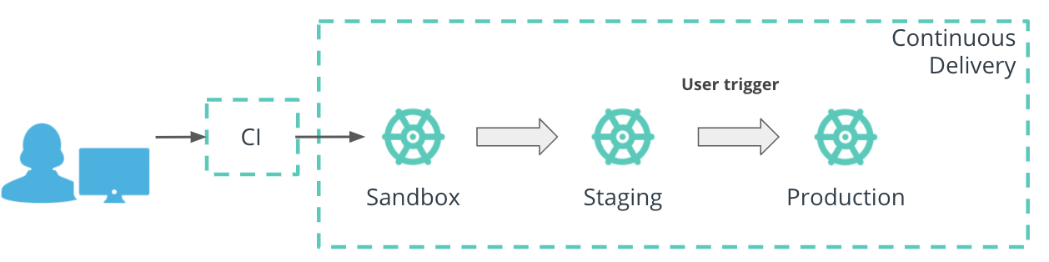

Continuous Delivery stages

Within the deployment pipeline, Continuous Delivery covers the **deploy** stage. Throughout this course, we have practiced the deployment of an application while using kubectl commands.

Kubernetes CLI (kubectl), support the management of imperative and declarative configuration. With the imperative approach, a Python hello-world application is deployed by creating a Deployment resource and referencing the desired Docker image:

*# deploy `python-helloworld` using the imperative approach*

kubectl create deploy python-helloworld --image=pixelpotato/python-helloworld:v1.0.0

On the other side, with the declarative approach, the Python hello-world Deployment is store in a YAML manifest and is created using the kubectl apply command:

*# deploy `python-helloworld` using the declarative approach*

kubectl apply -f deployment.yaml

Note: The declarative approach is the recommended way to deploy resources within a production environment. Hence, this configuration management technique will be referenced in the next sections.

## Argo CD

## Summary

The ecosystem is rich in the collection of tools that automate the Continuous Delivery stage, such as Jenkins, CircleCI, Concourse, and Spinnaker. However, in this lesson, we will explore ArgoCD to propagate an application to multiple Kubernetes clusters.

ArgoCD is a declarative Continuous Delivery tool for Kubernetes, which follows the GitOps patterns. As such, ArgoCD operates on configuration stored in manifests (declarative) and uses Git repositories as the source of truth for the desired state of an application (GitOps pattern). As such, ArgoCD monitors the new commits to Git repositories and applies the latest changes reconciled automatically or on a manual trigger. Additionally, ArgoCD offers deployment to target environments and multiple clusters, and support for multiple config management tools (such as plain YAML, Helm, Kustomize).

For application deployment through multiple environments, ArgoCD provides CRDs (Custom Resource Definitions) to configure and manage the application release.

#### Project resource

The **Project** resource is a CRD that provides a logical grouping of applications, including access to source and destination repositories, and permissions to resources within the cluster. This resource is handy to segregate and control the deployment to multiple clusters.

#### Application resource

The **Application** resource that stores the configuration of how an application should be deployed and managed.  
Let's explore how a Python hello-world application is deployed using an ArgoCD Application resource: Note: It is assumed that the declarative manifests for Python hello-world are available ((e.g. deploy.yaml, service.yaml, etc).

## API endpoint used to create the Application resource

apiVersion: argoproj.io/v1alpha1

kind: Application

## Set the name of the resource and namespace where it should be deployed.

## In this case the Application resource name is set to `python-helloworld `

## and it is deployed in the `argocd` namespace

metadata:

name: python-helloworld

namespace: argocd

spec:

## Set the target cluster and namespace to deploy the Python hello-world application.

## For example, the Python hello-world application is deployed in the `default` namespace

## within the local cluster or `https://kubernetes.default.svc`

destination:

namespace: default

server: https://kubernetes.default.svc

## Set the project the application belongs to.

## In this case the `default` project is used.

project: default

## Define the source of the Python hello-world application manifests.

## In this example, the manifests are stored in the `argocd-demo` repository

## under the `python-manifests` folder. Additionally, the latest commit within

## the repository is targeted or `HEAD`.

source:

path: python-manifests

repoURL:

https://github.com/kgamanji/argocd-demo

targetRevision: HEAD

# # Set the sync policy.

## If left empty, the sync policy will default to manual.

syncPolicy: {}

#### App of Apps

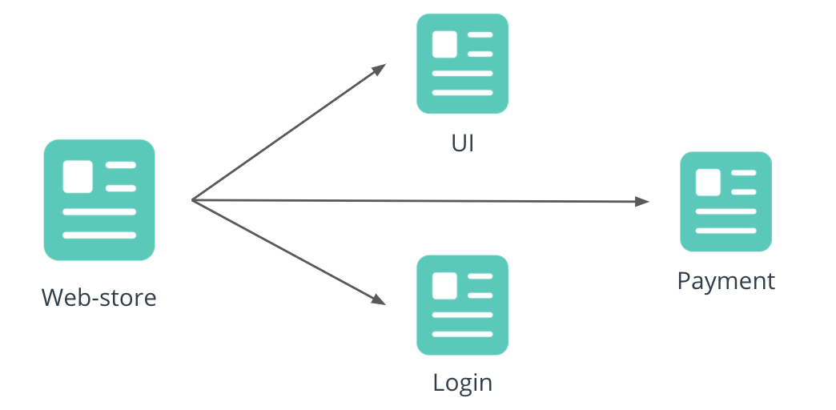

App of Apps: manage the Application CRDs for multiple microservices with a single Application CRD

ArgoCD provides an “app-of-apps” technique that enables a group of applications to be deployed and configured together. This technique is useful if a product is developed using a microservice-based architecture, and a single point of orchestration is necessary to deploy all microservices. For example, a Web-store Application CRD can be used to manage the Application CRDs for the UI, Login, and Payment units. In this case, one point of control is provisioned to release and manage multiple microservices.

## New Terms

* **GitOps** - an operating model that refers to the Git repositories as the source of truth for declarative infrastructure and applications.

## Further Reading

Explore the GitOps pattern and ArgoCD resources:

* [A Guide To GitOps](https://www.weave.works/technologies/gitops/)
* [ArgoCD Project CRD](https://argoproj.github.io/argo-cd/operator-manual/declarative-setup/#projects)
* [ArgoCD Application CRD](https://argoproj.github.io/argo-cd/operator-manual/declarative-setup/#applications)

NEXT

# ArgoCD Walkthrough

## Installation

## Summary

This demo is a walkthrough of the process of installing and accessing ArgoCD.

Here are some noteworthy steps:

* Use the official ArgoCD [install](https://argoproj.github.io/argo-cd/getting_started/#1-install-argo-cd) page
* The YAML manifest for the NodePort service can be found under the [argocd-server-nodeport.yaml file](https://github.com/udacity/nd064_course_1/blob/main/solutions/argocd/argocd-server-nodeport.yaml) in the course repository
* Access the ArgoCD UI by going to https://192.168.50.4:30008 or http://192.168.50.4:30007
* When accessing the ArgoCD UI, a browser SSL warning is encountered. This is happening because the ArgoCD server is not setup with SSL certificates to authenticate the server. Hence, an insecure connection is established with the server. As a result, the warning prompt is encountered and you should just bypass the warning page
* Login credentials can be retrieved using the steps in the [credentials guide](https://argoproj.github.io/argo-cd/getting_started/#4-login-using-the-cli)

## Application Deployment

This demo provides a step by step guide on how to deploy an application using ArgoCD.

To follow the demo closely, use the following resources:

* [Python-manifests](https://github.com/udacity/nd064_course_1/tree/main/solutions/argocd/python-manifests) folder contains the YAML configuration for the Python hello-world application
* [argocd-python](https://github.com/udacity/nd064_course_1/blob/main/solutions/argocd/argocd-python.yaml) manifest for the Application CRD to used to deploy the Python hello-world application

# Quizzes: The CD Fundamentals

### QUESTION 1 OF 3

What are the characteristics of a typical Continuous Delivery implementation?

* 

Deploys only to sandbox

* 

Always requires a trigger to push to production

* Release to multiple environments
* Should be automatic and replicable

SUBMIT

### QUESTION 2 OF 3

You are provided with a Python front-end application and need to implement the Continuous Delivery stage. Match each command to a deployment approach in a Kubernetes cluster?

kubectl create service frontend

kubectl create \

configmap frontend --from-file=/etc/values

**DEPLOYMENT APPORACH**

**COMMAND**

Declarative

kubectl apply -f frontend-deploy.yaml

Imperative

kubectl create deploy python-frontend \

--image=pixelpotato/python-frontend:6.3.8

SUBMIT

### QUESTION 3 OF 3

Which statements are true based on the ArgoCD Application CRD snippet below?

source:

path: go-backend

repoURL: https://github.com/kgamanji/argocd-demo

targetRevision: HEAD

* 

It will deploys the c592293 commit

* It will deploy plain YAML manifests
* The manifests are stored under argocd-demo/go-backend folder
* 

The manifests are stored under go-backend/argocd-demo folder

SUBMIT

NEXT

# Exercise: The CD Fundamentals

Continuous Delivery (CD) is the ability to get code changes reliably to production environments. This practice should be automated and should enable developers to provide value to consumers efficiently.

In this exercise, you will use ArgoCD to automate the delivery of an application to a Kubernetes cluster.

### **Environment Setup**

Prepare the environment to create your delivery pipeline.

***Note:*** Make sure to have [*VirtualBox installed*](https://www.virtualbox.org/wiki/Downloads).

Task List

* 

Install [vagrant](https://www.vagrantup.com/) on your machine

* 

Examine the Vagrantfile in the [course repository](https://github.com/udacity/nd064_course_1/blob/main/exercises/Vagrantfile)

* 

Crete a vagrant box by using vagrant up command (Note: you need to be in the same repository as the Vagrantfile for this command to work)

* 

SSH into the vagrant box by using vagrant ssh command

* 

Deploy a Kubernetes cluster using [k3s](https://k3s.io/)

* 

Examine your cluster using kubectl command (Note: you need to be root to access the kubeconfig file, use sudo su - before using kubectl commands)

# Exercise

Now that you have a Kubernetes cluster up and running, let's deploy your first application using ArgoCD.

### **The CD fundamentals**

Install ArgoCD and deploy your first application

Task List

* 

Install ArgoCD by referring to the [installation guide](https://argoproj.github.io/argo-cd/getting_started/)

* 

Expose the argocd-server using a NodePort service on port 30007 on HTTP and 30008 on HTTPS. The YAML manifest for the NodePort service can be found in the [course repository](https://github.com/udacity/nd064_course_1/blob/main/solutions/argocd/argocd-server-nodeport.yaml)

* 

Access the ArgoCD UI by going to https://192.168.50.4:30008 or, https://192.168.50.4:30007 pass the warning and reach the Log-in page

* 

Insert login credentials, by using [credentials guide](https://argoproj.github.io/argo-cd/getting_started/#4-login-using-the-cli)

* 

Create an ArgoCD application named nginx-alpine and use the manifests provided in the [course repository](https://github.com/udacity/nd064_course_1/tree/main/exercises/manifests)

# Solution: The CD Fundamentals Exercise

ArgoCD is a Kubernetes-native tool that is capable of automating the life cycle management of application YAML manifests. With the GitOps model, configuration changes reconcile with minimal manual intervention, reaching an efficient deployment mechanism.

The following snippet highlights the commands to deploy ArgoCD and expose it using a NodePort service:

*# deploy ArgoCD*

kubectl create namespace argocd

kubectl apply -n argocd -f https://raw.githubusercontent.com/argoproj/argo-cd/stable/manifests/install.yaml

# Create the NodePort service for ArgoCD server by using the

# `kubectl apply -f argocd-server-nodeport.yaml` command

apiVersion: v1

kind: Service

metadata:

annotations:

labels:

app.kubernetes.io/component: server

app.kubernetes.io/name: argocd-server

app.kubernetes.io/part-of: argocd

name: argocd-server-nodeport

namespace: argocd

spec:

ports:

- name: http

port: 80

protocol: TCP

targetPort: 8080

nodePort: 30007

- name: https

port: 443

protocol: TCP

targetPort: 8080

nodePort: 30008

selector:

app.kubernetes.io/name: argocd-server

type: NodePort

The Nodeport service for ArgoCD can be found in the [course repository](https://github.com/udacity/nd064_course_1/blob/main/solutions/argocd/argocd-server-nodeport.yaml).

Once logged in to the ArgoCD server, applications can be created. The declarative manifest for nginx-alpine Application CRD can be found below:

apiVersion: argoproj.io/v1alpha1

kind: Application

metadata:

name: nginx-alpine

namespace: argocd

spec:

destination:

namespace: default

server: https://kubernetes.default.svc

project: default

source:

path: exercises/manifests

repoURL: https://github.com/udacity/nd064_course_1

targetRevision: HEAD

# Sync policy

syncPolicy: {}

The nginx-alpine Application CRD can be found in the [course repository](https://github.com/udacity/nd064_course_1/blob/main/solutions/argocd/argocd-nginx.yaml).

An overview of the deployed nginx-alpine resources can be found below:

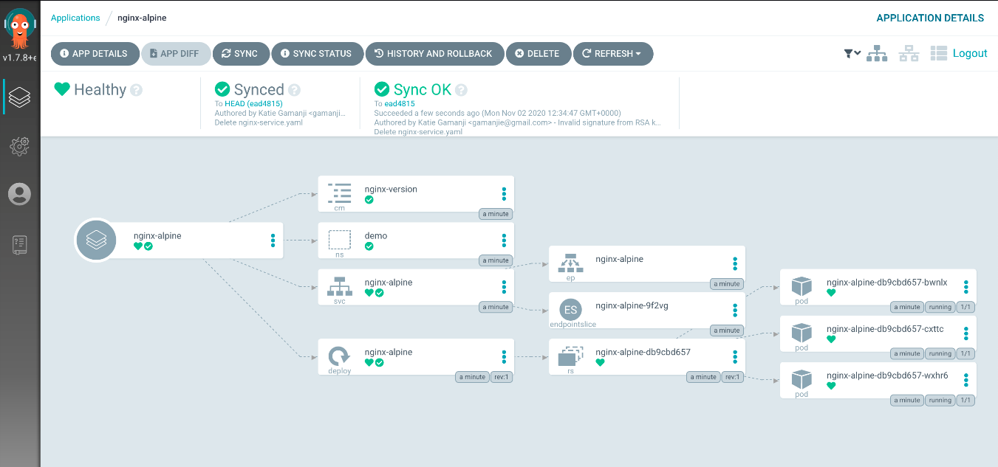

Deployed nginx-alpine resources using ArgoCD

NEXT

# Configuration Managers

## Summary

A CI/CD pipeline is essential to automate and standardize the application release process. New changes are propagated through multiple environments, including the production cluster, and ensure that the consumers can use the latest features. In an ideal situation, all clusters are similarly configured, such that the engineering team can inspect a realistic simulation of a production deployment. This implies that a set of nearly similar manifests are required for each cluster, sandbox, staging, and production. To reduce the management overhead of overseeing a similar suite configuration for each cluster, templating is necessary.

For example, to deploy the nginx-alpine application 4 resource manifests were necessary: Namespace, Deployment, Service, and Configmap. However, this suite of manifests represents the deployment to a single environment, e.g sandbox. The application should be propagated through staging and production environment, which reference a separate set of manifests. It is essential to ensure that the application configuration is tailored for each environment, for example, allocate more CPU and memory to the application in production since it handles more traffic, or have a different number of replicas for each cluster. In this case, an engineering team ends up managing 3 sets of manifests, 1 for each cluster.

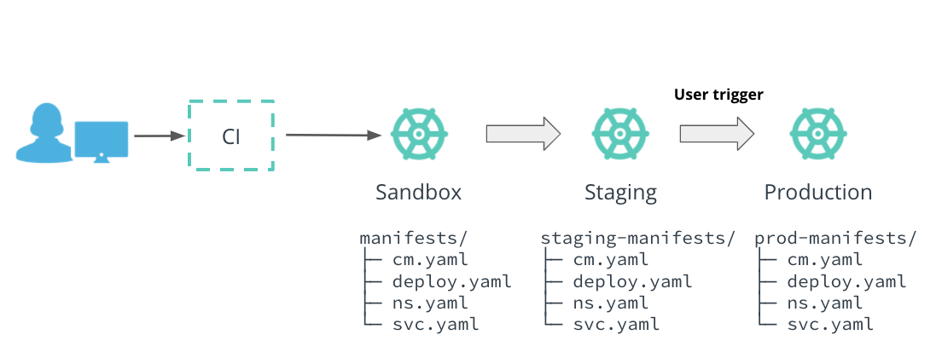

A team has to manage multiple manifests, one for each enviroment, to deploy an application successfully to ptoduction

However, the number of manifests grows exponentially when the application is distributed across multiple regions. As such, if the application is released in AP(Asia Pacific) and the US, a team ends up managing 9 different sets of manifests.

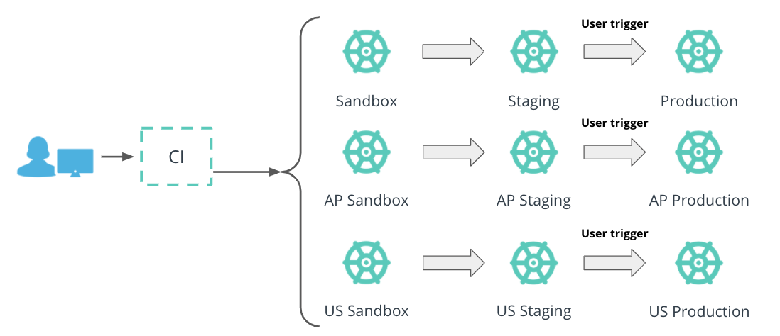

Application distribution across multiple regions implies a larger number of manifests that a team should manage

It is clear that it is necessary to introduce a mechanism to store and manage manifests in a reliable, scalable, and flexible way. This capability is offered by configuration management tools, such as:

* **Helm** - package manager that templates exiting manifests, and uses input files to tailor configuration for each environment
* **Kustomize** - a template-free mechanism that uses a base and multiple overlays, to manage the configuration for each environment
* **Jsonnet** - a programming language, that enables the templating of manifests as JSON files, that can be easily consumed by Kubernetes

In the following sections, we will deep-dive into Helm, as the template manager of choice for this course.

## Helm

## Summary

**Helm** is a package manager, that manages Kubernetes manifests through charts. A Helm chart is a collection of YAML files that describe the state of multiple Kubernetes resources. These files can be parametrized using Go template.

A Helm chart is composed of the following files:

* **Chart.yaml** - expose chart details, such as description, version, and dependencies
* **templates/**folder - contains templates YAML manifests for Kubernetes resources
* **values.yaml** - default input configuration file for the chart. If no other values file is supplied, the parameters in this file will be used.

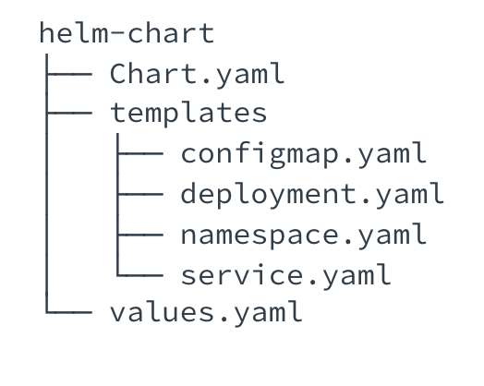

Helm Chart structure

#### Chart.yaml

A Chart.yaml file encompasses the details of the chart, such as version, description, and maintainer list. For example, a Python hello-world Helm chart contains the following Chart.yaml configuration:

## The chart API version

apiVersion: v1

## The name of the chart.

## In this case, the chart name is`python-helloworld `.

name: python-helloworld

## A single-sentence description of this project

description: Install Python HelloWorld

## A list of keywords about this project to quickly identify the chart's capabilities.

keywords:

- python

- helloworld

## The chart version, here set to `3.7.0`

version: 3.7.0

## List of maintainers, their names, and method of contact

maintainers:

- name: kgamanji

email: kgamanji@xyz.com

#### Templates folder

The templates/ folder is a directory containing templated YAML manifests, that require an input file to generate valid Kubernetes resources. For example, the templates/ folder contains the manifests for Deployment and Namespace resources, used to deploy the Python hello-world application:

templates/

├── deployment.yaml

└── namespace.yaml

These manifests can be templated using Go template. For example, instead of hardcoding the name of the Namespace, it can be parameterized as following:

apiVersion: v1

kind: Namespace

metadata:

name: {{ .Values.namespace.name }}

Note: The .Values object is used to access the parameters passed from the input values.yaml file.

#### values.yaml

The values.yaml file contains default input parameters for a Helm chart. The parameters are consumed by the templated YAML manifests through the .Values object. The end result is a suite of valid Kubernetes resources that can be successfully deployed. For example, to provide the configuration for the Deployment and Namespace resources, the values.yaml has the following structure:

## provide the name of the namespace

namespace:

name: test

## define the image to execute with the Deployment

image:

repository:

pixelpotato/python-helloworld

tag: v1.0.0

## set the number of replicas for an application

replicaCount: 3

It is noteworthy, that any fields within the Kubernetes resources can be parameterized. Additionally, the values.yaml file can be overwritten fully or partially, depending if changes are required to all parameters or just to a subset of them. If no override input file is provided, the Helm chart will fallback to using the default values.yaml file (included with the chart).

For example, to override the name of the Namespace to prod the following values-prod.yaml file can be constructed:

## override the name of the namespace

namespace:

name: prod

The end result will be a valid Kubernetes Namespace object:

apiVersion: v1

kind: Namespace

metadata:

name: prod

## Argo CD and Helm

## Summary

So far, we have explored how an engineering team can use Helm charts to template the manifests for multiple clusters. The next stage consists of integrating the Helm charts in the deploy phase of the CI/CD pipeline.

ArgoCD supports the deployment of manifests that are managed by a Helm chart. To implement this approach, the Application CRD requires to change the source of manifests to a Helm chart. An example of the manifest can be found below:

[...]

source:

## change the source of manifests to a Helm chart

helm:

## define the input values file

valueFiles:

- values.yaml

## set the path to the folder where the Helm chart is stored

path: solutions/helm/python-helloworld

## set the base repository that contains the Helm chart

repoURL: https://github.com/udacity/nd064_course_1

targetRevision: HEAD

The full YAML representation of the Application CRD that deploys a Helm chart can be found in the [course repository](https://github.com/udacity/nd064_course_1/blob/main/solutions/argocd/argocd-helm-python.yaml).

## New Terms

* **Helm** - package manager tool used to template a suite of Kubernetes manifests.
* **Helm chart** - a collection of configuration, input, and templated YAML files used to deploy Kubernetes resources.

## Further reading

Explore Helm configuration in more detail:

* [The Chart Template Developer's Guide](https://helm.sh/docs/chart_template_guide/#the-chart-template-developers-guide)
* [The Chart.yaml File](https://helm.sh/docs/topics/charts/#the-chartyaml-file)
* [Templates and Values](https://helm.sh/docs/topics/charts/#templates-and-values)

# Helm Walkthrough

This demo provides a step-by-step guide on how to create a Helm chart to deploy the Python hello-world application. Additionally, this demo showcases how ArgoCD is used to deploy the Python hello-world Helm chart using the default and prod input values files.

To follow this demo closely, reference these resources:

* [Python hello-world Helm chart](https://github.com/udacity/nd064_course_1/tree/main/solutions/helm/python-helloworld) that is used to parameterized the Namespace and Deployment resources. Note how the values.yaml and values-prod.yaml files are used to overwrite name of the Namespace.
* The Application CRD to deploy the Helm chart referencing the default input values file, can be found in [argocd-helm-python.yaml](https://github.com/udacity/nd064_course_1/blob/main/solutions/argocd/argocd-helm-python.yaml) manifest
* The Application CRD used to deploy the Helm chart referencing the values-prod.yaml file, can be found in [argocd-helm-python-prod.yaml](https://github.com/udacity/nd064_course_1/blob/main/solutions/argocd/argocd-helm-python-prod.yaml) manifest

# Quizzes: Configuration Managers

### QUESTION 1 OF 3

Match each configuration management technique with its main characteristic:

### ***Submit to check your answer choices!***

**CONFIGURATION MANAGEMENT TOOL**

**CHARACTERISTICS**

Jsonnet

A programming language used to template manifests as JSON files

Kustomize

A template-free mechanism that uses a base and multiple overlays

Helm

A package manager that template manifests using Go Template

SUBMIT

### QUESTION 2 OF 3

Which components construct a valid Helm chart?

* values.yaml
* 

manifests/ folder

* templates/ folder
* Chart.yaml

SUBMIT

### QUESTION 3 OF 3

What is the output of the following templated resource and input values file:

service.yaml

[...]

spec:

ports:

- port: {{ .Values.service.port }}

protocol: {{ .Values.service.protocol }}

type: {{ .Values.service.type }}

values.yaml

service:

port: 4112

protocol: UDP

type: ClusterIP

* 

port: 6755; protocol: UDP; type: ClusterIP

* 

port: 4112; protocol: TCP; type: ClusterIP

* 

port: 4112; protocol: UDP; type: LoadBalancer

* port: 4112; protocol: UDP; type: ClusterIP

SUBMIT

NEXT

# Exercise: Configuration Managers

For the management of multiple declarative Kubernetes manifests, a templating layer is necessary, especially if the application is replicated across different regions. For this purpose configuration managers, such as Helm and Kustomize, were introduced.

This exercise will focus on creating your first Helm chart to deploy multiple Nginx applications using the same template and multiple input files.

# Exercise

Using the manifests provided in the [course repository](https://github.com/udacity/nd064_course_1/tree/main/exercises/manifests), create a **helm chart (Chart.yaml, templates, values.yaml)** that will template the following parameters:

* namespace name
* replica count
* image:
  + name
  + tag
  + pull policy
* resources
  + requests for CPU and memory
* service
  + port
  + type (e.g. ClusterIP)
* configmap data (e.g. the key-value pair)

The chart details should be as following:

* name: nginx-deployment
* version: 1.0.0
* keywords: nginx

Once the Helm chart is available make sure that a default values.yaml file is available. This values file will be used as a default input file for the Helm chart. The values.yaml file should have the following specification:

* **values.yaml**
  + namespace name: demo
  + replica count: 3
  + image repository: nginx
  + image tag: alpine
  + image pull policy: IfNotPresent
  + resources: CPU 50m and memory 256Mi
  + service type: ClusterIP
  + service port: 8111
  + configmap data: "version: alpine"

Next, create 2 values files with the following specifications:

* **values-staging.yaml**
  + namespace name: staging
  + replica count: 1
  + image repository: nginx
  + image tag: 1.18.0
  + resources: CPU 50m and memory 128Mi
  + configmap data: "version: 1.18.0"
* **values-prod.yaml**
  + namespace name: prod
  + replica count: 2
  + image repository: nginx
  + image tag: 1.17.0
  + resources: CPU 70m and memory 256Mi
  + service port: 80
  + configmap data: "version: 1.17.0"

Finally, using the values files above (values-prod, values-staging), create 2 ArgoCD application, nginx-staging and nginx-prod respectively. These should deploy the nginx Helm Chart referencing each input values files.

Make sure you completed the following tasks:

Task List

* 

Using the manifests provided in the [course repository](https://github.com/udacity/nd064_course_1/tree/main/exercises/manifests), create a Helm chart (Chart.yaml, templates) with the provided requirements

* 

Create Helm values files with the required specifications

* 

Create ArgoCD applications, nginx-staging and nginx-prod, which will reference the existing Helm values files

NEXT

# Solution: Configuration Managers

## Create Helm Chart

Helm provides a powerful mechanism to inject values to templated YAML manifests.

The full Helm chart for nginx-deployment can found in the [course repository](https://github.com/udacity/nd064_course_1/tree/main/solutions/helm/nginx-deployment).

The Helm chart is defined in the Chart.yaml file, which contains the API version, name and version of the chart:

apiVersion: v1

name: nginx-deployment

description: Install Nginx deployment manifests

keywords:

- nginx

version: 1.0.0

maintainers:

- name: kgamanji

An example of the values.yaml file can be found below:

namespace:

name: demo

service:

port: 8111

type: ClusterIP

image:

repository: nginx

tag: alpine

pullPolicy: IfNotPresent

replicaCount: 3

resources:

requests:

cpu: 50m

memory: 256Mi

configmap:

data: "version: alpine"

The above configuration represents the default parameters of application deployment if it is not overwritten by a different values file.

Below is an example of the values-prod.yaml file, which will override the default parameters:

namespace:

name: prod

service:

port: 80

type: ClusterIP

image:

repository: nginx

tag: 1.17.0

pullPolicy: IfNotPresent

replicaCount: 2

resources:

requests:

cpu: 70m

memory: 256Mi

configmap:

data: "version: 1.17.0"

The values-staging.yaml can be found in the [course repository](https://github.com/udacity/nd064_course_1/blob/main/solutions/helm/nginx-deployment/values-staging.yaml).

## Deploy Helm Chart

And finally, here is ArgoCD application CRD for the nginx-prod deployment:

apiVersion: argoproj.io/v1alpha1

kind: Application

metadata:

name: nginx-prod

namespace: argocd

spec:

destination:

namespace: default

server: https://kubernetes.default.svc

project: default

source:

helm:

valueFiles:

- values-prod.yaml

path: helm

repoURL: https://github.com/kgamanji/argocd-demo

targetRevision: HEAD

The nginx-staging.yaml Application for ArgoCD can be found in the [course repository](https://github.com/udacity/nd064_course_1/blob/main/solutions/argocd/argocd-helm-nginx-staging.yaml).

# Edge Case: Push and Pull methodologies for CI/CD

## Summary

Within the CI/CD ecosystem, tools have a variate level of capabilities that offer the deployment of an application to production environments. At a high level, these tools are using a push-based or pull-based model to release new features.

Let's explore each CI/CD model in more detail!

#### Push-based CI/CD

In a **push-based model**, as shown in the image below, the developer commits new code to the Git repository (1), which triggers the Continuous Integration stages (2). The code is packaged and distributed using an image registry, such as DockerHub (3). The Continuous Delivery stage is triggered once the YAML manifests are updated to reference the new image tag (4). A Continuous Delivery tool then pushed the updated manifests to multiple clusters (5).

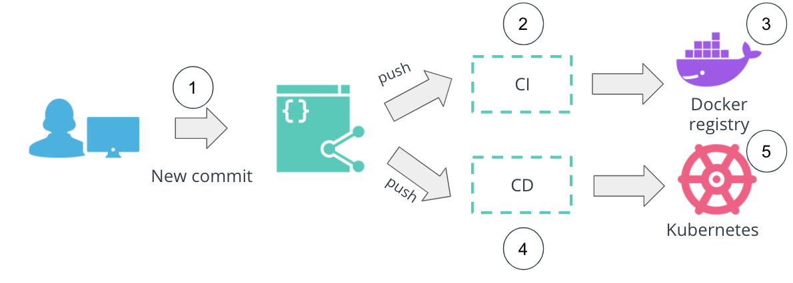

Push-based CI/CD workflow

This model is fully operational and many tools within the ecosystem offer this deployment approach, e.g. Jenkins and CircleCI. However, there is one downside to this model: changes should be actively propagated to all environments. If this is not fulfilled, a scenario might be reached where multiple changes need to be deployed to production, which increases the failure rate and complicated the recovery procedures. Hence, wide awareness is required of features pushed to a production environment.

#### Pull-based CI/CD

In a **pull-based** CI/CD approach, the release process is still be triggered by a developer that pushed new features to the source code (1). The package (2) of the application is similar, resulting in a new image stored in DockerHub (3). However, once the YAML manifests are updated with the new image tag, a pull-based Continuous Delivery tool identifies new changes (4) and applies them to a Kubernetes cluster (5). As a result, this simplifies the process of application release, as new features can be applied automatically as soon as they are available. Tools that offer this CI/CD model are ArgoCD and Flux.

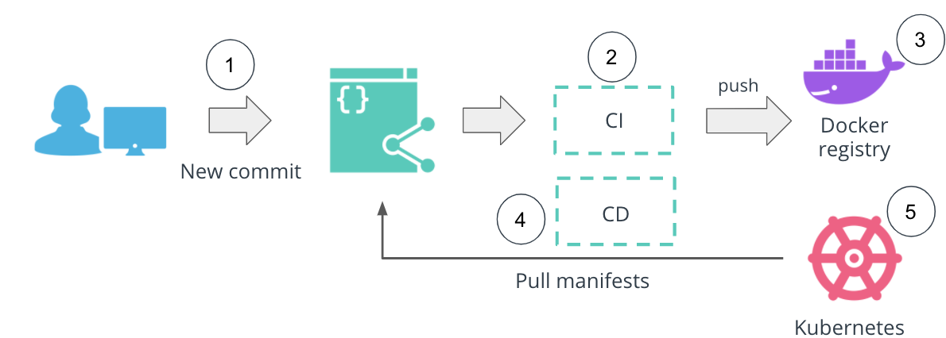

Pull-based CI/CD workflow

It is paramount to build a deployment pipeline that fits the business requirements closely and automates the release process. There is no "golden path" that would cover all engineering requirements. However, the pull and push-based CI/CD tools contribute to the ultimate goal to ships code securely, automatically, and reliably.

# Lesson Conclusion

## Summary

Once a team has developed a product, it is paramount to automate the release process. The building, testing, packaging, and deploying an application to multiple clusters should be highly automated. Building a structured and well-defined CI/CD process is the key to a successful product release. In this lesson, we have explored GitHub Actions to implement the Continuous Integration stages and ArgoCD to perform the Continuous Delivery stages. Additionally, we have covered Helm, as a template configuration manager, that allows the parameterization of YAML manifests and their easy deployment across multiple Kubernetes clusters.

Overall, in this lesson we have explored:

* Continuous Application Deployment
* The CI Fundamentals
* The CD Fundamentals
* Configuration Managers

## New Terms

* **Continuous Integration** - a mechanism that produces the package of an application that can be deployed.
* **Continuous Delivery** - a mechanism to push the packaged application through multiple environments, including production.
* **Continuous Deployment** - a procedure that contains the Continuous Integration and Continuous Delivery of a product.
* **GitOps** - an operating model that refers to the Git repositories as the source of truth for declarative infrastructure and applications.
* **Helm** - package manager tool used to template a suite of Kubernetes manifests.
* **Helm chart** - a collection of configuration, input, and templated YAML files used to deploy Kubernetes resources.

# Course Recap

## Summary

Throughout the Microservice Fundamentals course, we walked through a realistic example of how to choose an architecture for an application, package it using Docker, and deployed it to a Kubernetes cluster using a CI/CD pipeline.

We have started off with an overview of the cloud-native ecosystem and the tools it hosts. Then we've learned different application designs, such as monoliths and microservice, and implied trade-offs. We then moved to package an application using Docker and deploy it to a Kubernetes cluster using imperative and declarative configurations. Then, we transitioned into Platform as a Service (or PaaS) solutions and explored Cloud Foundry as an approach to deploy an application without worrying about the underlying infrastructure. And we finished this course, by practicing cloud-native tooling to construct a CI/CD pipeline. We deep-dived into GitHub Actions and ArgoCD and explored template configuration managers, such as Helm.

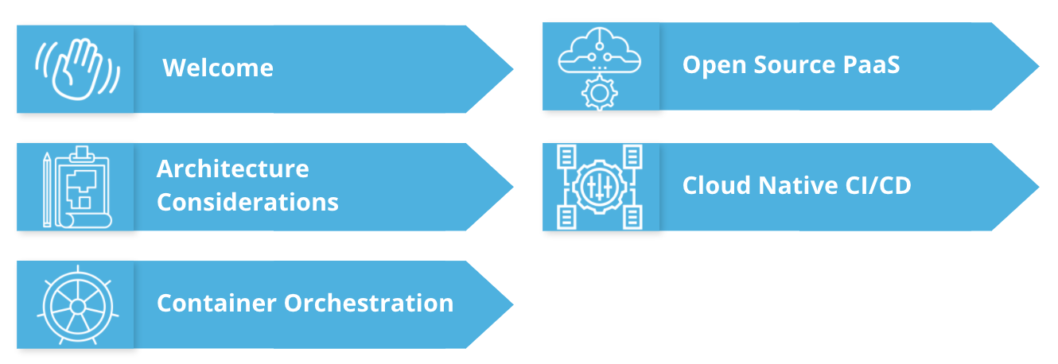

Microservice Fundamentals course outline

Overall, in this course we have covered the following lessons:

* Welcome
* Architecture Considerations
* Container Orchestration
* Open Source PaaS
* Cloud Native CI/CD

# Congratulations!

You have reached the end of the content for your Scholarship Challenge Phase. We commend you for your continued dedication to the program!

## Reiterate Timeline

The Scholarship Challenge Phase will end on **August 2, 2021.** You will receive an email from Udacity informing you whether you were awarded a full Nanodegree scholarship seat on **August 12, 2021.**

## What next?

Please use the time you have from now until the Scholarship Challenge Phase ends, on **August 2, 2021,** to review your coursework and to ensure that you did not miss any quizzes or lessons. This is also a great time to get more involved in the Slack Community. Use your expertise in the Challenge Course to support and motivate your fellow classmates!

Congratulations again for reaching the end of the Scholarship Challenge Course!